- Present simple or Present Continuous?

Dear Friends
I send / am sending you my e-mail to tell you how wonderful things are here in Legoland. I usually spend / am usually spending Christmas holidays at home and
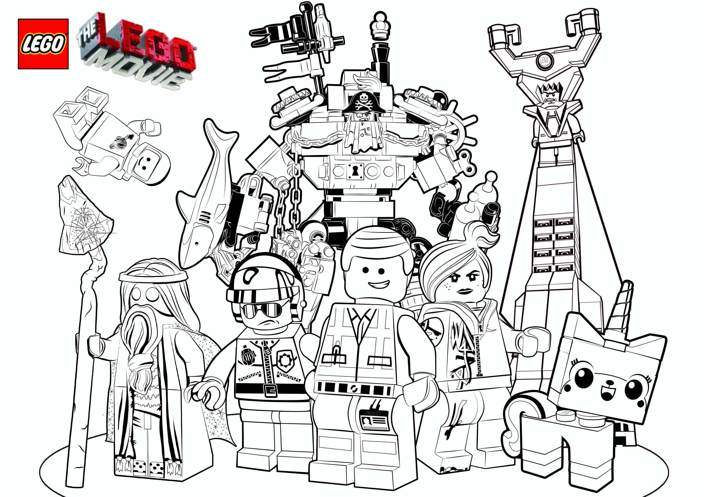
I am doing / do all the usual things; I visit / am visiting my grandparents, sing / am singing Christmas Carols and so on. But this year, things are different. I visit/ am visiting an incredible world built from more than 20 million LEGO bricks. My brother goes/ is going on a safari with the wild animals of the Savannah! My parents are having / have lunch at the saloon of a Wild West town. My sister and I have/ are having a great time at Pirate Land and we sail / are sailing in the secret pirate’s cave. And everything is made of bricks. Wow! I’ll tell you more when I get back.
Lots of kisses
Serena

- Look at the pictures and write what people say in each case. Use the expressions with look/ taste/ smell/ feel.

 This cheese …………………………………………….

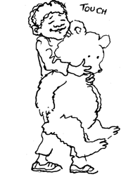 My teddy bear …………………………………………………..

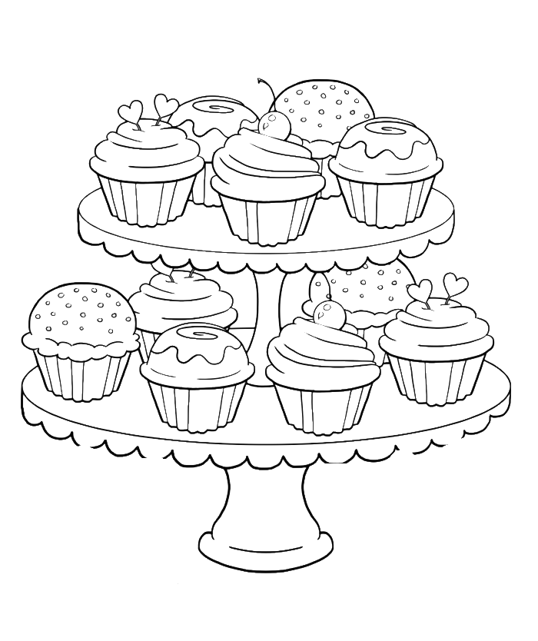 These cakes ………………………………………………

 Those stars ……………………………………………

- Correct the following sentences.
- They play always in the garden at the weekends.
…………………………………………………………………
- Sshhhh!Dad sleeping!Be quiet!
…………………………………………………………………
- She usually have eggs for breakfast.
…………………………………………………………………
- I often don’t wake up before 8 o’ clock.
………………………………………………………………….
- Does you like reading Christmas stories?
…………………………………………………………………...

- Imagine you are on holiday. Write a postcard to your best friend from where you are staying.
…………………………………………………………………………………………………………………………………………………………………………………………………………………………………………………………………………………………………………………………………………………………………………………………………………………………………………………………………………………………………………………………………………………………………………………………………………………………………………………………………………………………………………………………………………………………………………………………………………………………………………………………………………………………………………………………………………

Good luck!!!

Name : …………………………………………

