E. Look and write.

- 
your / brush / teeth
………………………………………….
- 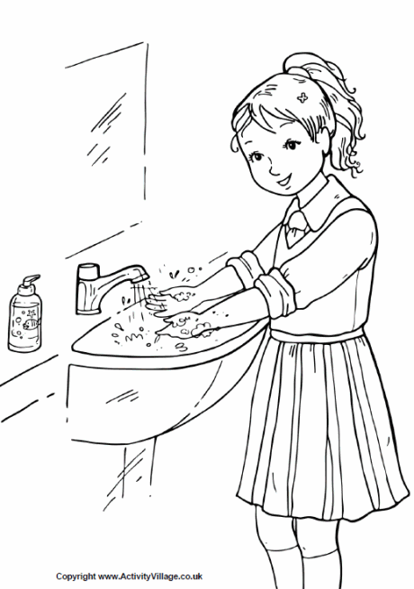
hands / your / wash
………………………………………….
- 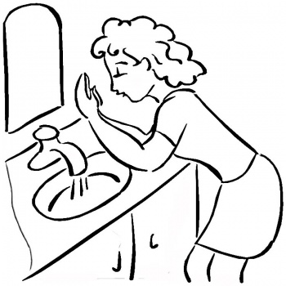
wash / face / your
………………………………………..

F. Look and write.

- L _ _ _ _ _ ! 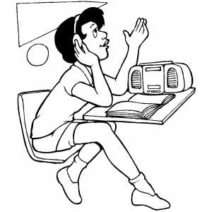 4. W r _ _ e ! 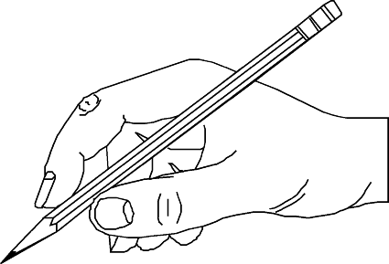

- _ o o _ ! 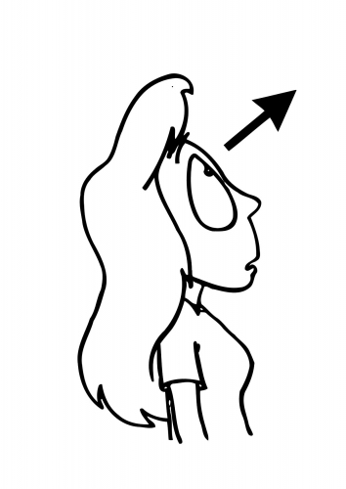 5. S _ _ g ! 

- _ _ a d ! 

