- Where are the kids from? (Από πού είναι τα παιδιά;)

- Hi! I’m Mark. I’m from 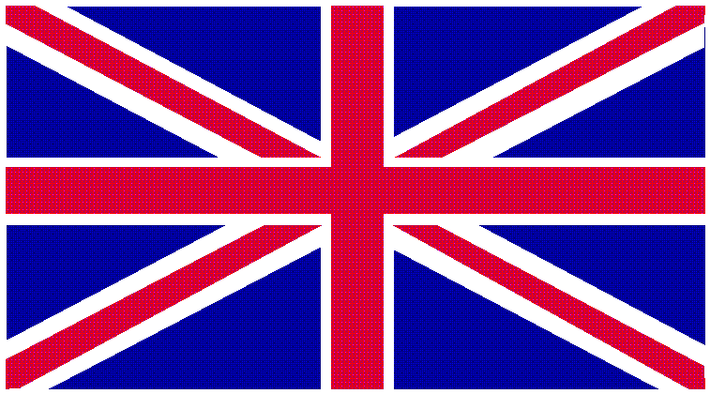 . I’m ……………………………
- Hi! I’m Omar. I’m from 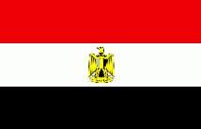 . I’m …………………………….
- Hi! I’m Spyros. I’m from 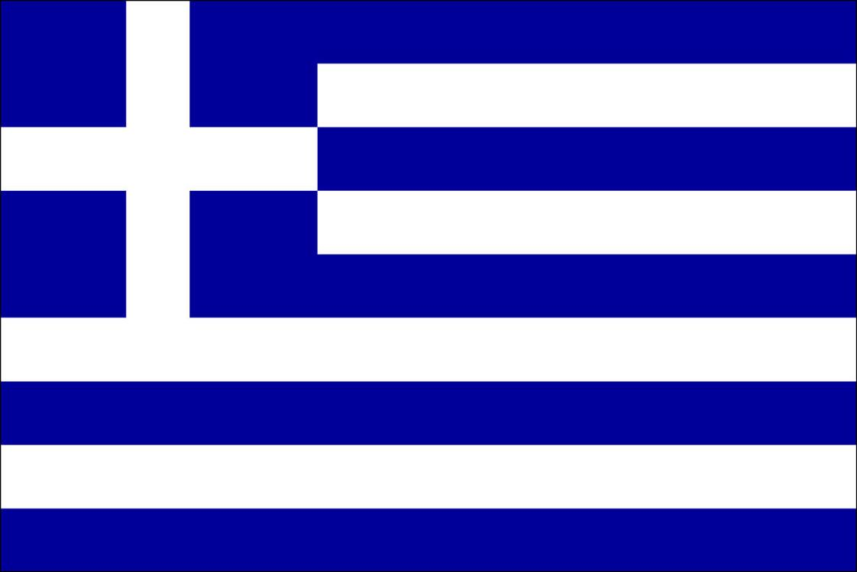 . I’m …………………………….
- Hi! I’m Kahi. I’m from 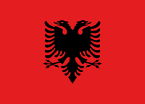 . I’m ………………………………

- Fill in with the correct building. (Συμπλήρωσε με το σωστό κτίριο)

church post office bank school block of flats museum

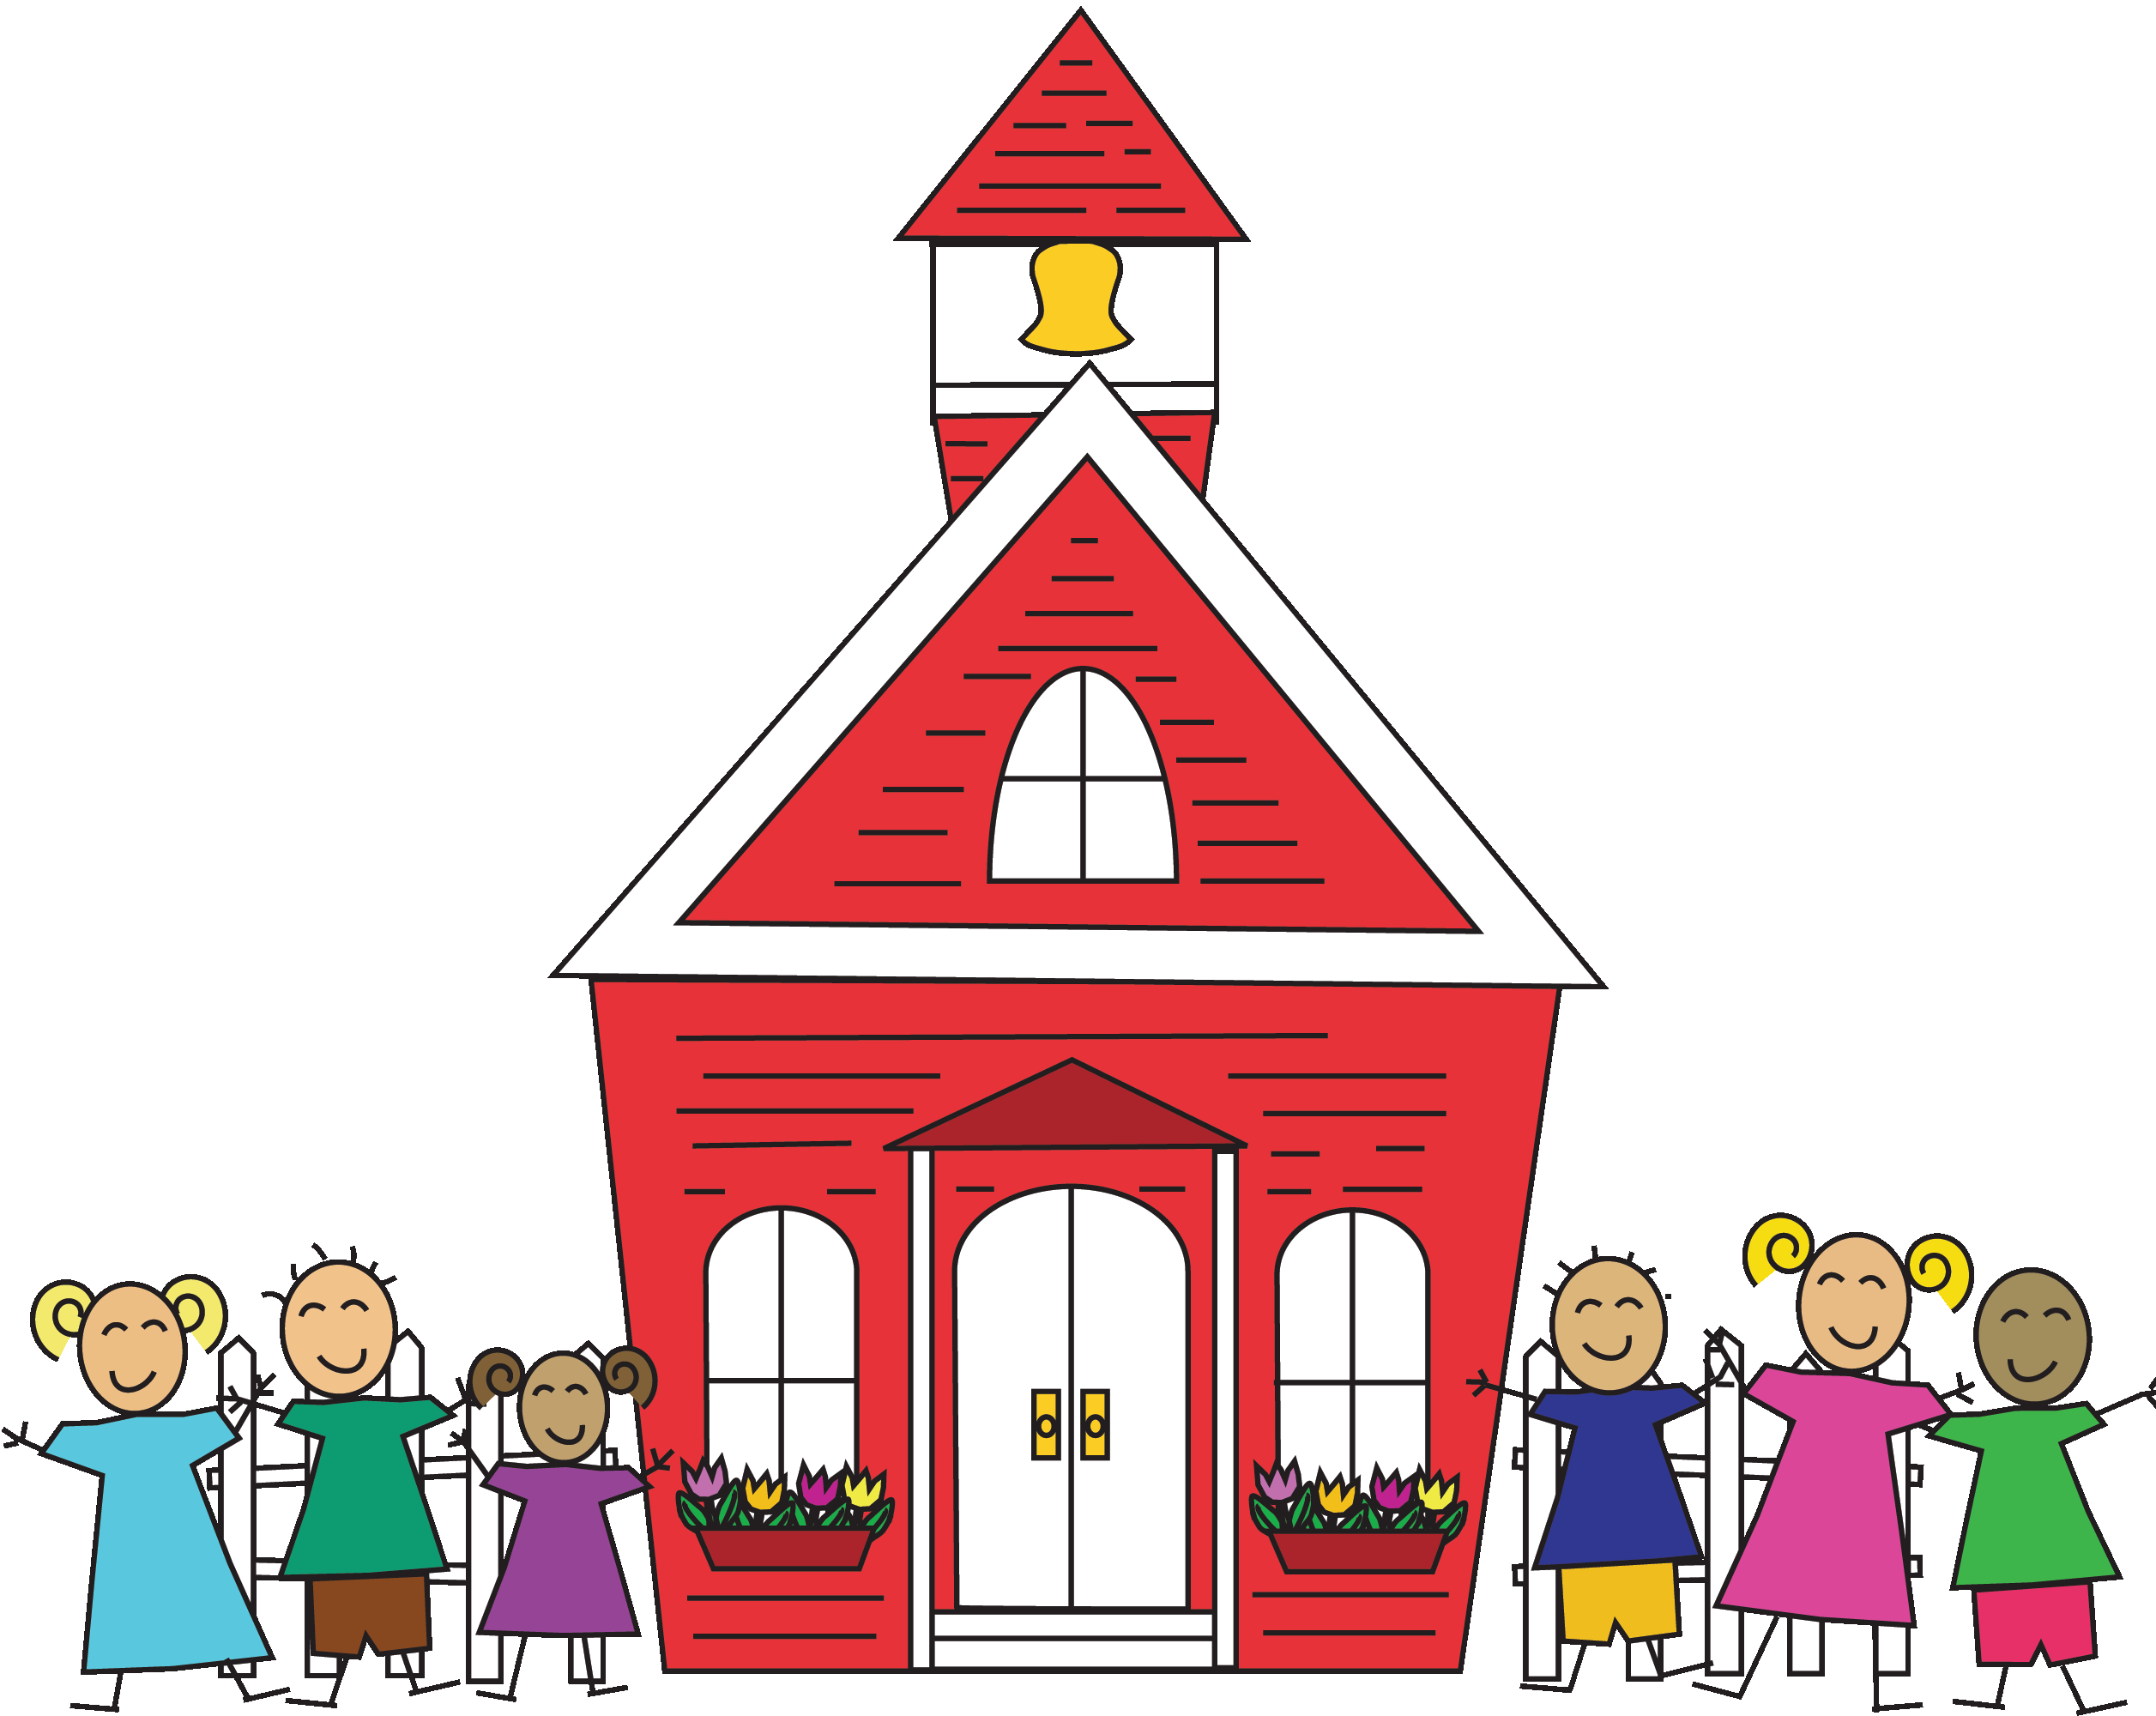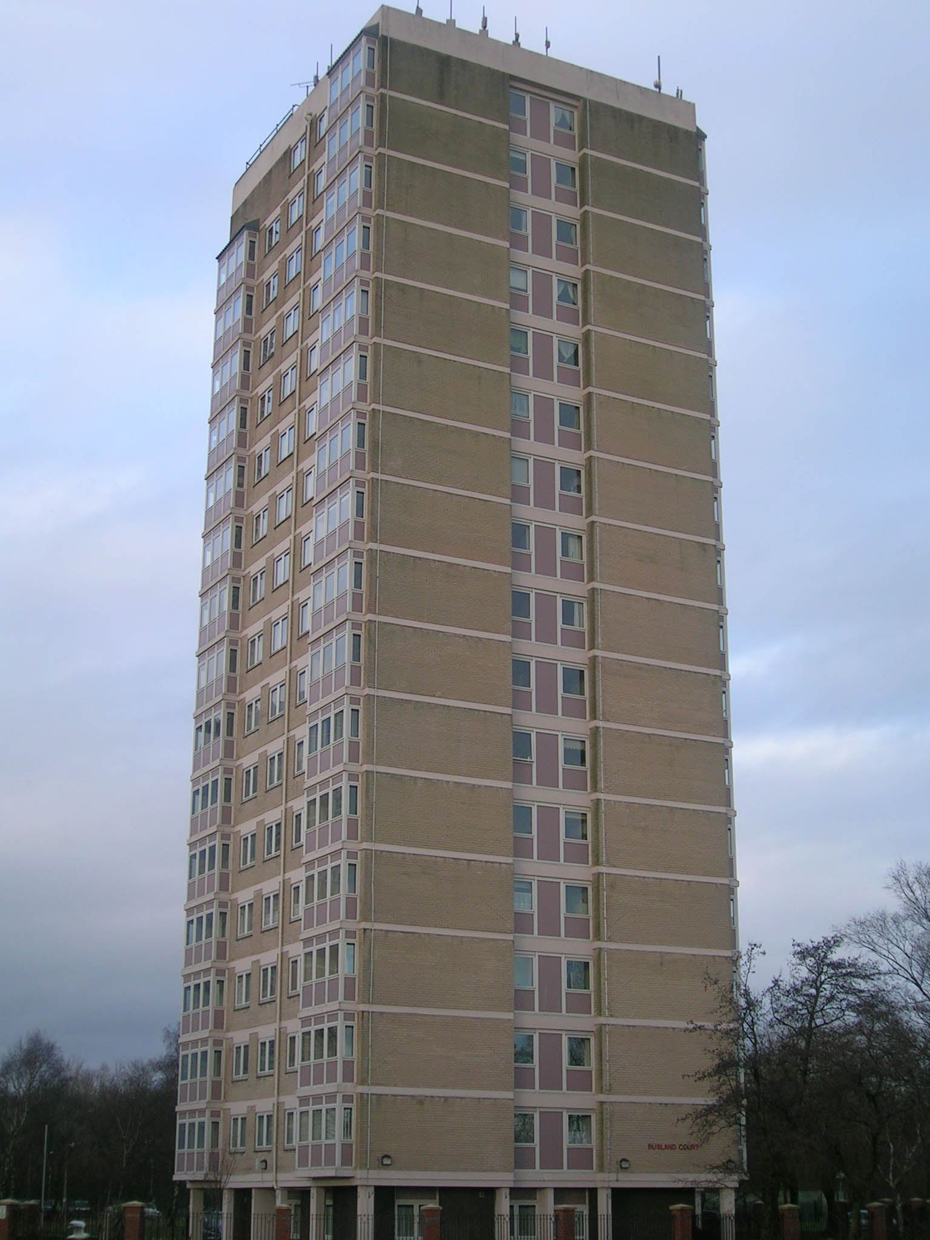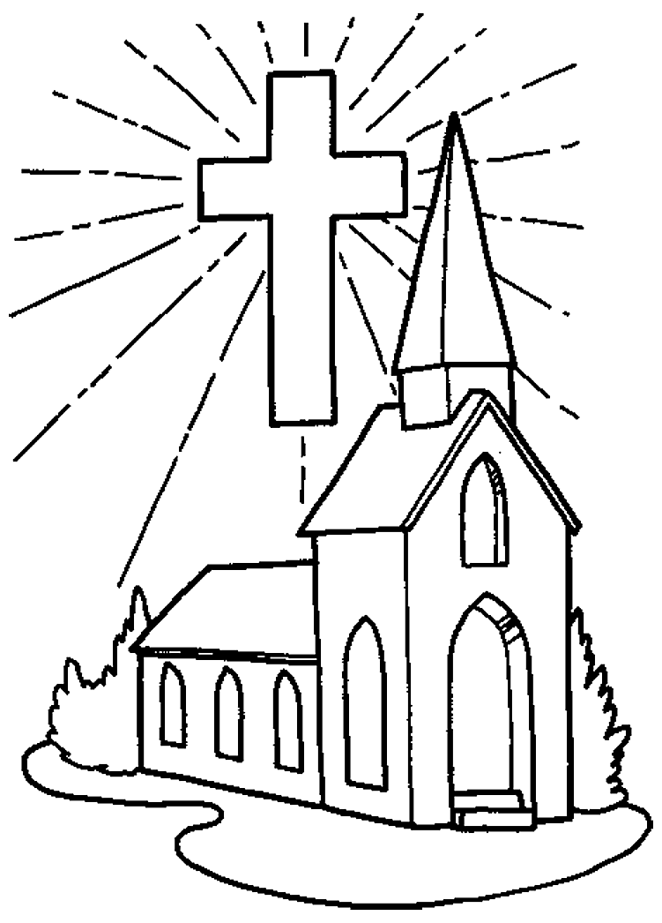
1.…………………………………………… 2.…………………………………… 3. ………………………………………….
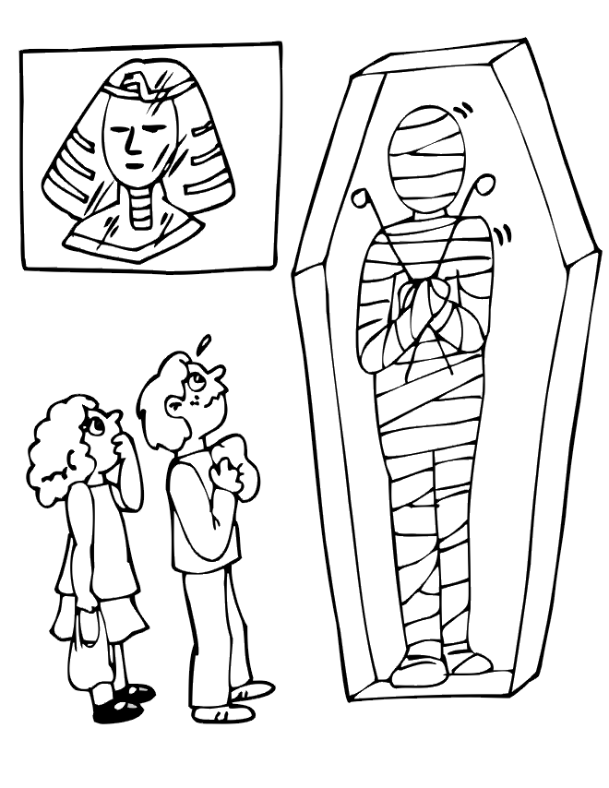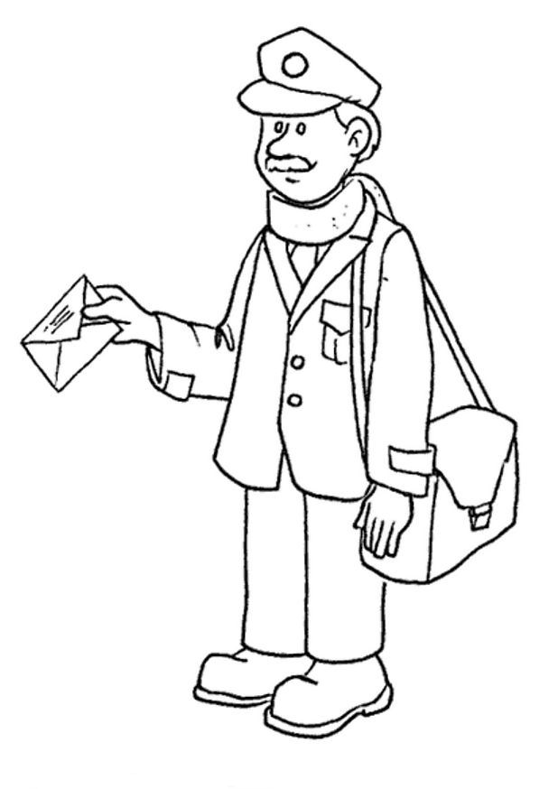
4.…………………………………… 5. …………………………………………… 6. …………………………………………

- Write the meaning of the following words. ( Γράψε τι σημαίνουν οι λέξεις)
- European = …………………….
- Area = …………………………
- Palace = ……………………….
- Square = ……………………….
- Temple = ………………………
- Village = ……………………….
- River = ………………………...
- Beach = ………………………..
- Where are the buildings? (πού είναι τα κτίρια;)

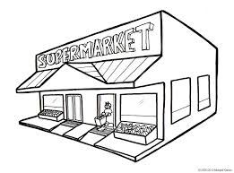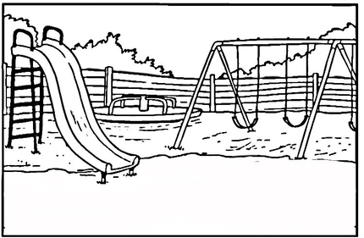
- Where is the supermarket? It’s ……………………….the park.

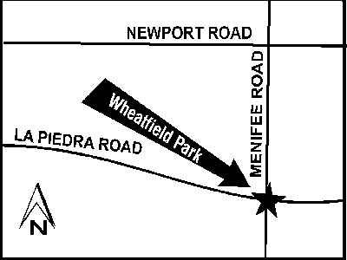

- Where is Wheatfield park?
It’s …………………………………………. La Piedra and Meniffe Road.

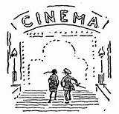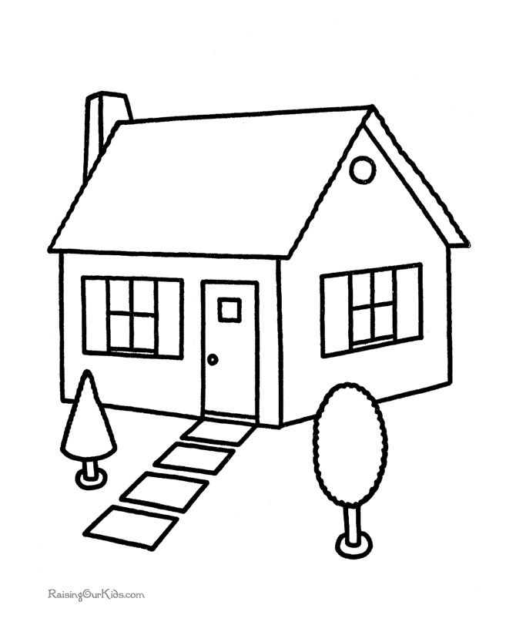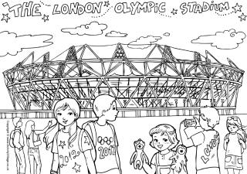
- Where is your house? It’s ……………………the cinema and the sports centre.

Good luck!!!

Name:……………………………………Class:………….Date:………

