Prepositions of place

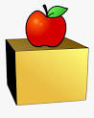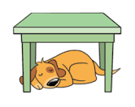

In On Under



Next to Behind In front of

- Write one sentence for each of the prepositions of place: in, on, under, next to, behind, in front of. Example : There’s a bed in my room.
- ………………………………………….
- ………………………………………….
- ………………………………………….
- ………………………………………….
- ………………………………………….
- ………………………………………….

- Write is, are, isn’t, aren’t.

- There …………any chairs on the balcony. X
- There …………a lot of plants in the garden. √
- ………….there a desk in your room? ?
- There ………..a pond in the park. √
- There ……….a library street. X
- ………..there six books on the table? ?

