1. Συμπλήρωσε τις προτάσεις με τον **Present Simple**.
2. We **don’t go** to school by bus. (not go)
3. I ……………………dinner twice a week. (cook)
4. On Saturdays, the Internet café ………………………at five o’clock. (not close)
5. Every afternoon, Toby …………………….. TV after school. (watch)
6. Sandra ………………………….her homework in her bedroom. (do)
7. You …………………………….trainers to school. (not wear)
8. The big ships …………………………at the harbor twice a week. (arrive)
9. Dad ……………………………to work in the morning. (hurry)
10. Διάλεξε τις σωστές απαντήσεις.
11. I don’t like bananas so I ………….eat them.
12. always b) never
13. Mr. Peters …………..to work in the morning
14. usually walks b) walks usually
15. “Do you …………….go to the cinema?” “Yes, we go once a month.”
16. never b) sometimes
17. Helen ……………….nice to her brother.
18. always isn’t b) isn’t always
19. Simon and Kelly love holidays. They ………………..to Greece.
20. Always go b) go always
21. Dianne really likes sport. She ……………..plays tennis with her friends.
22. never b) often
23. Κύκλωσε τις σωστές λέξεις.
24. The library doesn’t **opens / open** at 9 o’clock.
25. Dad **carries / carry** my baby brother to the park.
26. The children **do / does** their homework in the kitchen.
27. We **don’t / doesn’t** dance in the music lesson.
28. The pupils at my school **read / reads** lots of magazines.
29. I **enjoys / enjoy** art lessons.
30. Mum doesn’t **works / work** at the weekend.
31. Our teacher **tidy / tidies** the classroom every afternoon.
32. Συμπλήρωσε τα κενά με τις σωστές εθνικότητες.
33. Pablo is from **Spain**. He’s ……………………………
34. Kostas is from **Greece**. He’s …………………………
35. Svetlana is from **Russia**. She’s ……………………….
36. Szandra is from **Switzerland**. She’s …………………..
37. Sergio is from **Italy**. He’s …………………………….
38. Ian is from **England**. He’s …………………………….
39. Maria is from **Portugal**. She’s …………………………
40. Hans is from **Holland**. He’s …………………………...
41. Συμπλήρωσε τα κενά με τις σωστές λέξεις. Κάποιες λέξεις περισσεύουν.

***modem tower printer keyboard speakers screen scanner microphones and headphones mouse***

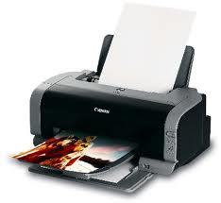

1. ……………………………………………………….

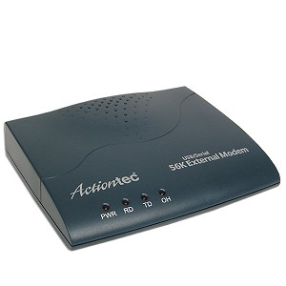

1. ………………………………………………………

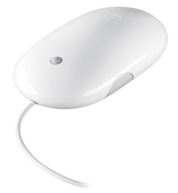

1. ……………………………………………………

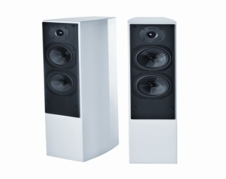

1. …………………………………………………..

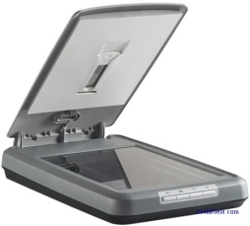

1. ………………………………………………..
2. Γράψε τη σημασία των λέξεων στα ελληνικά.
3. Be situated =
4. Be made up =
5. Population =
6. Main =
7. Island =
8. Include =
9. Southern =
10. Thistle =
11. Shamrock =
12. National =
13. Republic =
14. Side =
15. Northern =
16. Twice =
17. Capital =

ΟΝΟΜΑ :

ΤΑΞΗ :

ΒΑΘΜΟΣ :