1. Read the text carefully and decide whether the following statements are **true** or **false**.

My pen friend’s name is Olina. She is ten and she likes painting, dancing and reading books but she doesn’t like collecting things. Her favourite food is pizza and her favourite colours are pink and red. She can speak and write English.

1. Olina is ten years old.
2. She likes collecting stamps.
3. She doesn’t like dancing.
4. She doesn’t like pizza.
5. She can write English.
6. She likes reading books.
7. Match and draw lines.
8. Playing
9. Taking
10. Watching
11. Listening
12. Making
13. Collecting
14. Riding
15. Dancing

* to music
* board games
* photos
* TV
* tree leaves
* models
* ballet
* a horse

1. Can you write sentences?
2. I  🡪 …………………………………………
3. I 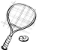🡪 ………………………………………….
4. Now, let’s choose the correct words.
5. Nick ( **like** – **likes** – **don’t like** ) playing football.
6. Andrew ( **don’t like** – **like** – **doesn’t like** ) playing baseball.
7. Tom and Omar ( **likes** – **like** – **doesn’t like**) basketball.
8. We all ( **like** – **likes** – **doesn’t like** ) playing volleyball.

E) Can you match the pictures to the words?

**( swimming, climbing, tennis, sailing, windsurfing, horse riding)**

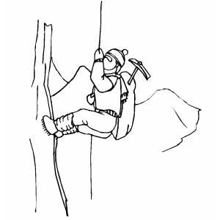 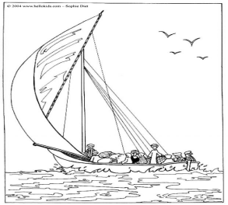

…………………………….. ………………………………

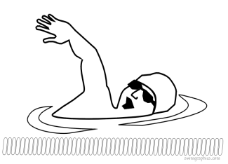 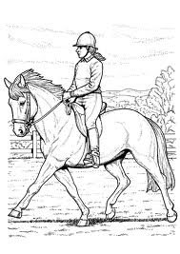

………………………………. ………………………………

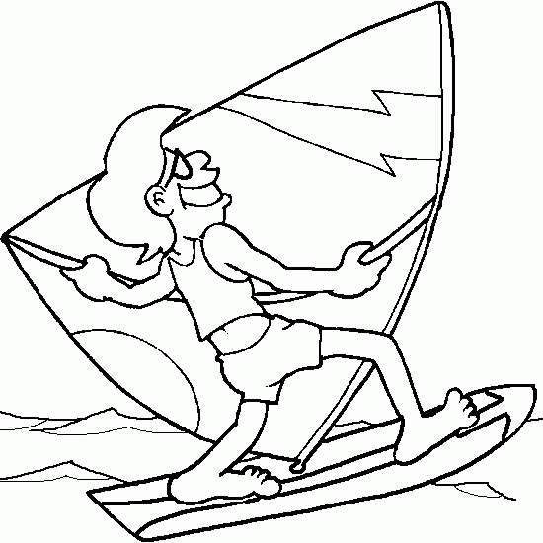 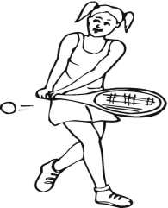

………………………………. ……………………………….

F) Now, write about yourself. (name, age, favourite hobbies, favourite sports, favourite food, favourite colour).

Hello! My name is …………………………………………………………………………………………………………………………………………………………………………………………………………………………………………………………………………………………………………………………………………………………………………………………………………………………………………………………………………………………………………………………………………………………………………………………………………………………………………………………

**GOOD LUCK !!!**

**NAME : ………………………………..**

**DATE : ………………………………..**

**MARK :**