ACTIVITIES

Look at the pictures and fill in the missing letters. Then colour!

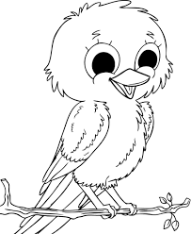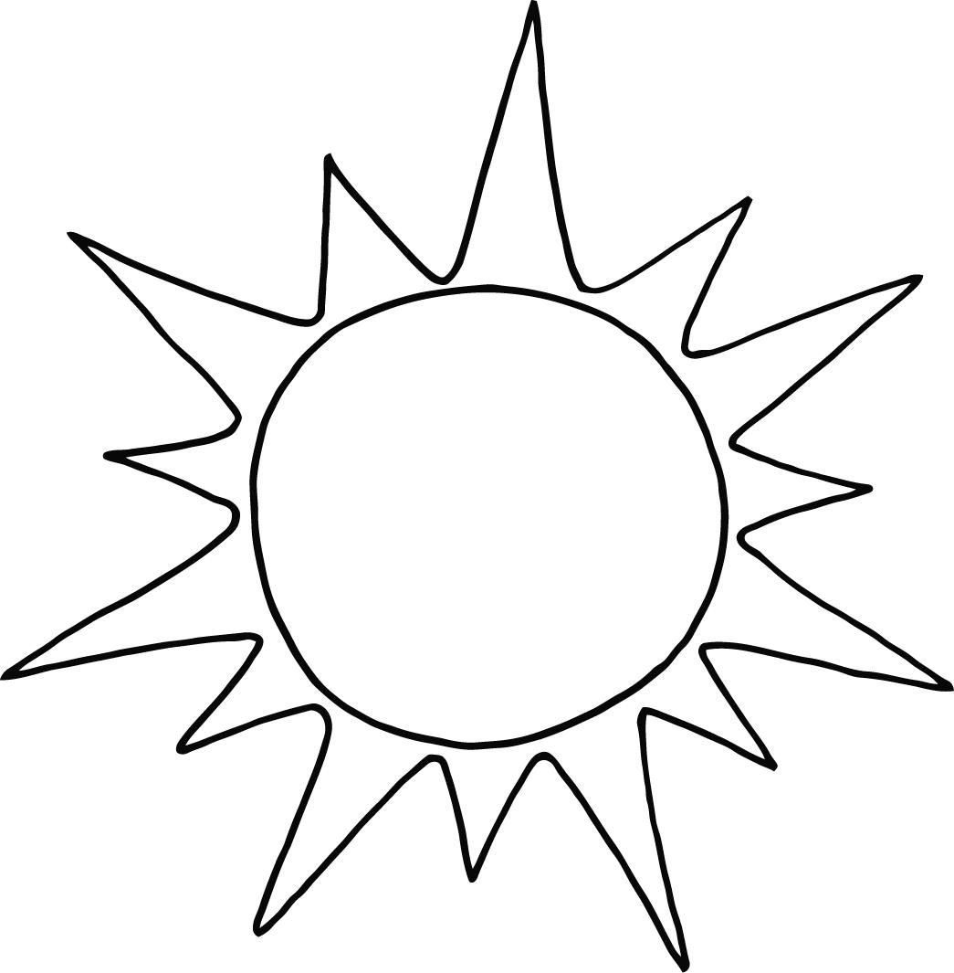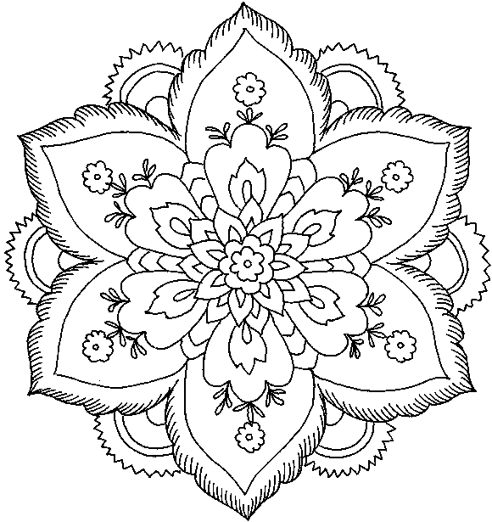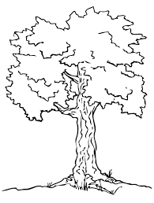
1. B_rd 2.S_n 3. Fl_w_r 4.Tr _ _

Look at the pictures and circle the correct word.

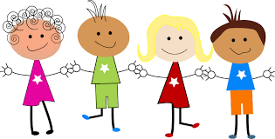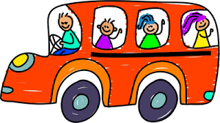
C hildren / Teacher House / Bus

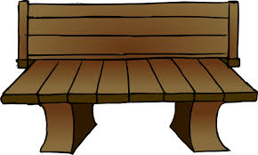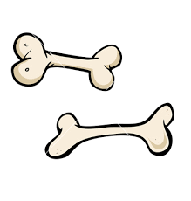
Slide / Bench Bones / Teeth
Look at the alphabet key and write the words.

a | b | c | d | e | f | g | h | i | j | k | l | m | n | o | p | q | r | s | t | u | v | w | x | y | z
◊ | ♣ | ♪ | * | Ђ | □ | € | ≤ | ≥ | ‼ | ∞ | † | ‡ | # | $ | % | & | = | ] | \ | ~ | £ | ¤ | § | ¥ | Ø

_ _ _ _ _ _ _ _
◊ ♪ ♪ ≥ * Ђ # \

_ _ _ _ _
◊ † $#Ђ

_ _ _ ‘ _ _ _ _ _ _ _ _ _ _ _ _
* $ # \ ‼ ~ * ‼ Ђ %Ђ$ % † Ђ

Can you find these words in the puzzle?

smile remember
a j c a r e s s d f u i n m u w
p y r s f a w w m e a j m m o
i s s w m m l o v e u m k p i o
r l m o e a u k m w p p i t n d
a d i f f e r e n t s s d e n e
t b l v q o p a e h t o l w b n
e r e m e m b e r s l o n t s i
a t o q i p b p l a y g r o u n d
u n i q u e y a n u a p r t n m i
a s p s c h o o l y a r d k l e r

schoolyard love

different caress

wooden unique

pirate playground

- Slide= τσουλήθρα
- Bench = παγκάκι
- Wooden= ξύλινος
- Caress = στοργή

