VOCABULARY PRACTICE – MAGIC BOOK 2

- Unscramble and write.

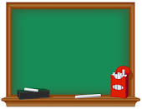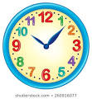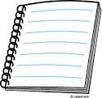
a b d r o e y k c k l o c g s w n i m m i b n o o o k e t
…………………. ………. ………….. ………………… …………….

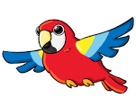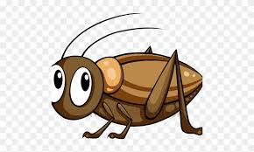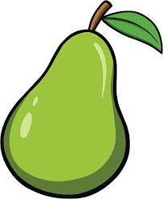
c e t a h r e p r t a e i r p r a o t r c i t k c e e a r p l l l p p o i o
…………… ……………. ……………. ………….. …………. ………………..

- Circle the odd out.

- Yoghurt salami cellar lettuce
- Lion kite hare fish
- Play happy sad strong
- Under in on tree
- Fight sing eye eat
- Panda ear nose tummy
- Eight two four summer

LET’S REMEMBER!!

