- Put the words in the correct groups.

green mouth cheese schoolbag swimming socks yoghurt weasel bathroom nose lettuce blue rubber mole parrot notebook bedroom red shoes pencil kitchen yellow running shoes jumping crocodile living room honey tummy book climbing eyes ears money lips spring sweets summer potatoes jacket winter ham autumn pink tooth dragon hat kangaroo

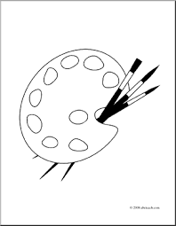…………………………………………………………………………………………………………………………………
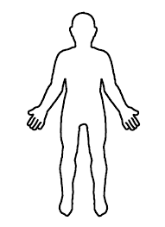…………………………………………………………………………………………………………………………………
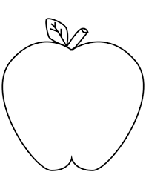……………………………………………………………………………………………………………………………………..
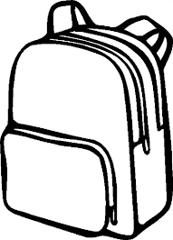……………………………………………………………………………………………………………………………………..
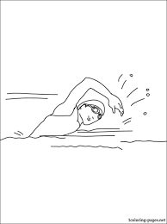………………………………………………………………………………………………………………………………
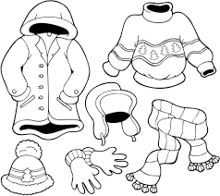………………………………………………………………………………………………………………………………….
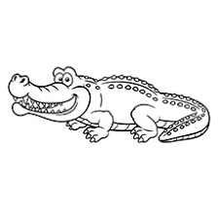……………………………………………………………………………………………………………………………….
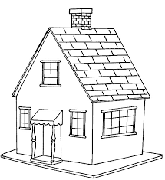…………………………………………………………………………………………………………………….
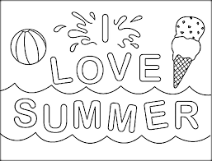 …………………………………………………………………………………………………………………………..

- Match the phrases.

- It’s cool to be different
- Respect my likes,
- I’m thin again
- We want to start a school
- Eat your vegetables and fruit
- What’s that munching
- One pear, two pears, three pears, four
- Hello! I’m Puff the dragon.
- We play together
- I’m out of here!
- All day long.
- Nice to meet you!
- Everybody is unique!
- Five pears, six pears, seven pears and more.
- Respect my rights.
- We want to learn.
- What’s that crunching?
- That’s the right kind of food!

- Do you remember?

The kitchen is y_ _ _ _ _ , the bedroom is b _ _ _ !
Hello Mr. Dragon, I want to f _ _ with you!
The l _ _ _ _ _ room’s red, the bathroom is g _ _ _ _ !
What a beautiful house! Oh it’s so c _ _ _ _ !

