around the world
EASTER TRADITIONS




LUXEMBOURG
BERMUDAS
GREECE
POLAND




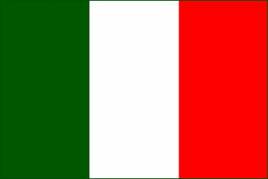
ROMANIA
FINLAND
Hauxe, FRANCE
Florence, ITALY

The day after Easter young boys try to get girls wet with water guns or buckets of water. The tradition says girls who get soaked will marry within the year.

4

People have
“egg battles” – they knock two hard-boiled eggs. The egg which shell doesn’t break – wins and the loser has to eat all the boiled eggs the winner breaks.

On Easter Monday people make a giant omelet and serve it in the town’s main square. It can feed up to 1000 people.

2

In the morning of
Holy Saturday people have a tradition to throw clay pots with water out of their windows. This symbolizes the coming of spring and new harvest season.

1
3




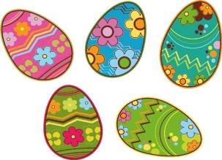

8

On Easter kids dress up in witch costumes and walk in the streets asking for treats.

7

People organize a parade through the town during which they explode a big cart. They believe it’s for a good harvest.

Guys give the girl
they like a pretzel on said Sunday. If she accepts the treat, the guy is allowed to visit the girl on Easter Sunday and will get an egg in return.

5

On Easter people make their own kites with wooden sticks, colorful paper and a special “hummer” on the top. They then gather and fly them in the sky.

6

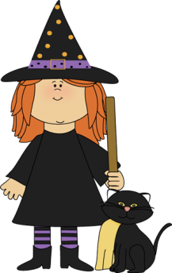





ANSWERS:
1 – Poland
2 - Greece
3 – Haux, France
4 - Romania
5 – Bermudas
6 – Luxembourg
7 – Florence, Italy
8 - Finland

