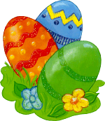
Hello to you all !Well I am so happy because , guess what ….I am on holidays for two weeks. Yes guys, I ‘m starting my Easter holidays on this very Friday. But first , let me tell you a little bit more about me. My name is Shannon and I live in Wembley in the suburbs of London in a big terraced house with a nice small front garden but a bigger back garden. Easter is very important for my parents , me and …. ; oh I forgot , my little brother Sam. It starts today with Good Friday, when according to the Catholic Church , Jesus Christ was put to death, and Easter is all about the celebration of the Resurrection of Christ on the third day after his death. At the moment I am just back from school and I am drinking tea and eating the hot cross buns Mum has made, this is a strong tradition here in England. Then on Easter Sunday we are going to Church in the morning for mass, the church is always full on that occasion !!.We went to church already last Sunday for Palm Sunday .My aunt, uncle and cousins are coming over for lunch. We will have , roast lamb with vegetables (roast potatoes and peas) and a very big Easter cake or cupcakes as it is getting more fashionable now ! My parents are going to hide Easter eggs( the ones we’ve painted and others in chocolate) in our back garden ,and then my brother , my cousins and I are going to look for them there. I hope it will be sunny, on TV the weather forecast says it will be fine but in Spring you never know, there can be very unpleasant showers , moreover if it rained, it would ruin the Easter bonnets we girls all wear on that day! Imagine , last year the eggs were under the snow. Anyway, we’ll let the younger children get most of these eggs. In late afternoon , we’ll all have tea eating our chocolate eggs and other cakes .I am happy because my cousin Amy is going to stay with us during the first week of the holiday and I’m sure you will also enjoy your Easter break !

2. answer these questions.
1. What do people celebrate at Easter ?
---------------------------------------------------------
2. What season is it celebrated in ?-----------------
3. Can you give three important dates ?------------------------------------------------------------------------
4. Who will come at Shannon’s for Sunday lunch?
---------------------------------------------------------
5. What are they going to eat?---------------------------------------------------------------------------------
6. Will they go for a walk in the afternoon?
----------------------------------------------------------
7. What do people do with eggs?
----------------------------------------------------------
8. What do ladies and girls wear on that occasion?
-------------------------------------------------------

1 . say if the statements are true of false and correct those that are false
- Shannon is talking about St Patrick’s day.
-----------------------------------------------
- That festival is celebrated in England only.
-----------------------------------------------
- Shannon is an only child.
--------------------------------------------------
- She likes that period because she has a two week holiday.-----------------------------------
- She lives in the north of England.
------------------------------------------------------
- Easter is a religious celebration .-------------
- Yet there aren’ t many people in churches.
---------------------------------------------------
8. She’s eating scones with her tea.-----------------------------------------------------------------



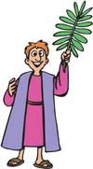
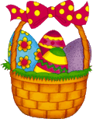
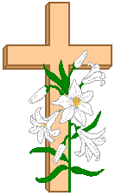
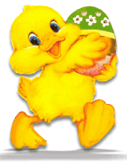

4. Match the pictures to the words
1 Basket
2. Spring
3. Bonnets
4. Chick
5. Easter Bunny
6. Egg hunting
7. Hot cross buns
8. Easter cupcakes
9. Resurrection
10. Church
11. Cross
12 Palm Sunday
13. Egg painting
14. Easter egg tree

3. put the words in the right order.
1. *important is * Easter* an * celebration*-------------------------------------------------------
2. * Jesus* resurrection* of* people*celebrate*
the * Christ*-----------------------------------------------------------------------------------------------
3. *Britain* eat* they * buns* Friday* hot * on *cross*Good*in*-------------------------------------------------------------------------------------------
4. *traditional * the * lamb* meal* includes *roast *--------------------------------------------------------------------------------------------------
5. * children * lots* looking * hidden* eggs * for* chocolate* of* like *---------------------------------------------------------------------------------------
6. *Easter*having * break *at * people * a * enjoy* ------------------------------------------------------------------------------------------------------

