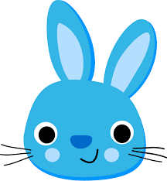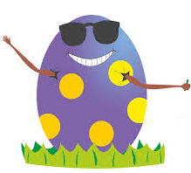

**EASTER SPECIALITIES**

**FOOD**

EGGS

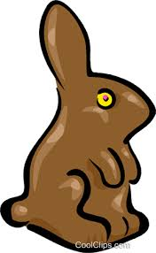CHOCOLAT BUNNY

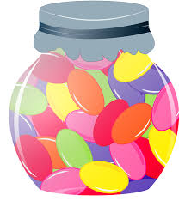JELLY BEANS

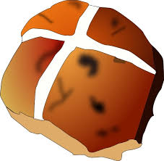HOT CROSS BUN

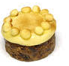SIMNAL CAKE

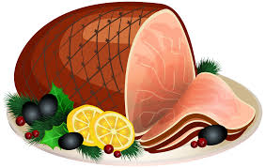HAM

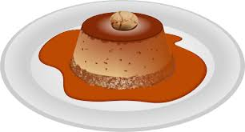

TOFFEE PUDDING

**EASTER RHYME**

Bunnies are brown   
Bunnies are white   
Bunnies are always   
An Easter delight.   
  
Bunnies are cuddly   
Large as well as small.   
But I like the chocolate ones   
the sweetest of them all.

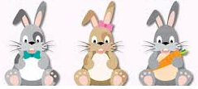

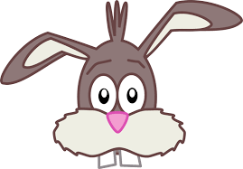

**EASTER SYMBOLS**

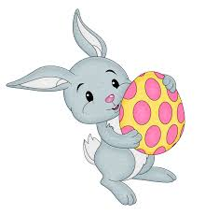.................

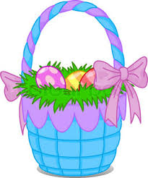.....................

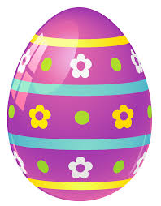........................

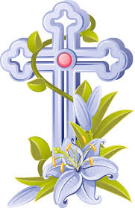........................

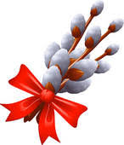.......................

CROSS – EGG – BUNNY

BASKET – PUSSY WILLOW