### 1 1 1

x 6 x 9 x 3

1 1

### x 1 x 9

1 1 1

### x 9 x 0 x 2

1 1

### x 9 x 8

1 1 1

### x 3 x 3 x 1

1 1

### x 8 x 1

1 1 1

### x 2 x 4 x 3

1 1

### x 7 x 8

1 1 1

### x 7 x 4 x 3

1 1

### x 8 x 5

2 2 2

### x 5 x 3 x 9

2 2

### x 0 x 7

2 2 2

### x 2 x 8 x 2

2 2

### x 4 x 7

2 2 2

### x 2 x 2 x 4

2 2

### x 8 x 5

2 2 2

### x 2 x 1 x 9

2 2

### x 9 x 8

2 2 2

### x 0 x 6 x 5

2 2

### x 3 x 9

3 3 3

### x 9 x 5 x 2

3 3

### x 0 x 6

3 3 3

### x 5 x 9 x 8

3 3

### x 0 x 2

3 3 3

### x 1 x 9 x 8

3 3

### x 5 x 5

3 3 3

### x 0 x 0 x 0

3 3

### x 3 x 8

3 3 3

### x 6 x 4 x 0

3 3

### x 7 x 4

4 4 4

### x 2 x 6 x 7

4 4

### x 8 x 0

4 4 4

### x 0 x 2 x 3

4 4

### x 4 x 2

4 4 4

### x 0 x 6 x 0

4 4

### x 0 x 2

4 4 4

### x 6 x 5 x 0

4 4

### x 3 x 4

4 4 4

### x 6 x 6 x 1

4 4

### x 8 x 1

5 5 5

### x 7 x 6 x 2

5 5

### x 8 x 2

5 5 5

### x 5 x 0 x 5

5 5

### x 8 x 8

5 5 5

### x 0 x 2 x 1

5 5

### x 0 x 5

5 5 5

### x 2 x 5 x 5

5 5

### x 0 x 2

5 5 5

### x 0 x 5 x 8

5 5

### x 2 x 6

6 6 6

### x 3 x 3 x 2

6 6

### x 9 x 6

6 6 6

### x 6 x 5 x 9

6 6

### x 1 x 1

6 6 6

### x 4 x 5 x 4

6 6

### x 0 x 4

6 6 6

### x 5 x 0 x 2

6 6

### x 4 x 7

6 6 6

### x 3 x 4 x 7

6 6

### x 0 x 9

7 7 7

### x 9 x 9 x 5

7 7

### x 4 x 0

7 7 7

### x 9 x 8 x 7

7 7

### x 8 x 5

7 7 7

### x 1 x 3 x 6

7 7

### x 6 x 2

7 7 7

### x 7 x 2 x 1

7 7

### x 1 x 8

7 7 7

### x 2 x 6 x 2

7 7

### x 2 x 3

8 8 8

### x 6 x 3 x 0

8 8

### x 7 x 0

8 8 8

### x 3 x 1 x 8

8 8

### x 5 x 9

8 8 8

### x 9 x 4 x 5

8 8

### x 7 x 0

8 8 8

### x 2 x 7 x 1

8 8

### x 1 x 1

8 8 8

### x 8 x 4 x 2

8 8

### x 3 x 8

9 9 9

### x 9 x 8 x 7

9 9

### x 7 x 1

9 9 9

### x 7 x 7 x 9

9 9

### x 9 x 3

9 9 9

### x 0 x 3 x 2

9 9

### x 6 x 1

9 9 9

### x 5 x 9 x 6

9 9

### x 5 x 1

9 9 9

### x 5 x 9 x 9

9 9

### x 4 x 8

|  |  |  |  |  |  |
| --- | --- | --- | --- | --- | --- |
| 1 | × | 2 | = | 7 × 2 = | 11 × 2 = |
| 6 | × | 3 | = | 11 × 3 = | 3 × 2 = |
| 5 | × | 3 | = | 6 × 2 = | 9 × 2 = |

12 × 2 = 7 × 3 = 10 × 3 =

3 × 3 = 8 × 2 = 12 × 3 =

|  |  |  |  |  |  |  |  |  |
| --- | --- | --- | --- | --- | --- | --- | --- | --- |
| 4 | × | 3 | = | 10 × 2 = | 8 | × | 3 | = |
| 9 | × | 3 | = | 2 × 2 = | 5 | × | 2 | = |
| 2 | × | 3 | = | 4 × 2 = | 1 | × | 3 | = |
| 2 | × | 3 | = | 11 × 3 = | 3 | × | 3 | = |

|  |  |  |  |  |  |  |  |  |
| --- | --- | --- | --- | --- | --- | --- | --- | --- |
| 11 × 2 = | 1 | × | 3 | = | 7 | × | 2 | = |
| 6 × 2 = | 5 | × | 3 | = | 5 | × | 2 | = |
| 7 × 3 = | 4 | × | 3 | = | 2 | × | 2 | = |
| 11 × 3 = | 1 | × | 2 | = | 4 | × | 2 | = |
| 10 × 3 = | 8 | × | 2 | = | 9 | × | 3 | = |
| 9 × 2 = | 10 × 2 = | | | | 3 | × | 3 | = |
| 12 × 3 = | 12 × 2 = | | | | 3 | × | 2 | = |
| 2 × 3 = | 6 × 3 = | | | | 8 | × | 3 | = |
| 8 × 3 = | 11 × 3 = | | | | 8 | × | 3 | = |

|  |  |  |  |  |  |  |  |  |  |  |  |
| --- | --- | --- | --- | --- | --- | --- | --- | --- | --- | --- | --- |
| 9 | × | 3 | = | 7 | × | 3 | = | 3 | × | 2 | = |
| 1 | × | 2 | = | 5 | × | 3 | = | 8 | × | 3 | = |
| 9 | × | 2 | = | 1 | × | 3 | = | 2 | × | 2 | = |

12 × 3 = 4 × 3 = 11 × 2 =

3 × 3 = 5 × 2 = 10 × 2 =

|  |  |  |  |  |  |
| --- | --- | --- | --- | --- | --- |
| 6 | × | 2 | = | 10 × 3 = | 4 × 2 = |
| 2 | × | 3 | = | 7 × 2 = | 11 × 3 = |
| 6 | × | 3 | = | 12 × 2 = | 8 × 2 = |
| 8 | × | 3 | = | 12 × 2 = | 9 × 3 = |

|  |  |  |  |  |  |  |  |  |  |  |
| --- | --- | --- | --- | --- | --- | --- | --- | --- | --- | --- |
| 7 × | 3 | = | 4 × 3 = | | | | 2 × 2 = | | | |
| 8 × | 3 | = | 11 × 2 = | | | | 4 × 2 = | | | |
| 9 × | 3 | = | 3 × 2 = | | | | 11 × 3 = | | | |
| 10 × 2 = | | | 3 | × | 3 | = | 5 | × | 3 | = |
| 9 × 2 = | | | 2 | × | 3 | = | 8 | × | 2 | = |
| 7 × 2 = | | | 10 × 3 = | | | | 6 | × | 2 | = |
| 12 × 2 = | | | 5 × 2 = | | | | 1 | × | 2 | = |
| 6 × 3 = | | | 12 × 3 = | | | | 1 | × | 3 | = |
| 10 × 3 = | | | 5 × 2 = | | | | 4 | × | 3 | = |

11 × 2 = 7 × 3 = 8 × 3 =

|  |  |  |  |  |  |  |  |  |
| --- | --- | --- | --- | --- | --- | --- | --- | --- |
| 4 | × | 2 | = | 1 | × | 2 | = | 2 × 3 = |
| 8 | × | 2 | = | 3 | × | 3 | = | 10 × 2 = |
| 1 | × | 3 | = | 4 | × | 3 | = | 6 × 2 = |
| 5 | × | 2 | = | 9 | × | 2 | = | 6 × 3 = |

12 × 3 = 9 × 3 = 10 × 3 =

5 × 3 = 2 × 2 = 3 × 2 =

|  |  |  |  |  |  |
| --- | --- | --- | --- | --- | --- |
| 12 × 2 = | 11 × 3 = | 7 | × | 2 | = |
| 5 × 2 = | 6 × 2 = | 1 | × | 3 | = |

|  |  |  |  |  |  |  |  |  |  |  |  |
| --- | --- | --- | --- | --- | --- | --- | --- | --- | --- | --- | --- |
| 3 | × | 2 | = | 4 | × | 2 | = | 6 × 3 = | | | |
| 1 | × | 2 | = | 7 | × | 2 | = | 5 × 2 = | | | |
| 9 | × | 2 | = | 7 | × | 3 | = | 11 × 2 = | | | |
| 12 × 2 = | | | | 8 | × | 2 | = | 2 | × | 3 | = |
| 11 × 3 = | | | | 4 | × | 3 | = | 3 | × | 3 | = |
| 9 | × | 3 | = | 12 × 3 = | | | | 2 | × | 2 | = |
| 6 × 2 = | | | | 8 | × | 3 | = | 10 × 2 = | | | |
| 10 × 3 = | | | | 5 | × | 3 | = | 1 × 3 = | | | |
| 11 × 2 = | | | | 7 | × | 3 | = | 4 × 3 = | | | |

5 × 2

= 5 ×

8 = 10

× 5 =

10 ×

7 = 5 ×

6 = 10

× 4 =

5 × 10

= 10

× 2 = 10

× 12 =

5 × 4

= 10

× 9 = 5 × 11 =

10 ×

3 = 10

× 11

= 5 × 12 =

10 ×

1 = 5 ×

1 = 5 ×

5 =

10 ×

6 = 10

× 10

= 5 ×

9 =

5 × 7

= 10

× 8 = 5 ×

3 =

5 × 3

= 10

× 3 = 5 ×

9 =

10 × 10

= 10

× 9 = 5 ×

9 =

5 × 2

= 10

× 7 = 5 ×

7 =

10 × 11

= 10

× 3 = 5 ×

8 =

5 × 4

= 10

× 12

= 5 ×

3 =

10 ×

2 = 5 × 11

= 10

× 5 =

10 ×

4 = 5 × 10

= 10

× 1 =

5 × 12

= 5 ×

1 = 5 ×

6 =

5 × 5

= 10

× 6 = 10

× 8 =

10 ×

4 = 5 ×

6 = 5 ×

2 =

5 × 8

= 5 ×

1 = 10

× 6 =

5 × 12

= 10

× 7 = 5 ×

3 =

10 ×

3 = 5 ×

6 = 10

× 2 =

5 × 11

= 10

× 11

= 10

× 4 =

5 × 5

= 10

× 12

= 10

× 9 =

5 × 4

= 10

× 10

= 5 ×

2 =

10 ×

8 = 5 ×

7 = 5 × 10 =

10 ×

5 = 10

× 1 = 5 ×

9 =

10 × 12

= 5 ×

7 = 10

× 1 =

10 ×

5 = 5 ×

7 = 5 ×

5 =

5 × 1

= 5 ×

3 = 5 ×

4 =

10 × 11

= 10

× 1 = 5 ×

8 =

5 × 2

= 5 × 10

= 10

× 12 =

10 ×

9 = 10

× 3 = 5 ×

9 =

10 × 10

= 10

× 8 = 10

× 7 =

10 ×

4 = 10

× 2 = 10

× 6 =

5 × 12

= 5 × 11

= 5 ×

6 =

5 × 6

= 10

× 2 = 5 ×

1 =

|  |  |  |
| --- | --- | --- |
| 5 × 9 = | 10 × 8 = | 5 × 3 = |
| 10 × 9 = | 5 × 12 = | 10 × 6 = |
| 5 × 1 = | 5 × 5 = | 10 × 3 = |
| 10 × 7 = | 10 × 12 = | 5 × 10 = |
| 5 × 11 = | 5 × 2 = | 5 × 6 = |
| 10 × 11 = | 10 × 4 = | 5 × 7 = |
| 5 × 8 = | 5 × 4 = | 10 × 10 = |
| 10 × 2 = | 10 × 5 = | 10 × 1 = |
| 10 × 3 = | 5 × 10 = | 10 × 10 = |

10 × 11

= 10

× 10

= 5 ×

6 =

10 ×

4 = 5 ×

2 = 5 ×

5 =

5 × 1

= 10

× 3 = 5 ×

4 =

5 × 8

= 10

× 6 = 10

× 7 =

5 × 7

= 10

× 1 = 10

× 2 =

5 × 12

= 5 ×

9 = 5 × 11 =

10 × 12

= 10

× 9 = 10

× 8 =

10 ×

5 = 5 × 10

= 5 ×

3 =

5 × 3

= 10

× 2 = 10

× 10 =

8 × 7

= 7 × 11

= 8 × 11 =

|  |  |  |  |  |  |  |  |  |  |
| --- | --- | --- | --- | --- | --- | --- | --- | --- | --- |
| 8 | × | 10 = | 8 | × | 3 = | 8 | × | 1 | = |
| 7 | × | 7 = | 8 | × | 5 = | 7 | × | 8 | = |
| 7 | × | 2 = | 8 | × | 12 = | 7 | × | 5 | = |
| 7 | × | 10 = | 7 | × | 12 = | 8 | × | 6 | = |
| 8 | × | 2 = | 8 | × | 4 = | 8 | × | 9 | = |
| 8 | × | 8 = | 7 | × | 3 = | 7 | × | 1 | = |
| 7 | × | 4 = | 7 | × | 6 = | 7 | × | 9 | = |
| 8 | × | 7 = | 8 | × | 5 = | 8 | × | 8 | = |

7 × 3

= 8 ×

6 = 7 ×

6 =

8 × 9

= 8 × 11

= 8 ×

8 =

8 × 10

= 7 × 11

= 8 ×

3 =

8 × 5

= 7 ×

9 = 7 × 12 =

7 × 2

= 8 ×

2 = 7 ×

5 =

7 × 8

= 7 ×

1 = 7 ×

7 =

7 × 4

= 8 × 12

= 7 × 10 =

8 × 7

= 8 ×

4 = 8 ×

1 =

8 × 6

= 7 ×

3 = 8 ×

1 =

8 × 6

= 8 ×

2 = 7 × 10 =

8 × 10

= 7 ×

1 = 7 ×

4 =

7 × 6

= 7 ×

8 = 8 ×

4 =

7 × 12

= 8 × 12

= 7 ×

3 =

|  |  |  |  |  |  |  |  |  |  |  |
| --- | --- | --- | --- | --- | --- | --- | --- | --- | --- | --- |
| 7 | × | 5 | = | 7 | × | 11 = | 8 | × | 3 | = |
| 8 | × | 8 | = | 8 | × | 1 = | 7 | × | 2 | = |
| 8 | × | 7 | = | 8 | × | 5 = | 7 | × | 7 | = |
| 7 | × | 9 | = | 8 | × | 11 = | 8 | × | 9 | = |

8 × 10

= 8 ×

8 = 8 ×

2 =

7 × 1

= 8 ×

4 = 7 × 12 =

8 × 12

= 8 ×

5 = 7 ×

7 =

7 × 8

= 8 × 11

= 7 ×

6 =

8 × 2

= 8 ×

1 = 7 ×

9 =

8 × 9

= 7 ×

2 = 7 × 11 =

8 × 8

= 7 × 10

= 8 × 10 =

7 × 3

= 8 ×

7 = 8 ×

3 =

8 × 6

= 7 ×

4 = 7 ×

5 =

7 × 9

= 8 ×

8 = 8 × 11 =

8 × 11

= 8 ×

5 = 7 ×

6 =

8 × 3

= 7 × 11

= 8 × 12 =

|  |  |  |  |  |  |  |  |  |  |  |
| --- | --- | --- | --- | --- | --- | --- | --- | --- | --- | --- |
| 8 | × | 10 = | 7 | × | 2 | = | 7 | × | 8 | = |
| 7 | × | 7 = | 8 | × | 9 | = | 8 | × | 7 | = |
| 7 | × | 10 = | 8 | × | 4 | = | 7 | × | 4 | = |
| 7 | × | 12 = | 8 | × | 6 | = | 8 | × | 2 | = |
| 8 | × | 1 = | 8 | × | 8 | = | 7 | × | 9 | = |
| 7 | × | 5 = | 7 | × | 3 | = | 7 | × | 1 | = |
| 8 | × | 10 = | 8 | × | 9 | = | 7 | × | 6 | = |

8 × 5

= 8 × 12

= 8 ×

4 =

7 × 7

= 7 ×

6 = 7 ×

1 =

8 × 6

= 7 ×

9 = 7 × 11 =

8 × 10

= 7 × 10

= 7 ×

3 =

7 × 4

= 8 ×

3 = 8 × 11 =

7 × 12

= 8 ×

7 = 8 ×

2 =

8 × 8

= 7 ×

8 = 8 ×

1 =

8 × 9

= 7 ×

5 = 7 ×

2 =

7 × 3

= 8 × 11

= 7 ×

2 =

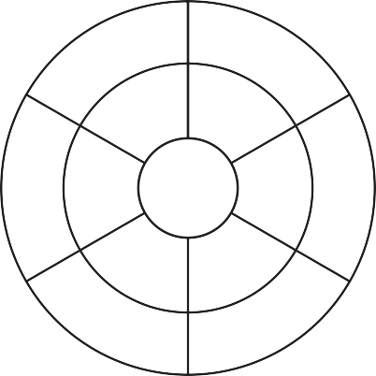

**6**

**5**

**8**

**1**

**7**

**1**

**4**

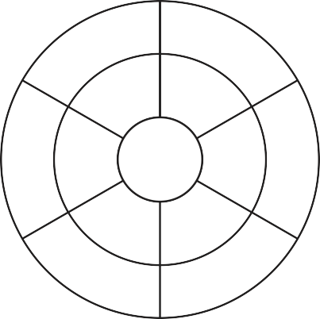

**4**

**1**

**5**

**1**

**2**

**7**

**3**

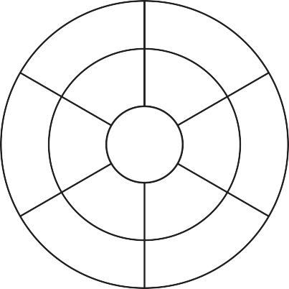

**1**

**2**

**3**

**1**

**7**

**8**

**9**

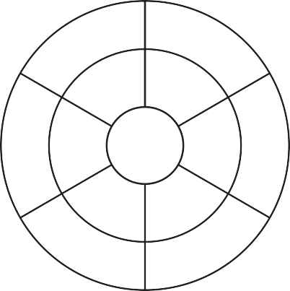

**8**

**7**

**6**

**1**

**4**

**2**

**3**

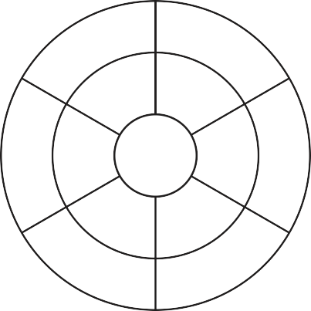

**4**

**9**

**7**

**1**

**2**

**1**

**6**

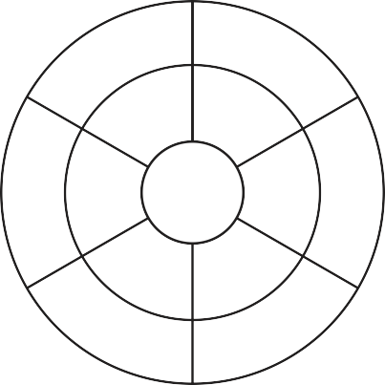

**6**

**5**

**4**

**1**

**2**

**3**

**1**

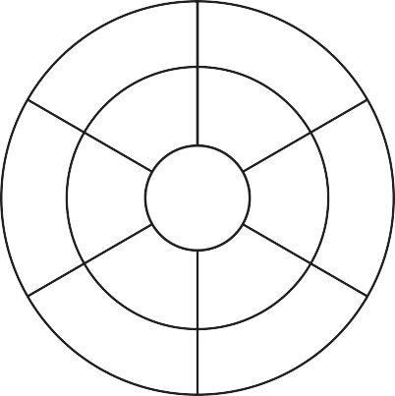

**4**

**6**

**7**

**1**

**2**

**1**

**8**

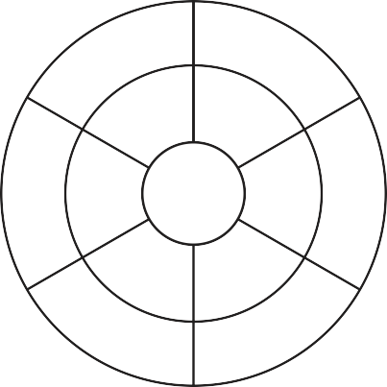

**9**

**8**

**2**

**1**

**6**

**3**

**5**

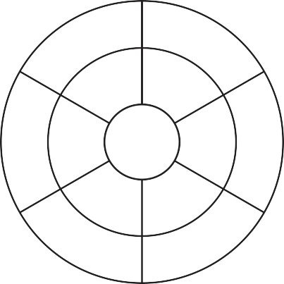

**6**

**9**

**2**

**1**

**8**

**5**

**7**

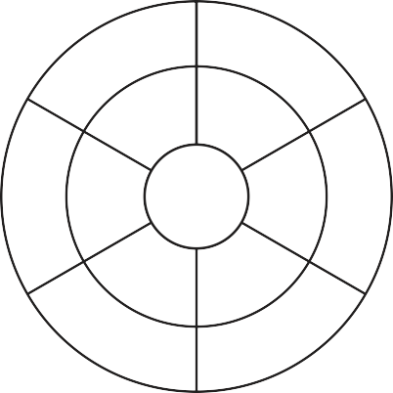

**12**

**3**

**10**

**2**

**18**

**1**

**4**

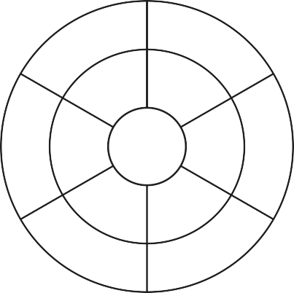

**6**

**7**

**9**

**2**

**2**

**2**

**16**

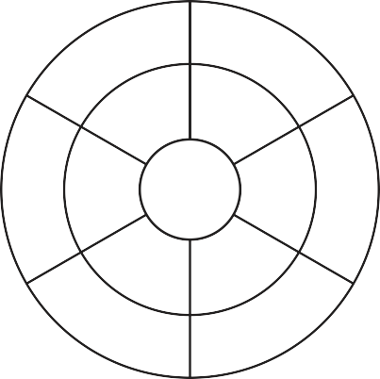

**2**

**5**

**16**

**2**

**8**

**6**

**3**

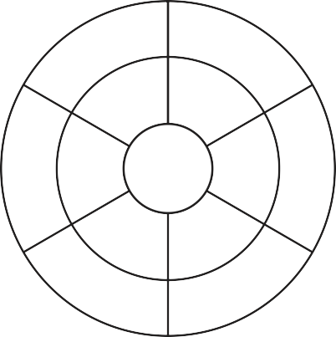

**12**

**4**

**2**

**2**

**5**

**2**

**14**

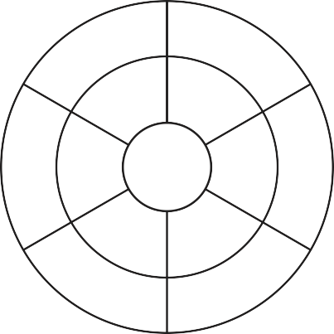

**14**

**8**

**9**

**2**

**10**

**4**

**12**

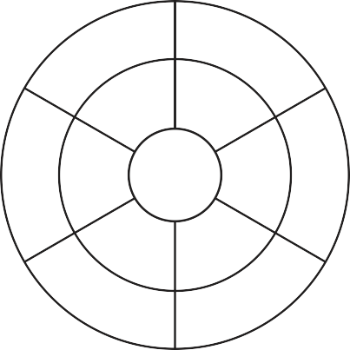

**7**

**3**

**10**

**2**

**2**

**8**

**6**

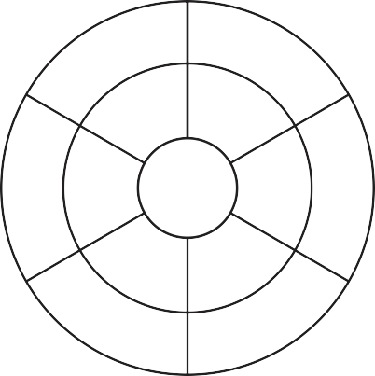

**12**

**4**

**8**

**2**

**9**

**10**

**14**



**10**

**8**

**12**

**2**

**4**

**3**

**8**

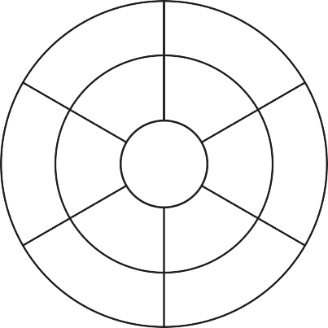

**18**

**3**

**6**

**2**

**4**

**4**

**16**

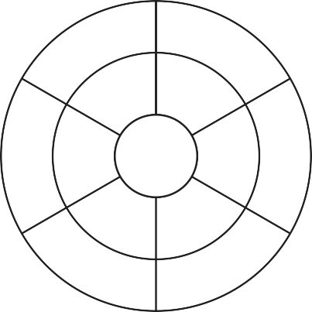

**4**

**9**

**5**

**3**

**2**

**7**

**18**

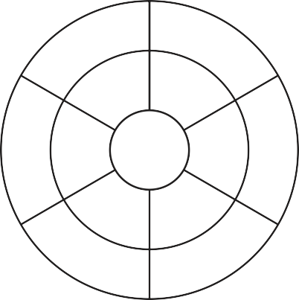

**24**

**27**

**5**

**3**

**18**

**7**

**1**

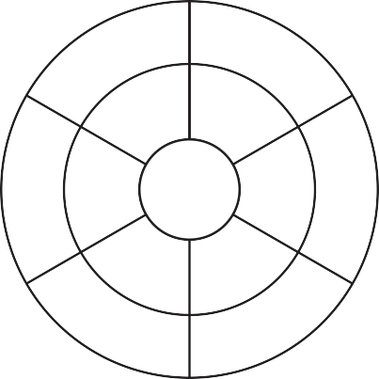

**9**

**2**

**3**

**3**

**4**

**9**

**6**

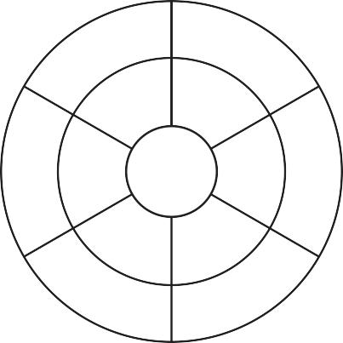

**6**

**3**

**15**

**3**

**9**

**4**

**24**

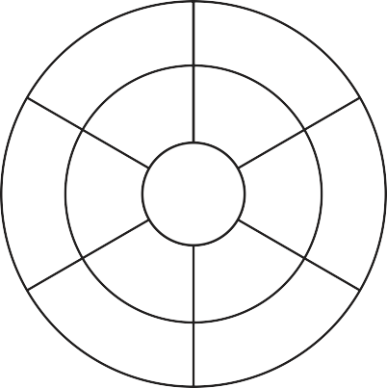

**15**

**7**

**6**

**3**

**1**

**27**

**9**

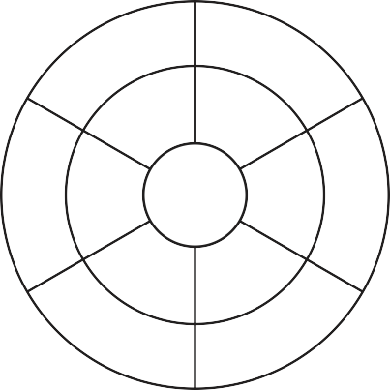

**4**

**3**

**6**

**3**

**24**

**27**

**3**

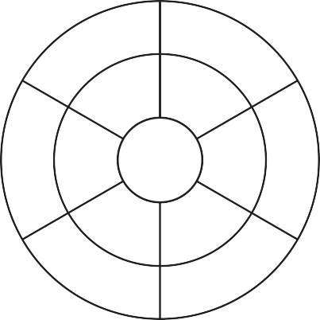

**21**

**12**

**1**

**3**

**18**

**2**

**15**

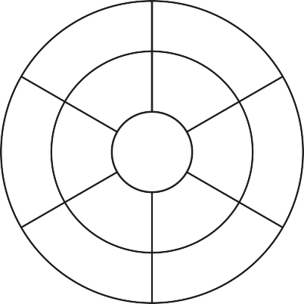

**24**

**7**

**6**

**3**

**3**

**15**

**18**

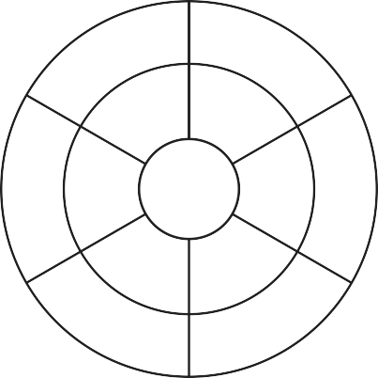

**3**

**7**

**6**

**3**

**8**

**4**

**27**

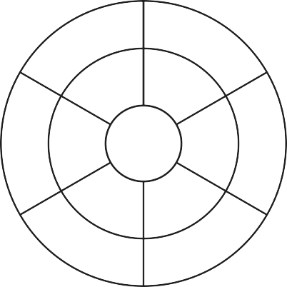

**24**

**28**

**8**

**4**

**9**

**5**

**12**

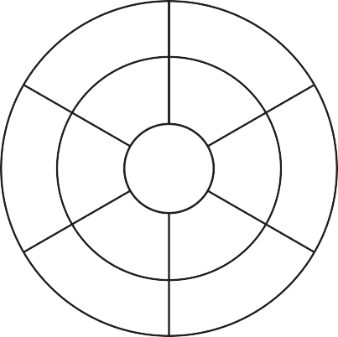

**7**

**8**

**3**

**4**

**24**

**2**

**20**

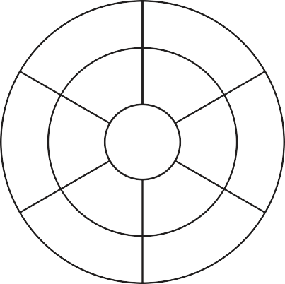

**24**

**7**

**32**

**4**

**4**

**2**

**5**

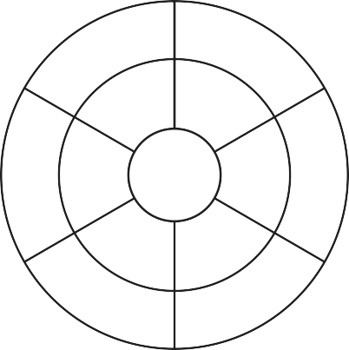

**4**

**7**

**12**

**4**

**5**

**24**

**36**

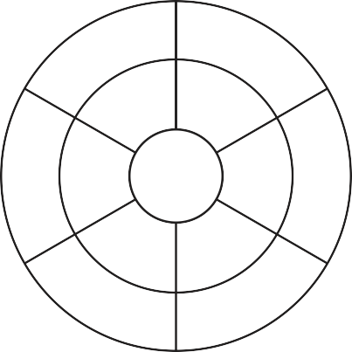

**16**

**9**

**20**

**4**

**3**

**7**

**8**

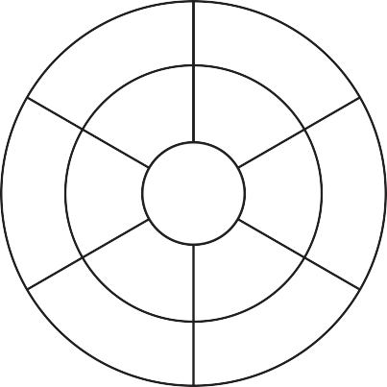

**4**

**6**

**8**

**4**

**36**

**3**

**5**

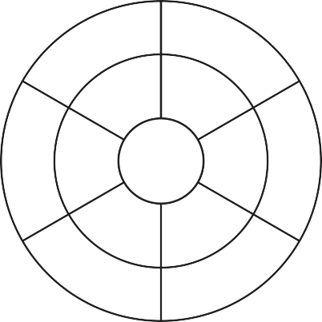

**8**

**8**

**16**

**4**

**5**

**7**

**6**

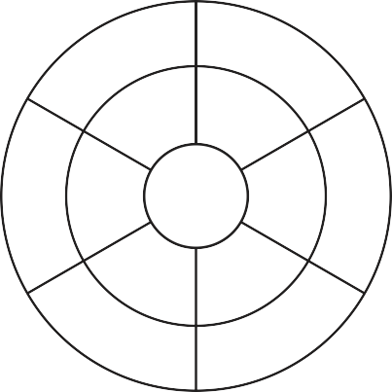

**32**

**1**

**5**

**4**

**24**

**9**

**28**

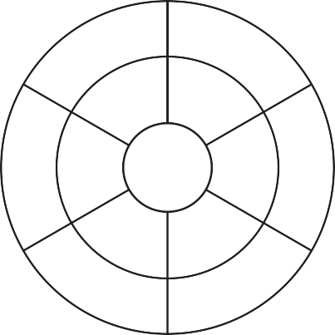

**28**

**1**

**16**

**4**

**8**

**2**

**5**

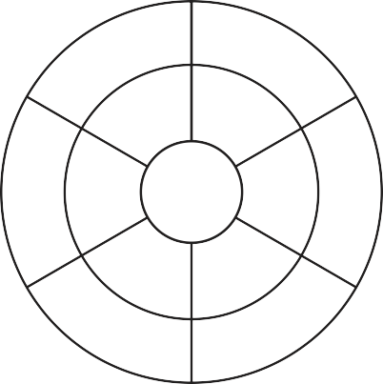

**3**

**6**

**25**

**5**

**35**

**8**

**9**

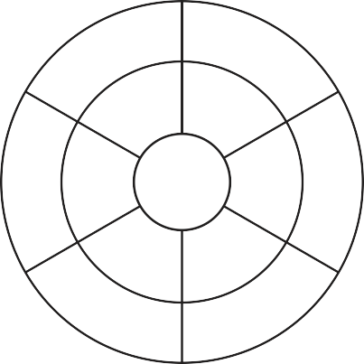

**4**

**8**

**9**

**5**

**15**

**6**

**25**

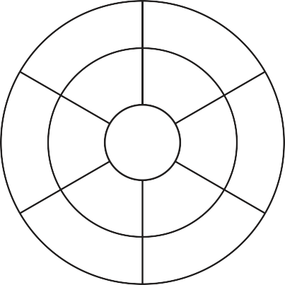

**1**

**6**

**4**

**5**

**35**

**25**

**45**

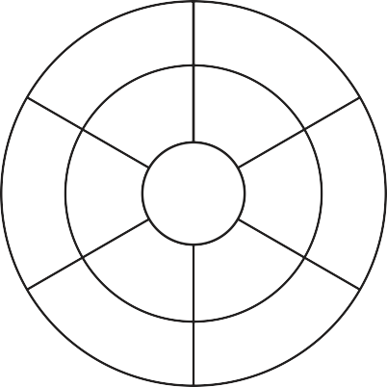

**6**

**9**

**5**

**5**

**3**

**7**

**2**

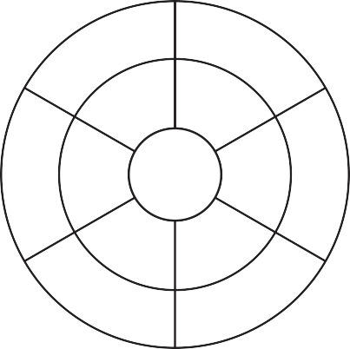

**15**

**1**

**7**

**5**

**6**

**10**

**20**

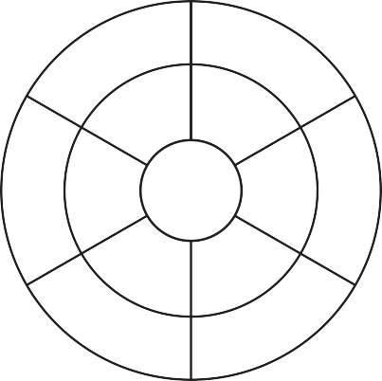

**20**

**8**

**6**

**5**

**3**

**2**

**25**

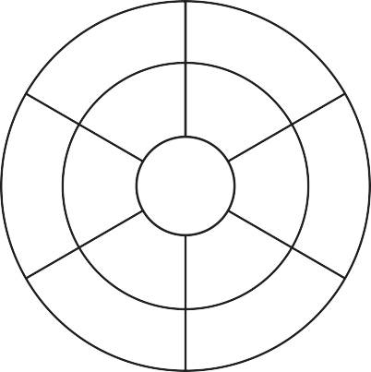

**35**

**6**

**1**

**5**

**8**

**45**

**20**

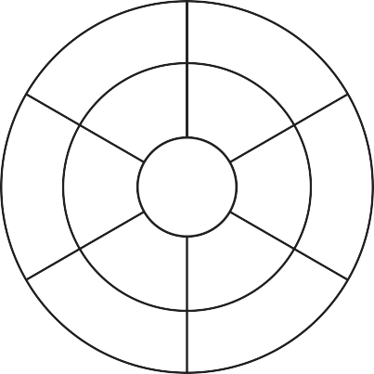

**30**

**5**

**15**

**5**

**5**

**8**

**4**

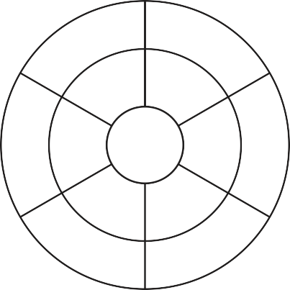

**35**

**6**

**5**

**5**

**2**

**3**

**9**

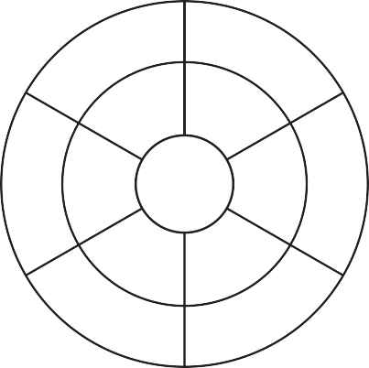

**4**

**2**

**5**

**6**

**48**

**7**

**18**

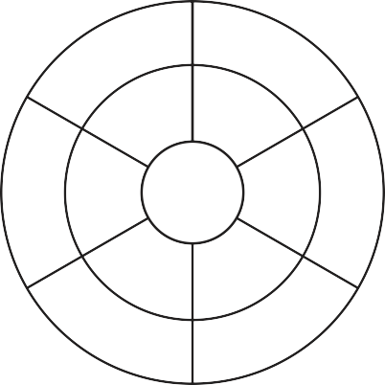

**54**

**4**

**36**

**6**

**1**

**48**

**30**

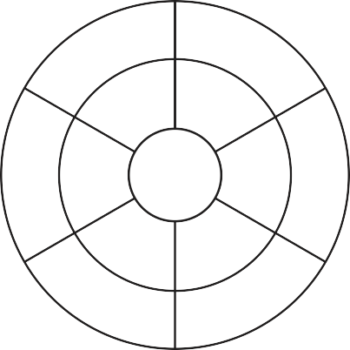

**2**

**6**

**3**

**6**

**6**

**7**

**48**

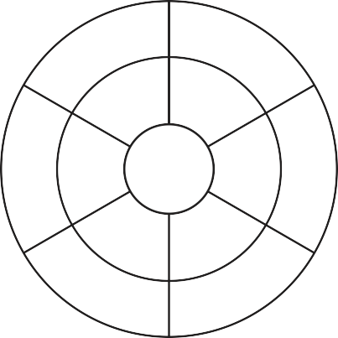

**5**

**8**

**7**

**6**

**36**

**9**

**6**

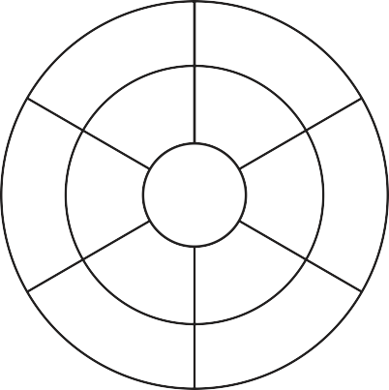

**7**

**4**

**6**

**6**

**30**

**3**

**54**

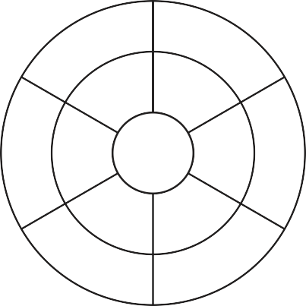

**12**

**1**

**9**

**6**

**42**

**8**

**36**

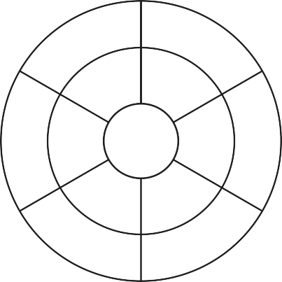

**36**

**5**

**7**

**6**

**9**

**1**

**18**

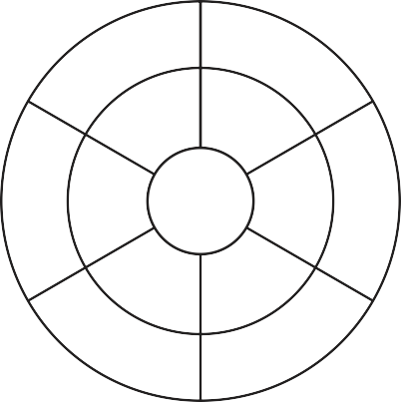

**5**

**7**

**48**

**6**

**3**

**6**

**6**

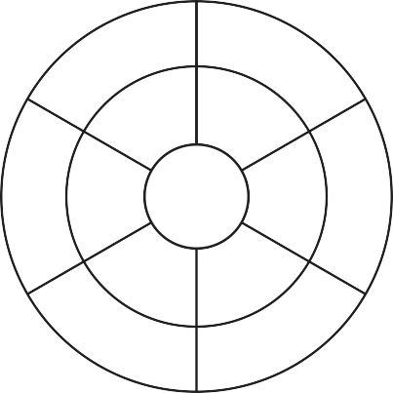

**54**

**3**

**2**

**6**

**42**

**5**

**36**

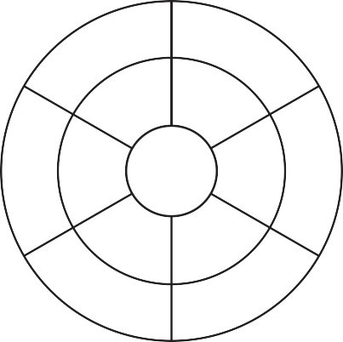

**14**

**63**

**4**

**7**

**21**

**1**

**56**

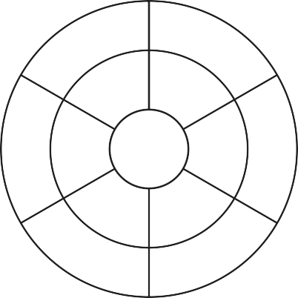

**63**

**1**

**28**

**7**

**5**

**8**

**7**

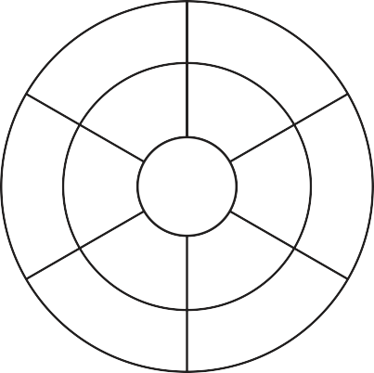

**35**

**1**

**14**

**7**

**4**

**7**

**56**

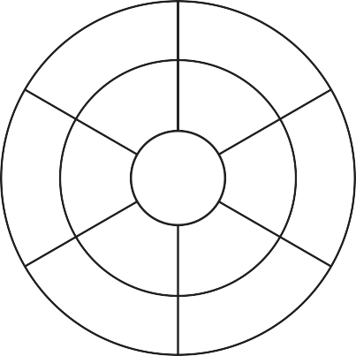

**63**

**7**

**1**

**7**

**5**

**4**

**3**

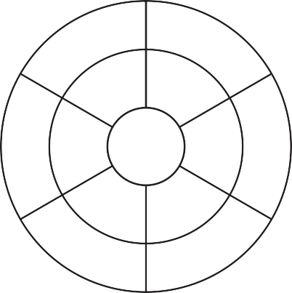

**4**

**2**

**1**

**7**

**35**

**9**

**56**

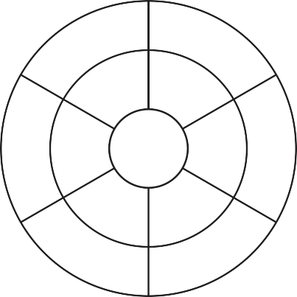

**8**

**6**

**9**

**7**

**28**

**5**

**49**

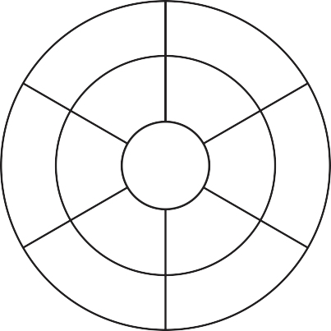

**42**

**4**

**9**

**7**

**1**

**14**

**49**

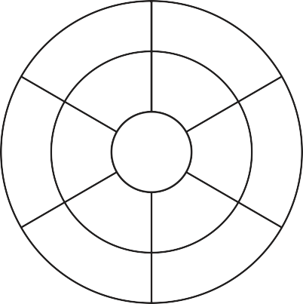

**14**

**28**

**5**

**7**

**7**

**8**

**7**

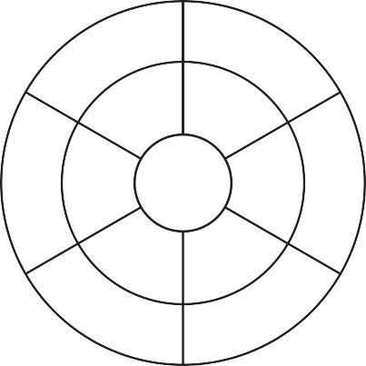

**2**

**6**

**5**

**7**

**49**

**8**

**9**

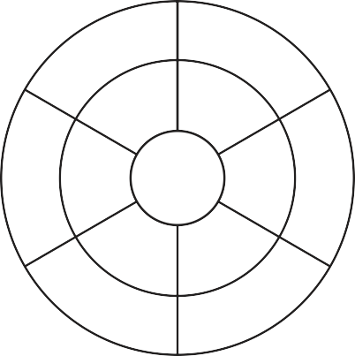

**48**

**64**

**5**

**8**

**2**

**1**

**56**

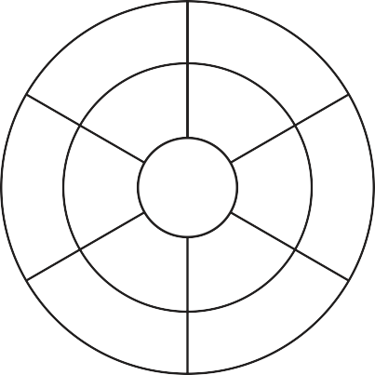

**32**

**5**

**1**

**8**

**6**

**9**

**64**

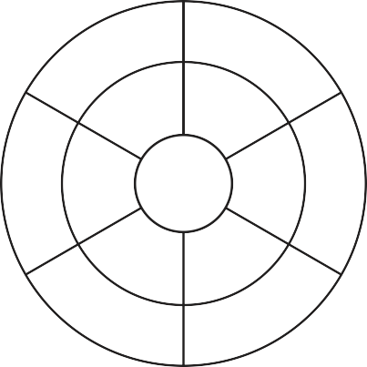

**16**

**3**

**5**

**8**

**48**

**8**

**32**

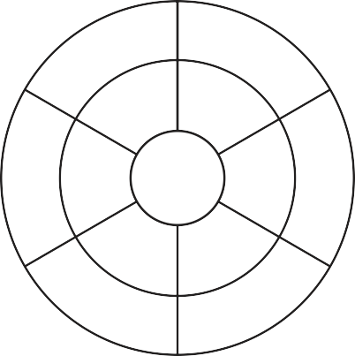

**8**

**9**

**24**

**8**

**16**

**5**

**7**

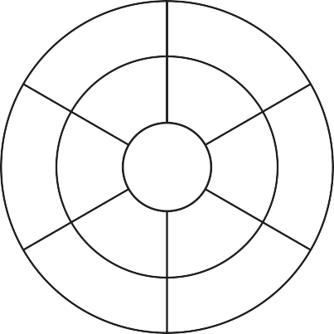

**3**

**2**

**32**

**8**

**9**

**1**

**8**

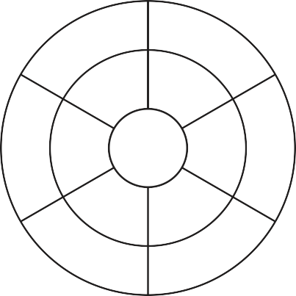

**56**

**9**

**48**

**8**

**8**

**1**

**2**

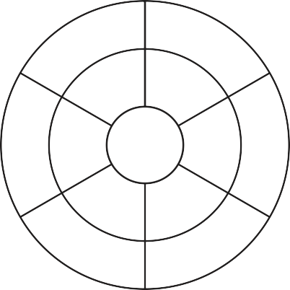

**16**

**3**

**48**

**8**

**64**

**5**

**4**

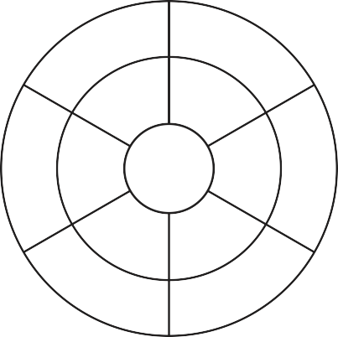

**6**

**4**

**16**

**8**

**56**

**5**

**64**

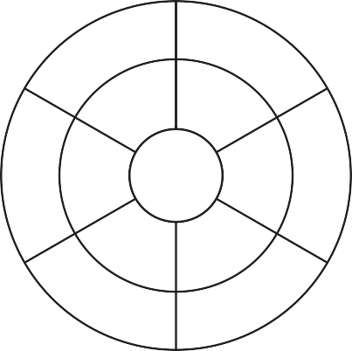

**72**

**1**

**4**

**8**

**6**

**40**

**64**

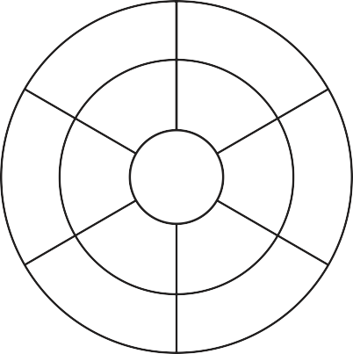

**27**

**4**

**6**

**9**

**63**

**5**

**72**

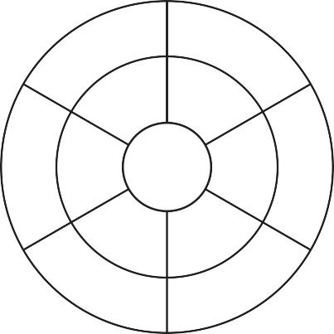

**6**

**3**

**8**

**9**

**45**

**9**

**63**

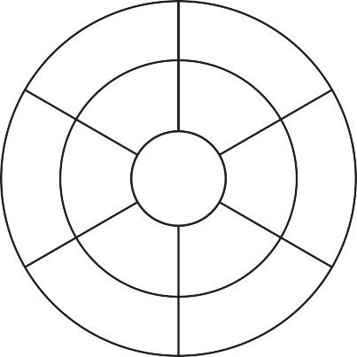

**63**

**6**

**4**

**9**

**81**

**2**

**5**

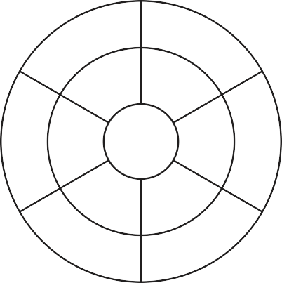

**3**

**7**

**9**

**9**

**2**

**4**

**9**

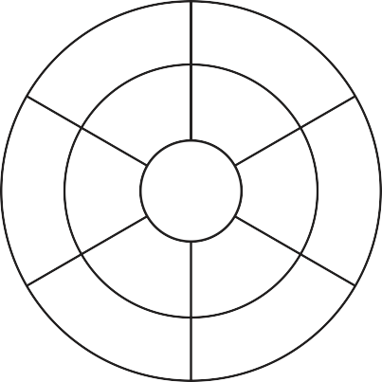

**81**

**7**

**18**

**9**

**5**

**4**

**8**

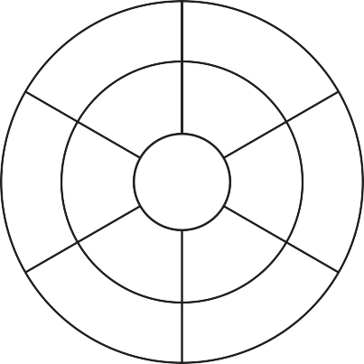

**72**

**9**

**36**

**9**

**18**

**5**

**7**

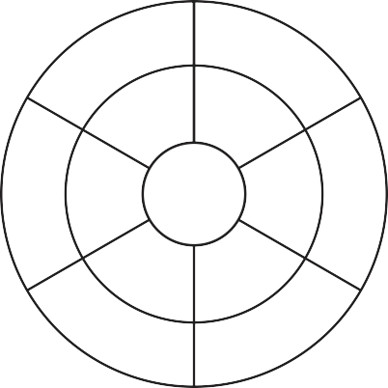

**2**

**6**

**5**

**9**

**9**

**4**

**63**

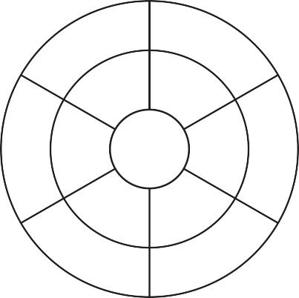

**81**

**4**

**7**

**9**

**8**

**5**

**9**

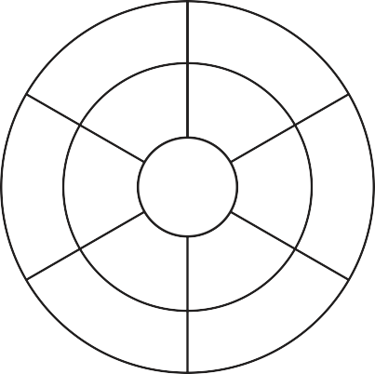

**72**

**2**

**63**

**9**

**45**

**4**

**6**



**70**

**1**

**20**

**10**

**9**

**40**

**80**



**20**

**7**

**60**

**10**

**4**

**3**

**10**



**60**

**1**

**2**

**10**

**3**

**40**

**90**

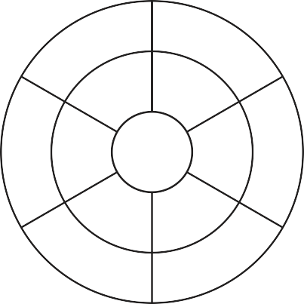

**70**

**4**

**1**

**10** **9**

**2**

**30**

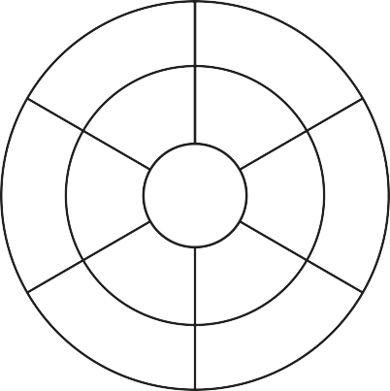

**20**

**9**

**30**

**10** **6**

**8**

**1**

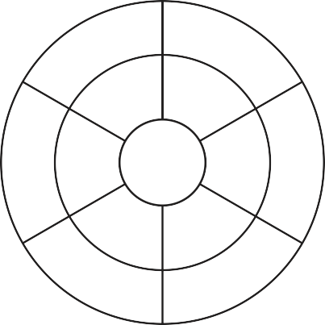

**90**

**3**

**6**

**10** **5**

**2**

**40**

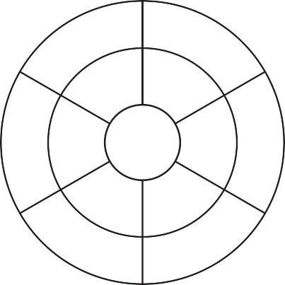

**7**

**1**

**60**

**10** **3**

**9**

**40**

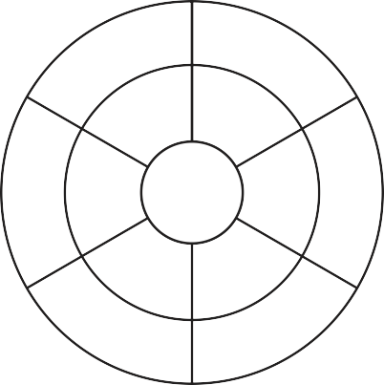

**40**

**8**

**7**

**10** **9**

**3**

**20**

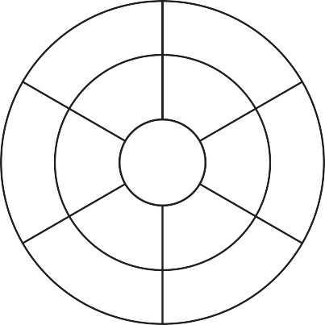

**40**

**3**

**6**

**10**

**8**

**9**

**70**

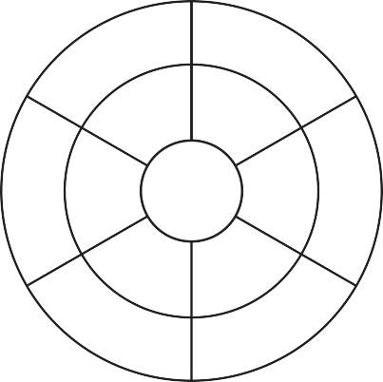

**88**

**5**

**11**

**11**

**3**

**6**

**22**

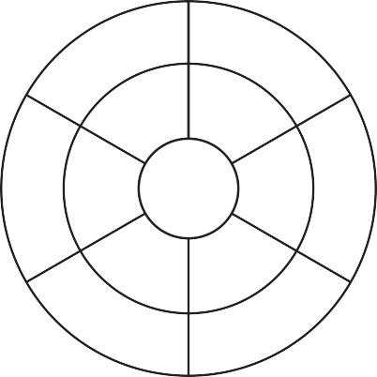

**22**

**4**

**8** **11**

**55**

**7**

**1**

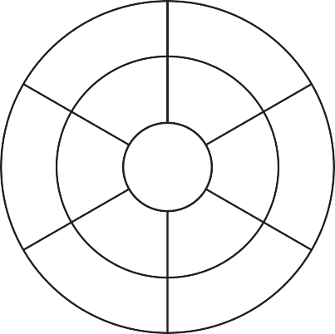

**11**

**3**

**2**

**11**

**77**

**5**

**44**

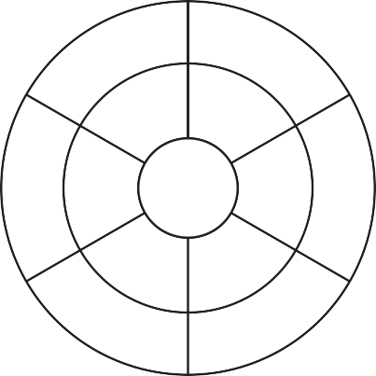

**1**

**8**

**6**

**11** **3**

**7**

**22**

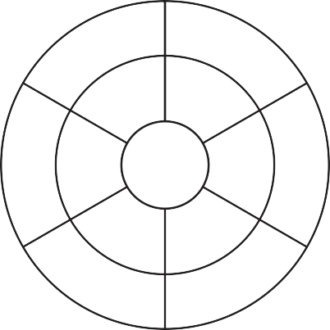

**11**

**7**

**4** **11**

**22**

**9**

**6**

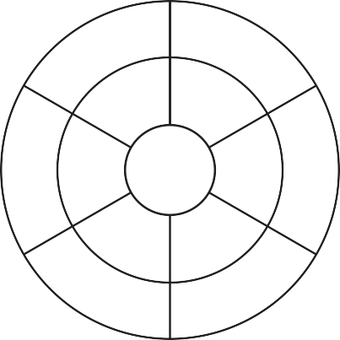

**77**

**6**

**33**

**11**

**55**

**2**

**1**

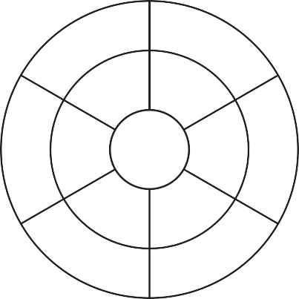

**11**

**3**

**55**

**11**

**77**

**6**

**2**

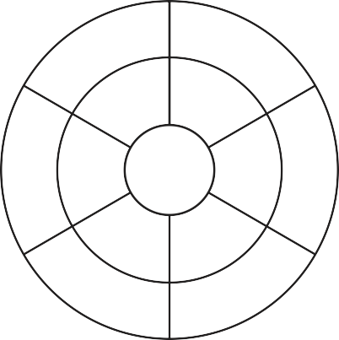

**6**

**2**

**44**

**11**

**33**

**9**

**11**

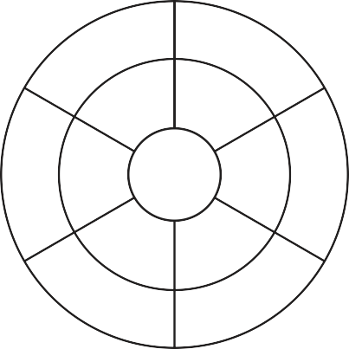

**44**

**33**

**22**

**11** **5**

**8**

**99**



**12**

**6**

**60**

**12** **8**

**7**

**24**



**9**

**1**

**36**

**12**

**84**

**8**

**72**



**96**

**60**

**24**

**12** **4**

**6**

**1**

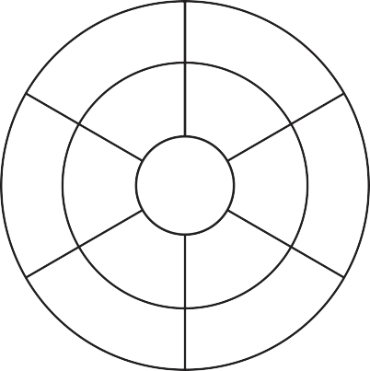

**24**

**48**

**6**

**12**

**84**

**5**

**108**

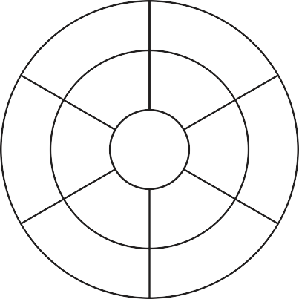

**12**

**6**

**108**

**12**

**96**

**2**

**5**

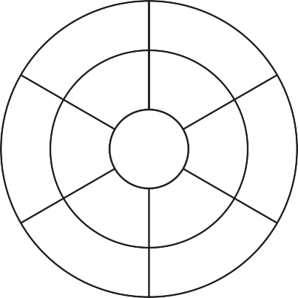

**7**

**8**

**60**

**12**

**36**

**9**

**12**

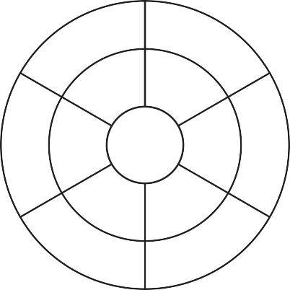

**12**

**84**

**9**

**12**

**24**

**6**

**5**

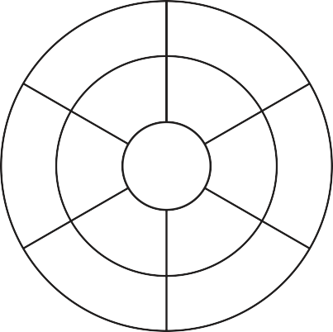

**84**

**5**

**12**

**12**

**3**

**9**

**72**

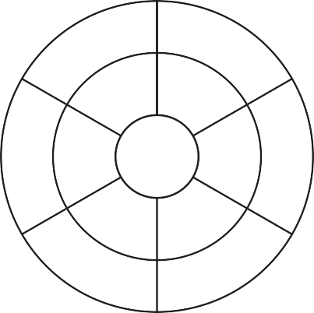

**36**

**108**

**5**

**12** **6**

**4**

**12**

προπαίδεια

**προπαίδεια του 1**

**προπαίδεια του 2**

**προπαίδεια του 3**

**προπαίδεια του 4**

|  |  |  |  |  |  |  |  |  |  |  |  |  |  |  |  |  |  |  |  |
| --- | --- | --- | --- | --- | --- | --- | --- | --- | --- | --- | --- | --- | --- | --- | --- | --- | --- | --- | --- |
| **1** | **X** | **1** | **=** | **1** | **2** | **X** | **1** | **=** | **2** | **3** | **X** | **1** | **=** | **3** | **4** | **X** | **1** | **=** | **4** |
| **1** | **X** | **2** | **=** | **2** | **2** | **X** | **2** | **=** | **4** | **3** | **X** | **2** | **=** | **6** | **4** | **X** | **2** | **=** | **8** |
| **1** | **X** | **3** | **=** | **3** | **2** | **X** | **3** | **=** | **6** | **3** | **X** | **3** | **=** | **9** | **4** | **X** | **3** | **=** | **12** |
| **1** | **X** | **4** | **=** | **4** | **2** | **X** | **4** | **=** | **8** | **3** | **X** | **4** | **=** | **12** | **4** | **X** | **4** | **=** | **16** |
| **1** | **X** | **5** | **=** | **5** | **2** | **X** | **5** | **=** | **10** | **3** | **X** | **5** | **=** | **15** | **4** | **X** | **5** | **=** | **20** |
| **1** | **X** | **6** | **=** | **6** | **2** | **X** | **6** | **=** | **12** | **3** | **X** | **6** | **=** | **18** | **4** | **X** | **6** | **=** | **24** |
| **1** | **X** | **7** | **=** | **7** | **2** | **X** | **7** | **=** | **14** | **3** | **X** | **7** | **=** | **21** | **4** | **X** | **7** | **=** | **28** |
| **1** | **X** | **8** | **=** | **8** | **2** | **X** | **8** | **=** | **16** | **3** | **X** | **8** | **=** | **24** | **4** | **X** | **8** | **=** | **32** |
| **1** | **X** | **9** | **=** | **9** | **2** | **X** | **9** | **=** | **18** | **3** | **X** | **9** | **=** | **27** | **4** | **X** | **9** | **=** | **36** |
| **1** | **X** | **10** | **=** | **10** | **2** | **X** | **10** | **=** | **20** | **3** | **X** | **10** | **=** | **30** | **4** | **X** | **10** | **=** | **40** |
| **1** | **X** | **11** | **=** | **11** | **2** | **X** | **11** | **=** | **22** | **3** | **X** | **11** | **=** | **33** | **4** | **X** | **11** | **=** | **44** |
| **1** | **X** | **12** | **=** | **12** | **2** | **X** | **12** | **=** | **24** | **3** | **X** | **12** | **=** | **36** | **4** | **X** | **12** | **=** | **48** |

**προπαίδεια του 5**

**προπαίδεια του 6**

**προπαίδεια του 7**

**προπαίδεια του 8**

|  |  |  |  |  |  |  |  |  |  |  |  |  |  |  |  |  |  |  |  |
| --- | --- | --- | --- | --- | --- | --- | --- | --- | --- | --- | --- | --- | --- | --- | --- | --- | --- | --- | --- |
| **5** | **X** | **1** | **=** | **5** | **6** | **X** | **1** | **=** | **6** | **7** | **X** | **1** | **=** | **7** | **8** | **X** | **1** | **=** | **8** |
| **5** | **X** | **2** | **=** | **10** | **6** | **X** | **2** | **=** | **12** | **7** | **X** | **2** | **=** | **14** | **8** | **X** | **2** | **=** | **16** |
| **5** | **X** | **3** | **=** | **15** | **6** | **X** | **3** | **=** | **18** | **7** | **X** | **3** | **=** | **21** | **8** | **X** | **3** | **=** | **24** |
| **5** | **X** | **4** | **=** | **20** | **6** | **X** | **4** | **=** | **24** | **7** | **X** | **4** | **=** | **28** | **8** | **X** | **4** | **=** | **32** |
| **5** | **X** | **5** | **=** | **25** | **6** | **X** | **5** | **=** | **30** | **7** | **X** | **5** | **=** | **35** | **8** | **X** | **5** | **=** | **40** |
| **5** | **X** | **6** | **=** | **30** | **6** | **X** | **6** | **=** | **36** | **7** | **X** | **6** | **=** | **42** | **8** | **X** | **6** | **=** | **48** |
| **5** | **X** | **7** | **=** | **35** | **6** | **X** | **7** | **=** | **42** | **7** | **X** | **7** | **=** | **49** | **8** | **X** | **7** | **=** | **56** |
| **5** | **X** | **8** | **=** | **40** | **6** | **X** | **8** | **=** | **48** | **7** | **X** | **8** | **=** | **56** | **8** | **X** | **8** | **=** | **64** |
| **5** | **X** | **9** | **=** | **45** | **6** | **X** | **9** | **=** | **54** | **7** | **X** | **9** | **=** | **63** | **8** | **X** | **9** | **=** | **72** |
| **5** | **X** | **10** | **=** | **50** | **6** | **X** | **10** | **=** | **60** | **7** | **X** | **10** | **=** | **70** | **8** | **X** | **10** | **=** | **80** |
| **5** | **X** | **11** | **=** | **55** | **6** | **X** | **11** | **=** | **66** | **7** | **X** | **11** | **=** | **77** | **8** | **X** | **11** | **=** | **88** |
| **5** | **X** | **12** | **=** | **60** | **6** | **X** | **12** | **=** | **72** | **7** | **X** | **12** | **=** | **84** | **8** | **X** | **12** | **=** | **96** |

**προπαίδεια του 9**

**προπαίδεια του 10**

**προπαίδεια του 11**

**προπαίδεια του 12**

|  |  |  |  |  |  |  |  |  |  |  |  |  |  |  |  |  |  |  |  |
| --- | --- | --- | --- | --- | --- | --- | --- | --- | --- | --- | --- | --- | --- | --- | --- | --- | --- | --- | --- |
| **9** | **X** | **1** | **=** | **9** | **10** | **X** | **1** | **=** | **10** | **11** | **X** | **1** | **=** | **11** | **12** | **X** | **1** | **=** | **12** |
| **9** | **X** | **2** | **=** | **18** | **10** | **X** | **2** | **=** | **20** | **11** | **X** | **2** | **=** | **22** | **12** | **X** | **2** | **=** | **24** |
| **9** | **X** | **3** | **=** | **27** | **10** | **X** | **3** | **=** | **30** | **11** | **X** | **3** | **=** | **33** | **12** | **X** | **3** | **=** | **36** |
| **9** | **X** | **4** | **=** | **36** | **10** | **X** | **4** | **=** | **40** | **11** | **X** | **4** | **=** | **44** | **12** | **X** | **4** | **=** | **48** |
| **9** | **X** | **5** | **=** | **45** | **10** | **X** | **5** | **=** | **50** | **11** | **X** | **5** | **=** | **55** | **12** | **X** | **5** | **=** | **60** |
| **9** | **X** | **6** | **=** | **54** | **10** | **X** | **6** | **=** | **60** | **11** | **X** | **6** | **=** | **66** | **12** | **X** | **6** | **=** | **72** |
| **9** | **X** | **7** | **=** | **63** | **10** | **X** | **7** | **=** | **70** | **11** | **X** | **7** | **=** | **77** | **12** | **X** | **7** | **=** | **84** |
| **9** | **X** | **8** | **=** | **72** | **10** | **X** | **8** | **=** | **80** | **11** | **X** | **8** | **=** | **88** | **12** | **X** | **8** | **=** | **96** |
| **9** | **X** | **9** | **=** | **81** | **10** | **X** | **9** | **=** | **90** | **11** | **X** | **9** | **=** | **99** | **12** | **X** | **9** | **=** | **108** |
| **9** | **X** | **10** | **=** | **90** | **10** | **X** | **10** | **=** | **100** | **11** | **X** | **10** | **=** | **110** | **12** | **X** | **10** | **=** | **120** |
| **9** | **X** | **11** | **=** | **99** | **10** | **X** | **11** | **=** | **110** | **11** | **X** | **11** | **=** | **121** | **12** | **X** | **11** | **=** | **132** |
| **9** | **X** | **12** | **=** | **108** | **10** | **X** | **12** | **=** | **120** | **11** | **X** | **12** | **=** | **132** | **12** | **X** | **12** | **=** | **144** |





livebooks.gr

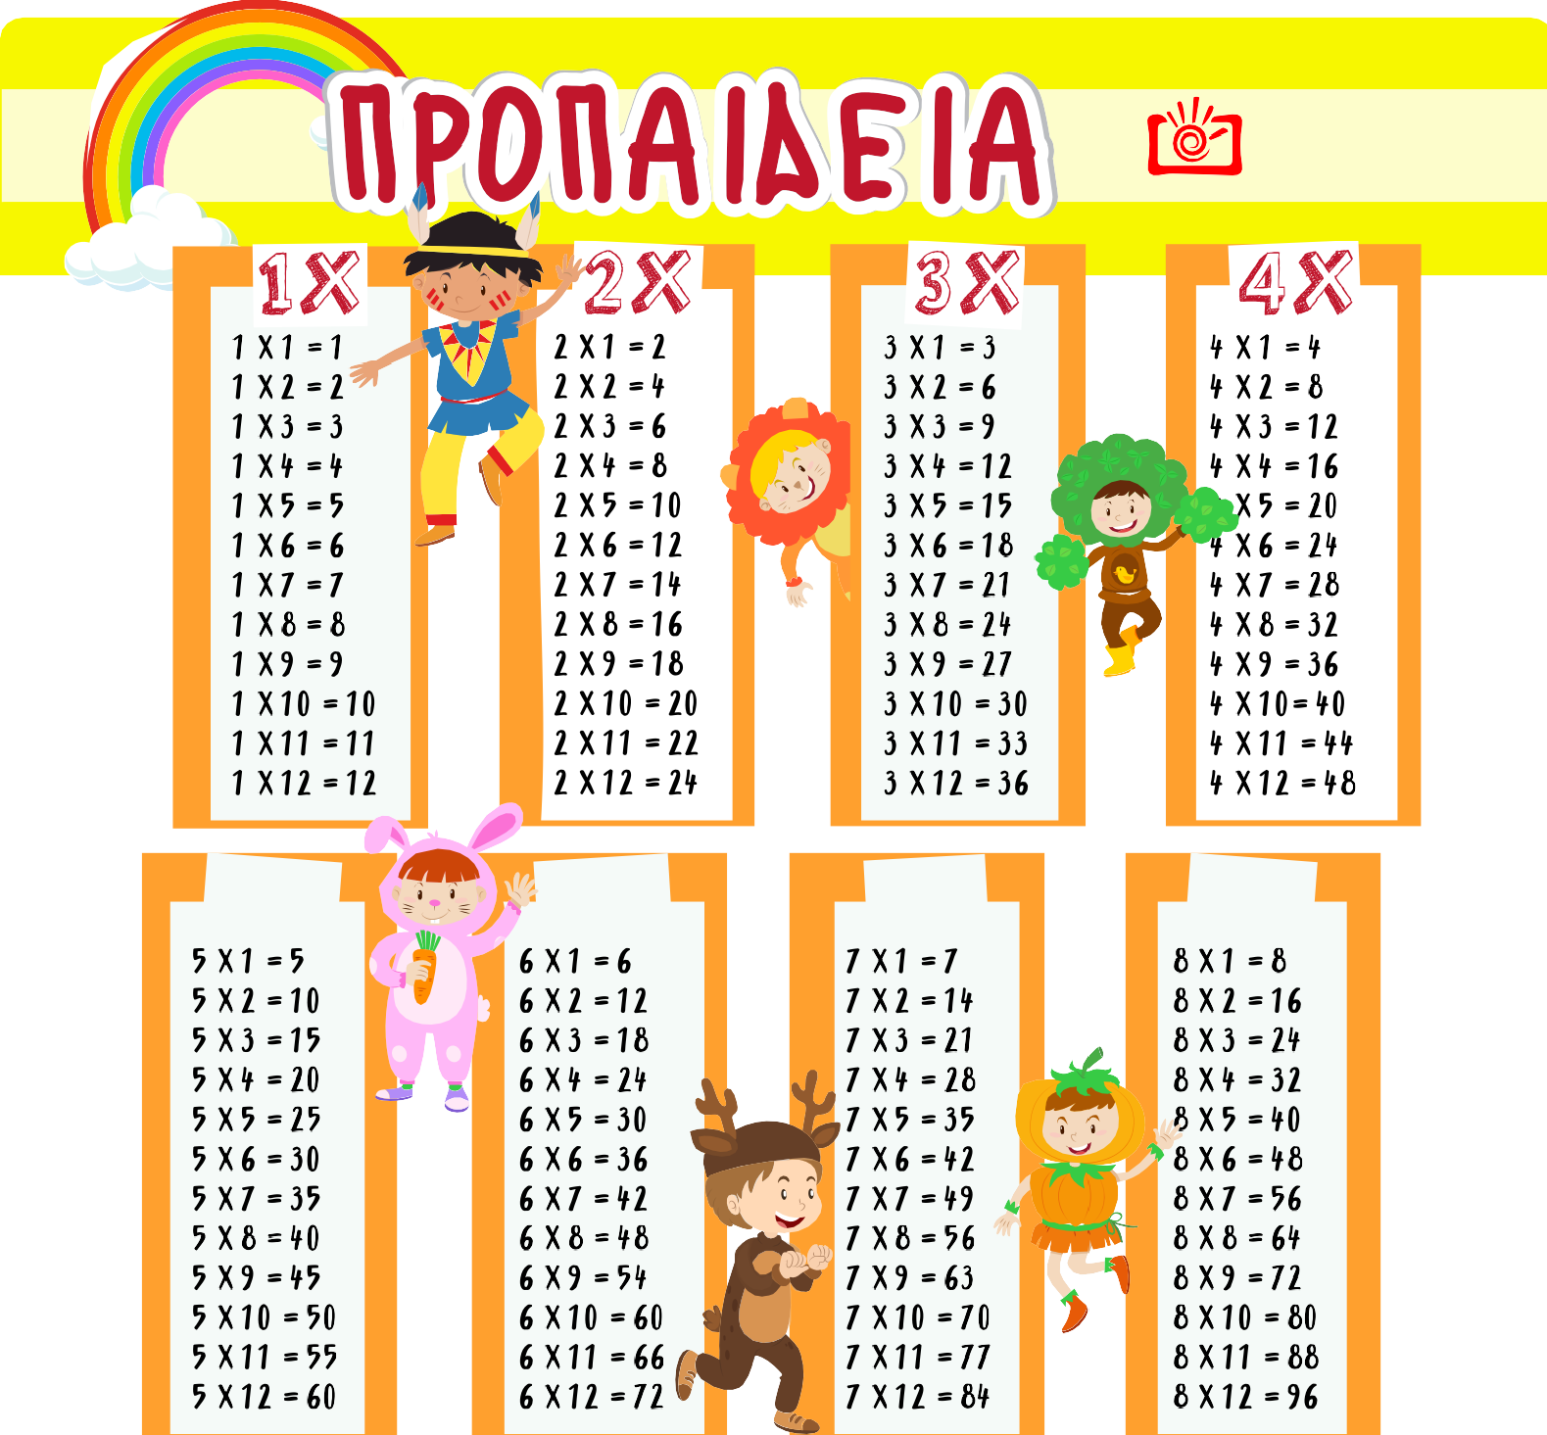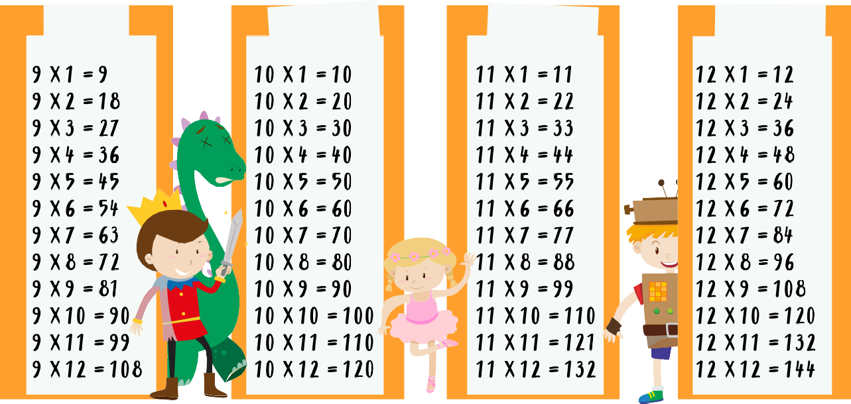

LiveBooks

**DIDΛIΛ N0Y ZfiNTΛNEY0YN**

# 6 X

8X

7X

5X

9X 10X 11X

12 X

## πίνακας προπαίδειας με μεγέθη



1 2 3 4 5 6 7 8 9 10

2 4 6 8 10 12 14 16 18 20

3 6 9 12 15 18 21 24 27 30

4 8 12 16 20 24 28 32 36 40

5 10 15 20 25 30 35 40 45 50

6 12 18 24 30 36 42 48 54 60

7 14 21 28 35 42 49 56 63 70

8 16 24 32 40 48 56 64 72 80

9 18 27 36 45 54 63 72 81 90

10 20 30 40 50 60 70 80 90 100





|  |  |  |  |  |  |  |  |  |  |  |
| --- | --- | --- | --- | --- | --- | --- | --- | --- | --- | --- |
|  |  |  |  |  |  |  |  |  |  |  |
|  |  |  |  |  |  |  |  |  |  |  |
|  |  |  |  |  |  |  |  |  |  |  |
|  |  |  |  |  |  |  |  |  |  |  |
|  |  |  |  |  |  |  |  |  |  |  |
|  |  |  |  |  |  |  |  |  |  |  |
|  |  |  |  |  |  |  |  |  |  |  |
|  |  |  |  |  |  |  |  |  |  |  |
|  |  |  |  |  |  |  |  |  |  |  |
|  |  |  |  |  |  |  |  |  |  |  |
|  |  |  |  |  |  |  |  |  |  |  |

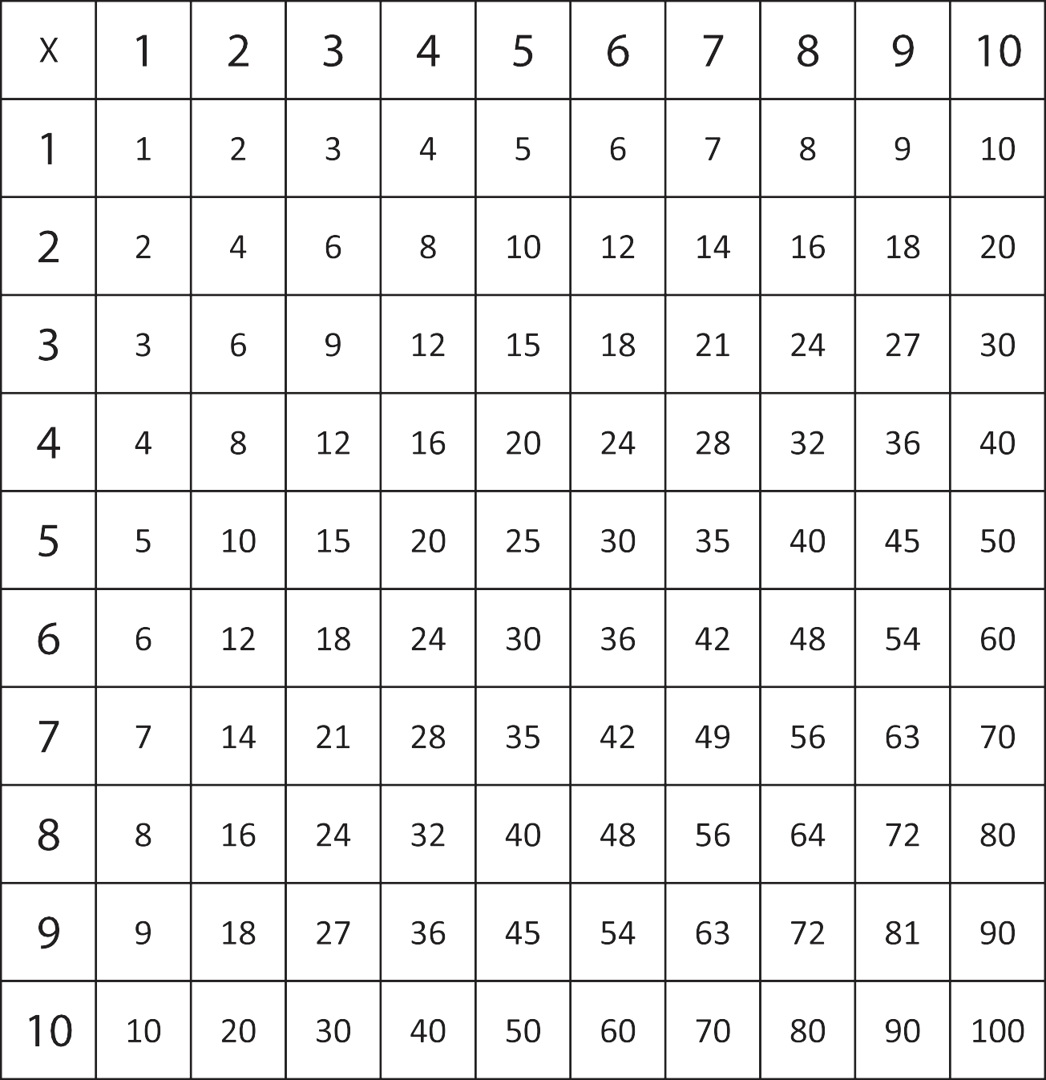



|  |  |  |  |  |  |  |  |  |  |  |
| --- | --- | --- | --- | --- | --- | --- | --- | --- | --- | --- |
|  |  |  |  |  |  |  |  |  |  |  |
|  |  |  |  |  |  |  |  |  |  |  |
|  |  |  |  |  |  |  |  |  |  |  |
|  |  |  |  |  |  |  |  |  |  |  |
|  |  |  |  |  |  |  |  |  |  |  |
|  |  |  |  |  |  |  |  |  |  |  |
|  |  |  |  |  |  |  |  |  |  |  |
|  |  |  |  |  |  |  |  |  |  |  |
|  |  |  |  |  |  |  |  |  |  |  |
|  |  |  |  |  |  |  |  |  |  |  |
|  |  |  |  |  |  |  |  |  |  |  |

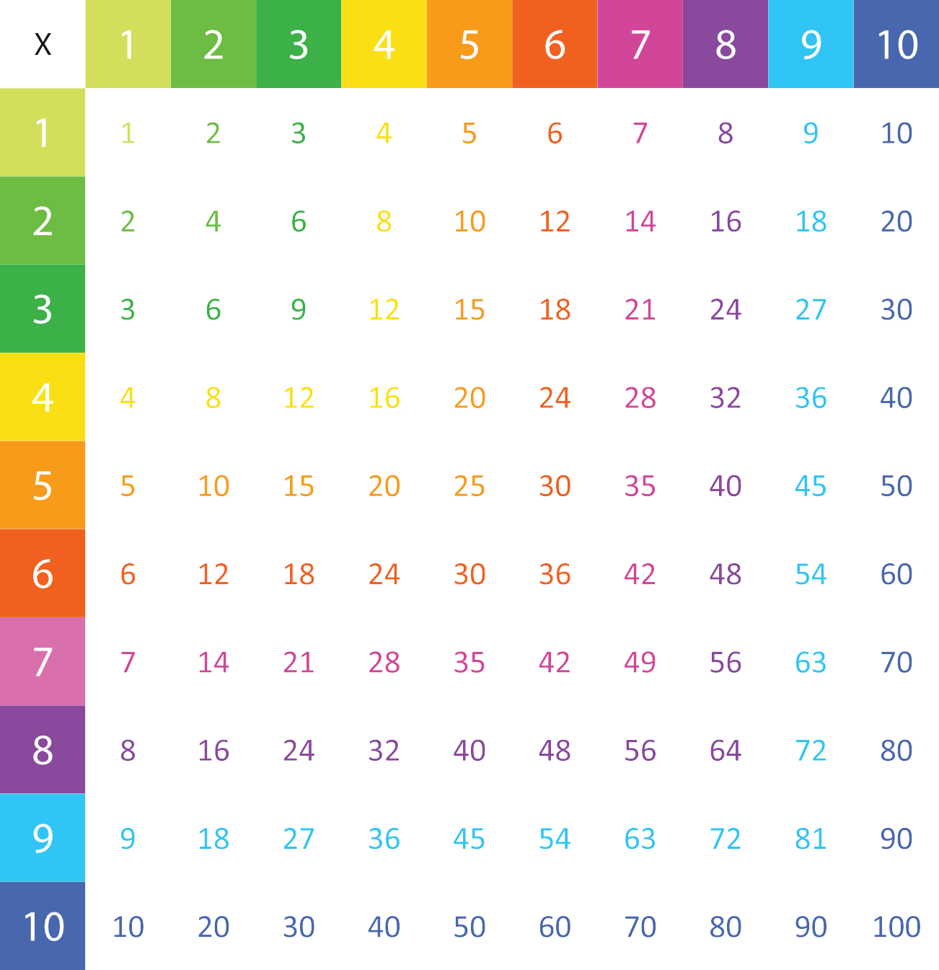



ΔΕΥΤΕΡΑ ΤΡΙΤΗ ΤΕΤΑΡΤΗ ΠΕΜΠΤΗ ΠΑΡΑΣΚΕΥΗ

|  |  |  |  |  |  |  |  |  |  |  |  |  |  |  |  |  |  |  |  |  |  |  |  |  |
| --- | --- | --- | --- | --- | --- | --- | --- | --- | --- | --- | --- | --- | --- | --- | --- | --- | --- | --- | --- | --- | --- | --- | --- | --- |
| **1** | **X** | **1** | **=** | **1** | **2** | **X** | **1** | **=** | **2** | **3** | **X** | **1** | **=** | **3** | **4** | **X** | **1** | **=** | **4** | **5** | **X** | **1** | **=** | **5** |
| **1** | **X** | **2** | **=** | **2** | **2** | **X** | **2** | **=** | **4** | **3** | **X** | **2** | **=** | **6** | **4** | **X** | **2** | **=** | **8** | **5** | **X** | **2** | **=** | **10** |
| **1** | **X** | **3** | **=** | **3** | **2** | **X** | **3** | **=** | **6** | **3** | **X** | **3** | **=** | **9** | **4** | **X** | **3** | **=** | **12** | **5** | **X** | **3** | **=** | **15** |
| **1** | **X** | **4** | **=** | **4** | **2** | **X** | **4** | **=** | **8** | **3** | **X** | **4** | **=** | **12** | **4** | **X** | **4** | **=** | **16** | **5** | **X** | **4** | **=** | **20** |
| **1** | **X** | **5** | **=** | **5** | **2** | **X** | **5** | **=** | **10** | **3** | **X** | **5** | **=** | **15** | **4** | **X** | **5** | **=** | **20** | **5** | **X** | **5** | **=** | **25** |
| **1** | **X** | **6** | **=** | **6** | **2** | **X** | **6** | **=** | **12** | **3** | **X** | **6** | **=** | **18** | **4** | **X** | **6** | **=** | **24** | **5** | **X** | **6** | **=** | **30** |
| **1** | **X** | **7** | **=** | **7** | **2** | **X** | **7** | **=** | **14** | **3** | **X** | **7** | **=** | **21** | **4** | **X** | **7** | **=** | **28** | **5** | **X** | **7** | **=** | **35** |
| **1** | **X** | **8** | **=** | **8** | **2** | **X** | **8** | **=** | **16** | **3** | **X** | **8** | **=** | **24** | **4** | **X** | **8** | **=** | **32** | **5** | **X** | **8** | **=** | **40** |
| **1** | **X** | **9** | **=** | **9** | **2** | **X** | **9** | **=** | **18** | **3** | **X** | **9** | **=** | **27** | **4** | **X** | **9** | **=** | **36** | **5** | **X** | **9** | **=** | **45** |
| **1** | **X** | **10** | **=** | **10** | **2** | **X** | **10** | **=** | **20** | **3** | **X** | **10** | **=** | **30** | **4** | **X** | **10** | **=** | **40** | **5** | **X** | **10** | **=** | **50** |
| **6** | **X** | **1** | **=** | **6** | **7** | **X** | **1** | **=** | **7** | **8** | **X** | **1** | **=** | **8** | **9** | **X** | **1** | **=** | **9** | **10** | **X** | **1** | **=** | **10** |
| **6** | **X** | **2** | **=** | **12** | **7** | **X** | **2** | **=** | **14** | **8** | **X** | **2** | **=** | **16** | **9** | **X** | **2** | **=** | **18** | **10** | **X** | **2** | **=** | **20** |
| **6** | **X** | **3** | **=** | **18** | **7** | **X** | **3** | **=** | **21** | **8** | **X** | **3** | **=** | **24** | **9** | **X** | **3** | **=** | **27** | **10** | **X** | **3** | **=** | **30** |
| **6** | **X** | **4** | **=** | **24** | **7** | **X** | **4** | **=** | **28** | **8** | **X** | **4** | **=** | **32** | **9** | **X** | **4** | **=** | **36** | **10** | **X** | **4** | **=** | **40** |
| **6** | **X** | **5** | **=** | **30** | **7** | **X** | **5** | **=** | **35** | **8** | **X** | **5** | **=** | **40** | **9** | **X** | **5** | **=** | **45** | **10** | **X** | **5** | **=** | **50** |
| **6** | **X** | **6** | **=** | **36** | **7** | **X** | **6** | **=** | **42** | **8** | **X** | **6** | **=** | **48** | **9** | **X** | **6** | **=** | **54** | **10** | **X** | **6** | **=** | **60** |
| **6** | **X** | **7** | **=** | **42** | **7** | **X** | **7** | **=** | **49** | **8** | **X** | **7** | **=** | **56** | **9** | **X** | **7** | **=** | **63** | **10** | **X** | **7** | **=** | **70** |
| **6** | **X** | **8** | **=** | **48** | **7** | **X** | **8** | **=** | **56** | **8** | **X** | **8** | **=** | **64** | **9** | **X** | **8** | **=** | **72** | **10** | **X** | **8** | **=** | **80** |
| **6** | **X** | **9** | **=** | **54** | **7** | **X** | **9** | **=** | **63** | **8** | **X** | **9** | **=** | **72** | **9** | **X** | **9** | **=** | **81** | **10** | **X** | **9** | **=** | **90** |
| **6** | **X** | **10** | **=** | **60** | **7** | **X** | **10** | **=** | **70** | **8** | **X** | **10** | **=** | **80** | **9** | **X** | **10** | **=** | **90** | **10** | **X** | **10** | **=** | **100** |



