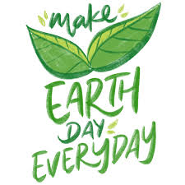

Don’t leave the water running when you are brushing your teeth.
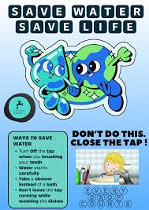

Take a shower instead of a bath.

Don’t waste paper. You can write on both sides of it.
Planting just one tree can save the sky from smoke and factories.
Turn off the lights and the TV when you are not in the room. 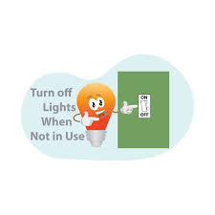
Keep the sea clean so the fish will stay healthy and safe.

Make a bird feeder. The birds in the city have a hard time finding enough food to eat.
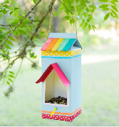
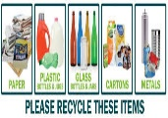
Recycle glass, paper, aluminium and steel.

If you litter, animals will eat the garbage and get sick.
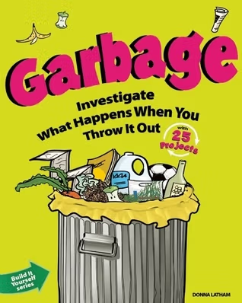

Use a paper bag instead of a plastic one. 