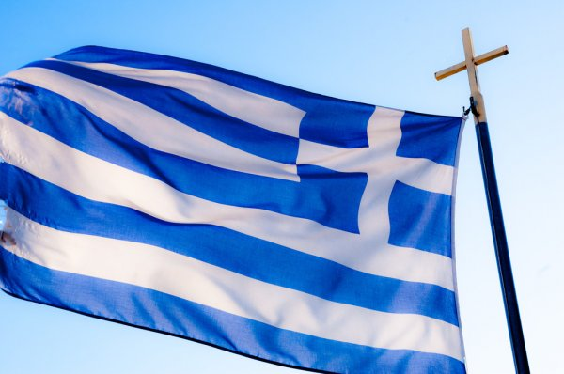The October 28th celebration is also called the **“Ochi day”** (ochi meaning ‘no’), reminding that in 1940 prime minister Ioannis Metaxas refused the Italian forces to enter Greece. As a result, Greece entered World War II and the Greek-Italian war of 1940-1941 began.

***What happened on October 28, 1940?***

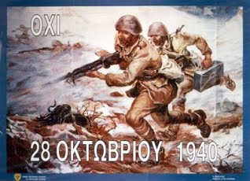At dawn of October 28, 1940, the Italian ambassador, Emanuele Grazzi, presented the Greek Prime Minister Ioannis Metaxas the ultimatum of Italian Dictator Benito Mussolini. This required the Italian army to cross the border with Albania and to occupy Greece. Metaxas replied in French “Alors, c’est la guerre” [‘So this is war’]. In a few hours the Italian army entered northeastern Greece. Greek soldiers successfully fought the Italian-Albanian forces and pushed them back into Albania. Because of that, Hitler’s German army had to step in and it invaded Greece in April 1941. The occupation lasted until October 1944.

***How do Greeks celebrate their national anniversary?***

Greek flags are everywhere!. Greek TV broadcasts movies about the war of 1940. On the state radio you will hear heroic songs of the time.

In schools, pupils recite poems, sing songs or play scenes from the Greek-Italian war wearing costumes of the time. The school teachers usually talk about Greeks’ heroism at the war.

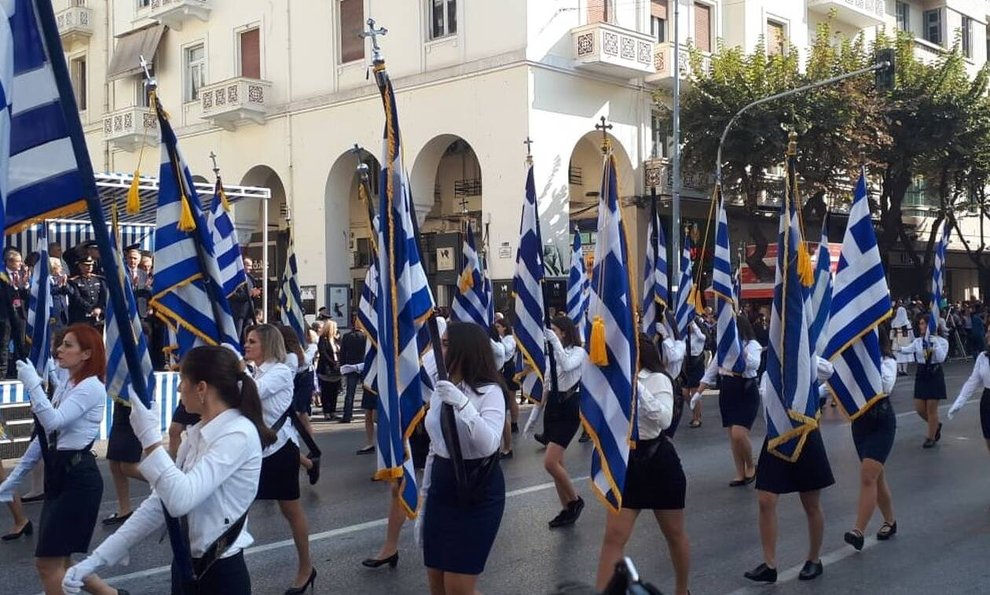

On the anniversary day, schoolchildren parade on the main street of their village or neighborhood, along with military music. Pupils’ parents and many people watch the parade, wave small flags and applaud. Before the parade they lay a wreath onto the monument.