****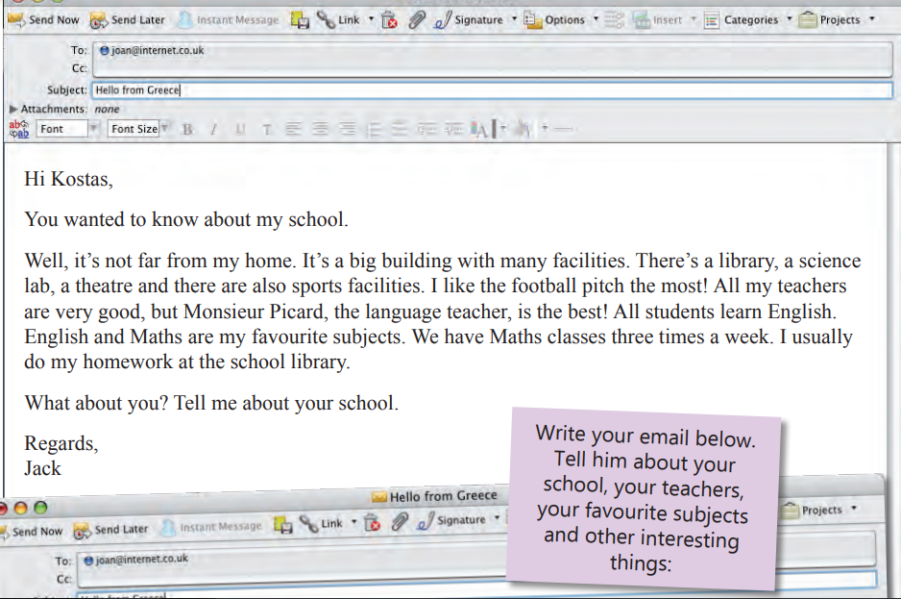

**This is an e-mail from your friend Jack from Bordeaux, France.**

**Read his message and write your answer. Use your notebook.**