**The days of the week**

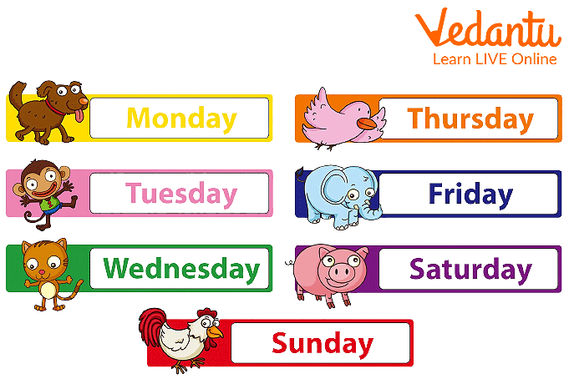

1. Put the days of the week in the correct order

FRIDAY 1. ______________________

TUESDAY 2. ______________________

MONDAY 3.______________________

SUNDAY 4.______________________

WEDNESDAY 5. ______________________

SATURDAY 6. ______________________

THURSDAY 7. ______________________

1. Unscramble the words

ATSUYDHR _____________________

DNWESEYAD _____________________

YSDUAN _____________________

YAOMDN _____________________

DYAFIR _____________________

TSARUYDA _____________________

DETUYSA _____________________

