Name: Date:
DESCRIBING MY COUNTRY
(--------------------------------)
LOCATION  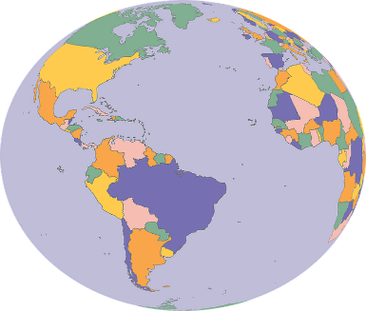 | Where is it?  In which continent is it?  What is the copital city? | It’s in………………………………  ………………………………………..  The capital city of ………………………………….is  …………………………………….
BORDERS  NORTH  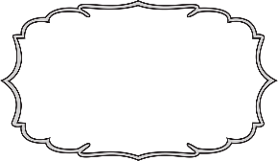  WESTTEST | Border sharing countries?  EAST | It shares borders with……  ………………………to the north,………………………..to the  south,………………………………  to the east…………………………………  to the west
RIVERS  SOUTH  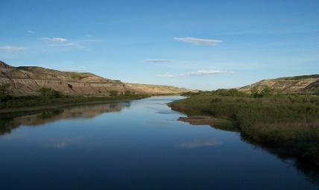 | What is the longest river? | The longest river in my country is…………………….
MOUNTAINS  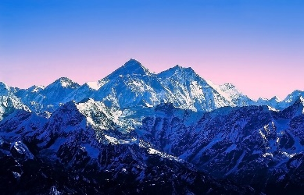 | Name two mountains | The highest mountain in my country is……………………
LANGUAGE  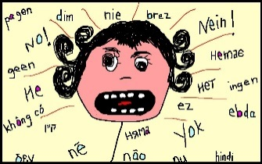 | What is the official language? | The official language is / are……….  …………………………………  …………………………….....  …………………………………
CURRENCY   | What is the currency?  (money) | The currency is the……………………….
FLAG  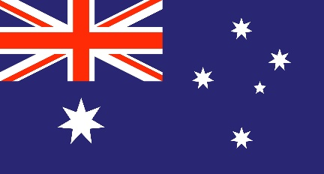 | What is the flag like? | The flag is( colours )
POPULATION  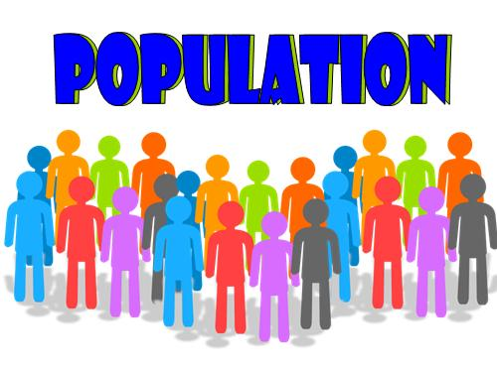 | What is the population? | The population is about………………………

Write a short paragraph describing your country.

