FIND THE RIGHT JOB FOR THESE PEOPLE:

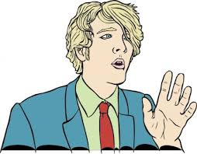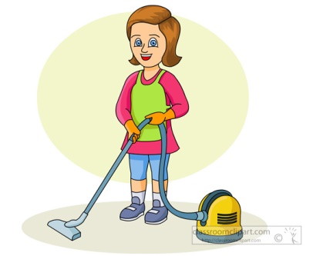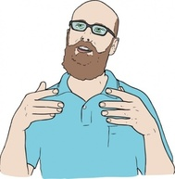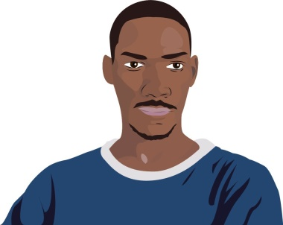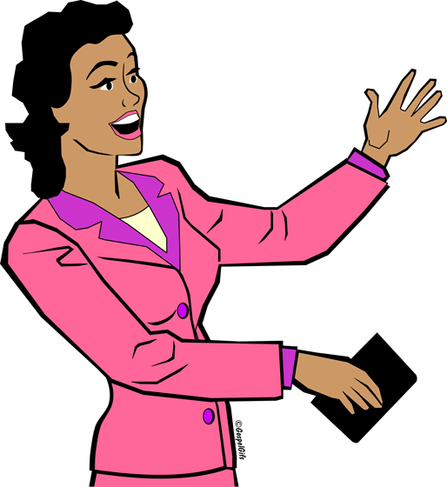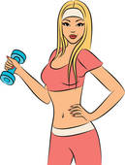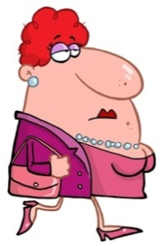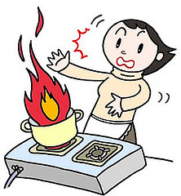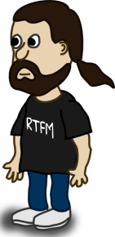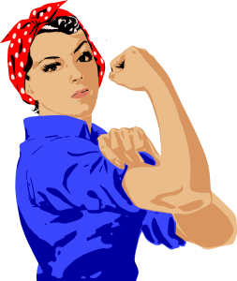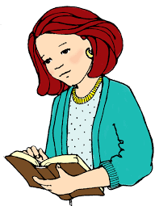

Jim likes to build things. He spends hours drawing his new projects.

Brad is very theatrical and wants to be admired by people around him.

Christine likes to travel around the world and learn foreign languages. She has a passion for clouds.

Chris loves animals. He takes care of 3 dogs and 4 cats. He is very friendly.

Maggie is very athletic. She likes to work out. She is determined and wants to make people feel good about them.

Helen loves fashion and clothes. She is always well dressed and wears matching colors. Some might consider her eccentric.

Dona wants to learn to cook. She tries everyday a new recipe, but she doesn’t know to use the cooker.

Bob is very protective. He hates criminals and likes to obey the law and protect people.

Joan is a very strong woman. She fixes things that are broken. She is not afraid to get dirty.

James cares a lot about people. He knows what pills you need to and how to take care of your health.

Amanda loves money. She wants to count, gather and invest them in many businesses ideas.

Monica likes to keep things clean. Her friends say that she spends too much time cleaning.

Dave is very tall. His hobby is to play basketball with his friends. He is a winner.

Steve wants to help people. He is very smart and is not afraid of fire or dangerous situations.

Diana talks a lot. She likes to convince people. She wants everyone to follow the law.

Since she was a child, Elsa likes to write stories and draw fantasy characters.

Steve is unemployed. He spends all day playing computer games and making applications for his phone.

Mary likes to read and spend time with children. She is very patient. Mary loves long holidays in the summer.

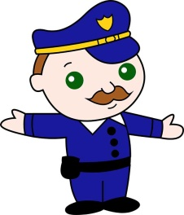WHAT DO THEY DO?

POLICEMAN

………………………………………………………………………………………………………………………………………………………………………………………………………………………………………………………………………………

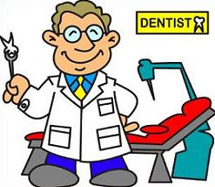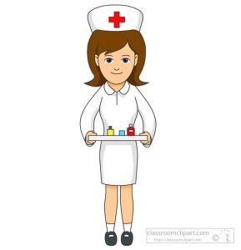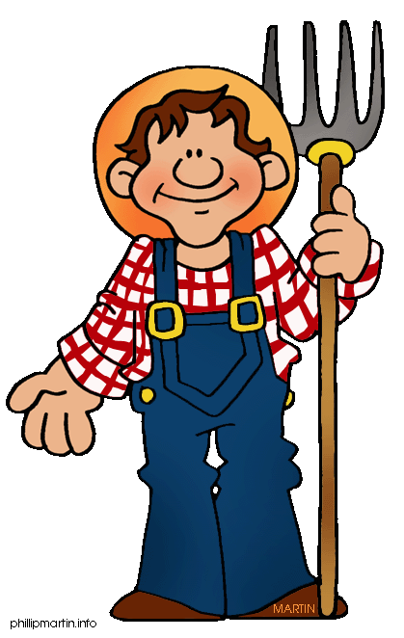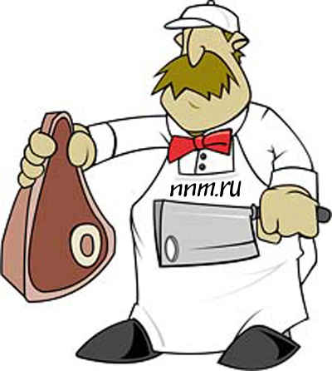

NURSE

………………………………………………………………………………………………………………………………………………………………………………………………………………………………………………………………………………

FARMER

………………………………………………………………………………………………………………………………………………………………………………………………………………………………………………………………………………

DENTIST

………………………………………………………………………………………………………………………………………………………………………………………………………………………………………………………………………………

TEACHER

………………………………………………………………………………………………………………………………………………………………………………………………………………………………………………………………………………

BUTCHER

………………………………………………………………………………………………………………………………………………………………………………………………………………………………………………………………………………

JUDGE

………………………………………………………………………………………………………………………………………………………………………………………………………………………………………………………………………………

JOB RIDDLES

I am a very good speaker.

I convince people of someone’s guilt or innocence.

You come to me when you feel sorry or you want to celebrate.

I work with flowers.

I make beautiful bouquets.

I wear a white uniform.

I know how often you should take a pill.

You buy your medicines from me.

I spend half a day with children.

I help them understand Math or teach them how to read.

I wear a uniform.

I want to keep you safe.

I am not afraid of fire.

I

I

I

I sit at a desk.

I answer calls.

I make appointments for people to see my boss.

I prepare good food.

You pay to eat what I prepare.

I wear a white uniform.

I am very good with numbers.

I keep track of all money in a business.

I “speak” to animals.

I can heal them when they are sick and I can bring new animal life on earth.

I

I spend a lot of hours in front of a computer.

I can make programs that can do what I want.

My job is to observe the facts and ask questions.

I take pictures and I write what happened in your town.

I have a passion for cars.

I am not afraid to get dirty.

I can improve or repair any vehicle.

I am beautiful and talented.

I play different roles on a stage.

People come to see me.

I know how to handle a screwdriver.

I repair what you break.

I know how appliances work.

I wear comfortable clothes.

I work outside.

I take care of animals and they give me food.

I wear a uniform.

My uniform is blue.

I am allowed to have a gun.

I give tickets or I catch thieves.

I wear a white overall.

I do my best to save lives.

I work shifts.

I wear a stethoscope.

I use scissors a lot.

I stay on my feet all day.

I cut people’s hair.

I work in a salon.