Jobs at Hogwarts
(Adapted from Bugs World 4 page 58, Macmillan)

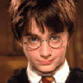
There are different people who work in my school. They help in different ways.

I’m a ____________________.
I work in the _______________.
I help find books.
I’m a _____________.
I work in the _____________.
I cook the lunch.
I’m a __________________.
I work in the _____________.
I organise things in the school.
I’m a ________________.
I clean the ___________.

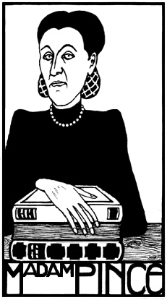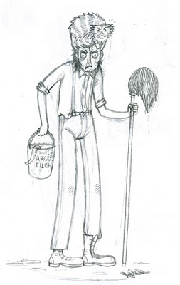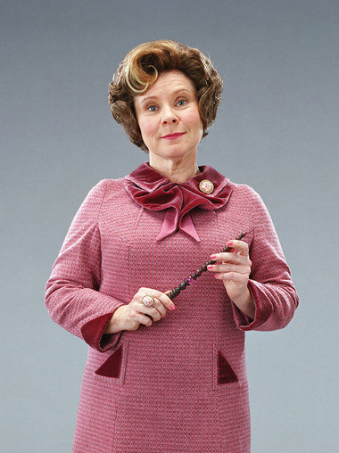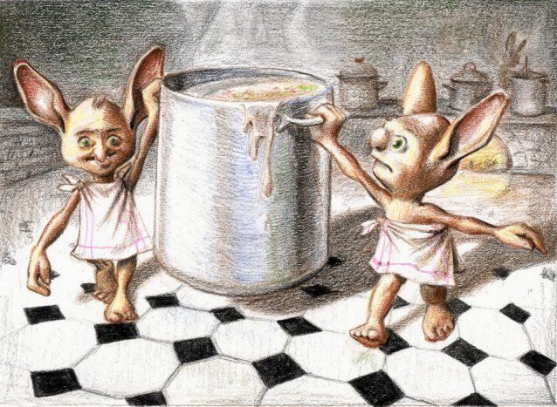
Madam Pince Argus Filch Dolores Umbridge Dolly Jones

library cook librarian cleaner kitchen secretary school office

What does Madam Pince do? _She’s a librarian.______________  Where does she work? _She works in the office._________  What does Argus Filch do? _______________________________  Where does he work? ______________________________ | What does Dolores Umbridge do? ____________________________  Where does she work? ___________________________  What does Dolly Jones do? ___________________________  Where does she work? ___________________________

Match up the jobs with their descriptions:
- The librarian______  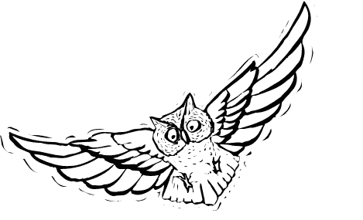  - The head teacher______  - The cook______  - The cleaner______  - The caretaker______  - The nurse______  - The teacher______  - The secretary______ | - makes delicious meals in the school kitchen.  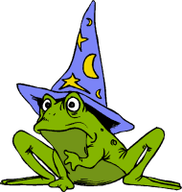  - repairs things and checks the school at night.  - helps people to find information in the school library.  - helps sick students in the school hospital.  - cleans the school.  - teaches classes in a classroom.  - organises the teachers and makes important decisions.  - works in the office and organises things in the school.
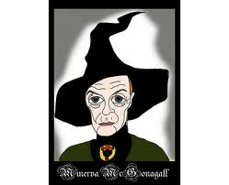  teacher | Minerva Mc Gonagall is a teacher.  She works in a classroom.  She teaches classes and helps students when they have a problem.

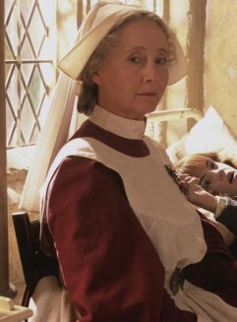  nurse | Madam Pomfrey __________ __________________________.  She works __________________ ___________________________.  She ________________________ ____________________________  ____________________________.

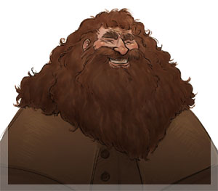  caretaker | Rubeus Hagrid ____________  ___________________________  ___________________________  ___________________________  ___________________________  ___________________________

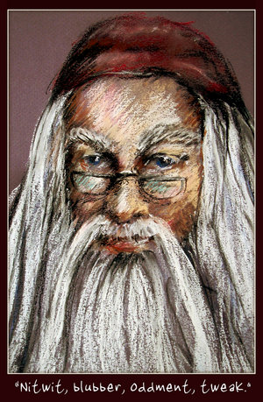  head teacher | Albus Dumbledore _________  ___________________________  ___________________________  ___________________________  ___________________________  ___________________________

