WATCH THE VIDEO ABOUT HEALTHY EATING

**Tick the types of food you hear:**

1. Olive oil…… 23. Pop corn…
2. Vegetable oil… 24. Sodas….
3. Canola oil (= λάδι κανόλα ή κραμβέλαιο) … 25. Sport drinks…
4. Fish ……… 26. Fresh juice….
5. Meat …….. 27. Water….
6. Chicken ……. 28. milk…..
7. Vegetables...
8. Sweets ….. 
9. White flour …..
10. Whole grain flour…..
11. Whole grain bread…..
12. Tortillas…… 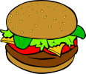
13. White bread ……. 
14. White rice……..
15. Brown rice……
16. Salt……..
17. Pepper…….
18. Cilantro (US coriander= κόλιανδρο)……..
19. Oregano……..
20. Chilli (AE=chili)……..
21. Cumin(=κίμινο)…….
22. Lemon juice……..

Complete the table

|  |  |
| --- | --- |
| COUNTABLE NOUNS | UNCOUNTABLE NOUNS |
|  |  |
|  |  |
|  |  |
|  |  |
|  |  |
|  |  |
|  |  |
|  |  |
|  |  |
|  |  |
|  |  |
|  |  |
|  |  |
|  |  |
|  |  |
|  |  |
|  |  |
|  |  |
|  |  |
|  |  |
|  |  |
|  |  |
|  |  |
|  |  |
|  |  |
|  |  |

 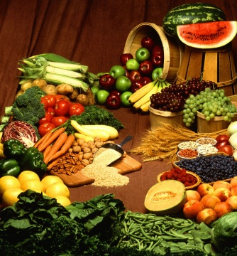

**GRAMMAR: Countable or uncountable?**• **Fruit** is usually uncountable:I love fruit.✗Don’t say: I love fruits.• **Fruit** is used as a countable noun when talking about particular types of fruit:They grow mainly citrus fruits.

The noun **soda** can be countable or **uncountable**. In more general, commonly used, contexts, the plural form will also be **soda**. However, in more specific contexts, the plural form can also be **sodas** e.g. in reference to various types of **sodas** or a collection of **sodas**.