1. Match

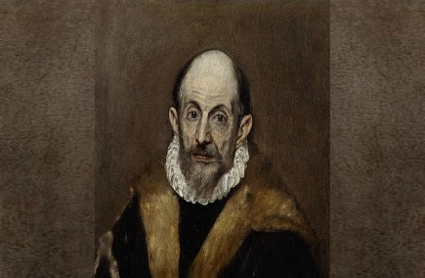

SHAKESPEARE

EL GRECO 

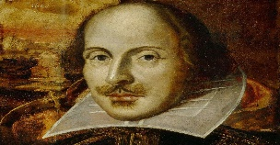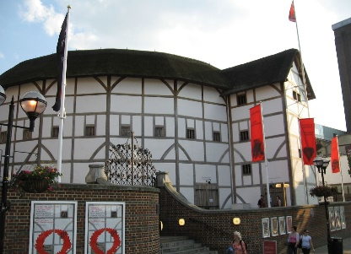

[Αυτή η φωτογραφία](https://wikitravel.org/shared/File:Shakespeare's_Globe_Theatre,_London.JPG) από Άγνωστος συντάκτης με άδεια χρήσης [CC BY-SA](https://creativecommons.org/licenses/by-sa/3.0/)

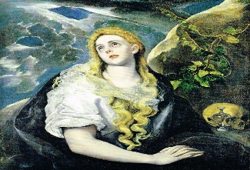

[Αυτή η φωτογραφία](https://www.flickr.com/photos/33255628@N00/7401314848/) από Άγνωστος συντάκτης με άδεια χρήσης [CC BY](https://creativecommons.org/licenses/by/3.0/)

B. Write **(Sh)** for Shakespeare and **(El**) for El Greco

1. I was born in Chania, Crete …………….. 2. I wrote 37 plays……………….

3. I studied Byzantine icon painting……………. 4. I was born in Stratford-upon-Avon………….

5. I had 7 brothers and sisters………….. 6. I moved to Spain in 1564…………….

7. I died in 1614………………. 8. I died in 1616…………………..

C. Write the **questions** for the answers above

**SHAKESPEARE**

1…………………………………………………………………………………………………………………………………

2……………………………………………………………………………………………………………………………….

3………………………………………………………………………………………………………………………………

4…………………………………………………………………………………………………………………

**EL GRECO**

1………………………………………………………………………………………………………………………………….

2………………………………………………………………………………………………………………………………..

3………………………………………………………………………………………………………………………………..

4………………………………………………………………………………………………………………………………..