British Isles – Great Britain – UK

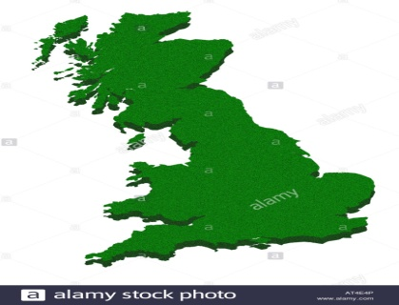Tick the correct answer

1. The British isles are : 1. 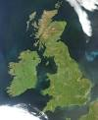 2.

Complete

1. 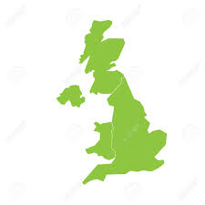This picture shows………………………………….  
   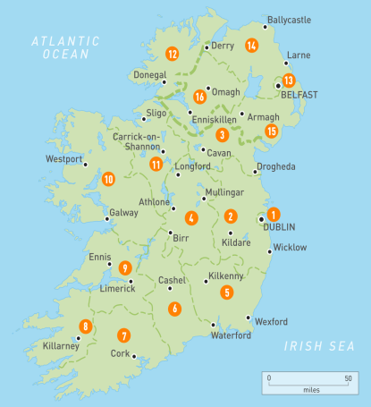 C) This is a map of……………………..

CAPITALS: Circle the correct answer

1. The capital of England is London/Cardiff
2. The capital of Scotland is Cardiff/ Edinburgh
3. The capital of Wales is Dublin/Cardiff
4. The capital of Northern Ireland is Belfast/Edinburgh
5. The capital of Ireland is Dublin/Belfast

SYMBOLS OF ENGLAND

Complete:

1.This is the British Flag. It’s name is the………………………….

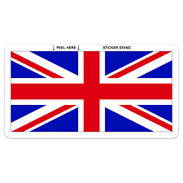

The national flower of **England** is…………………….

The national bird of England is…………………

The national animal of England is……………

The national tree of England is…………….

The national game is…………………..

The national fruit is ……………………….

The national currency is the euro/pound

The national animal of **Scotland** is…………..

The national animal of **Wales**…………….