**22ND APRIL**

**HAPPY EARTH DAY!**

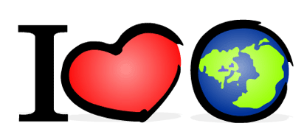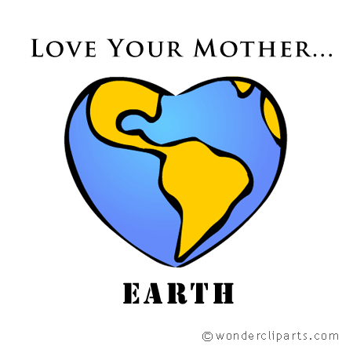

**Today is Earth Day  an international celebration of our one and only planet *Earth*!   
It's a great time to learn about our planet and how to take care of it!**

**Our planet is sick because of us, because we do not take care of it and it  is our responsibility to look after the planet. It´s our home, the only place we have to live in.**

**We can do a lot of things to save our planet:**

1. **Save energy**
2. **Do not waste water**
3. **Do not waste paper at school**
4. **RECYCLE, RECYCLE, RECYCLE: we must recycle glass, paper, cans, plastic**
5. **Leave wasted batteries in the special containers**
6. **Do not pollute, keep our beaches, rivers, parks, forests....clean.**
7. **The 3 Rs RECYCLE, REDUCE, REUSE.**

**IN PAIRS OR IN GROUPS**

**DECIDE MORE WAYS OF SAVING THE PLANET. WRITE THEM.**