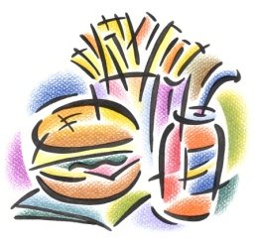**Food Survey**

|  |  |  |
| --- | --- | --- |
| Names | Questions | Responses |
|  | 1. What’s your favorite food? |  |
|  | 1. Do you usually eat breakfast? |  |
|  | 1. What do you usually have for breakfast? |  |
|  | 1. What time do you usually have dinner? |  |
|  | 1. Do you like cooking? |  |
|  | 1. Do you often snack between meals? |  |
|  | 1. What do you like to have for snacks? |  |
|  | 1. Do you like desserts? What kind of dessert do you like? |  |
|  | 1. Do you like American food? |  |
|  | 1. Do you like spicy food? |  |
|  | 1. Do you eat quickly or slowly? |  |
|  | 1. Do you like to eat out at a restaurant? |  |
|  | 1. Do you think you have a healthy diet? |  |
|  | 1. Do you like ________? |  |