Name…………………………Class……
HEALTHY OR UNHEALTHY HABITS?
- Read two stories about Sheila and Mark and give the correct form of the verbs.
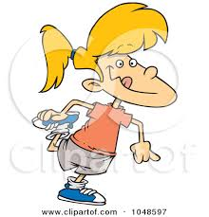
Sheila is 12 years old. She (go) …………..to school in the morning and (come) ……………back home at 2 in the afternoon. Then, she (take) ………….a shower and she (have)……………… lunch. Sheila usually (eat)……………….. vegetables and some meats. For example, she (have)……….. chicken or fich with rice and salad and she (like)……………. drinking water or juice. After that, she (brush)……………. her teeth. In the evening, sheila (walk)………………… to the sports center. There, she (play)………….. tennis or (do)…………. some exercise. When she (be)………… hungry, she always (eat)…………… some fruit. Sheila never (go)………. to bed after ten because she (need)………………. to get enough rest to get up early in the morning.

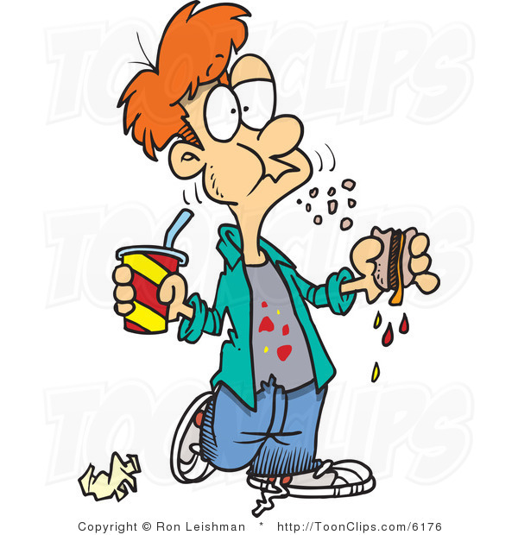
Mark always (get)………….. up at twelve in the morning. He (not have)……………………………… breakfast. Mark (like)………………….. having hamburgers, pizza, crisps and hot dogs for lunch. He always (have) ………………. fizzy drinks like cola. So there (be)………………. any vegetables or fruit at home. After lunch, he (take)………………. the bus and (go)………………. to school – six blocks far away. At six o’clock, Mark (go)………………. to the bus stop and (come)……………….back home. He (sit)………………. on his dad’s sofa and (watch)………………. TV for three hours. When he (be)………………. hungry, he (eat)………………. lots of sweets or chocolate biscuits and he always (drink)………………. cola. He usually (go)………………. to sleep at eleven or twelve because before that he (like)………………. playing computer games. He usually (stay)………………. at home all day at weekends.
- What about you? Write a short paragraph about what you usually do everyday.



