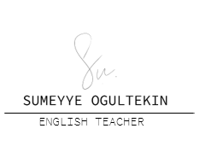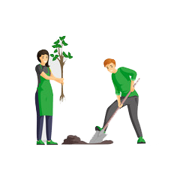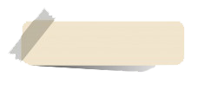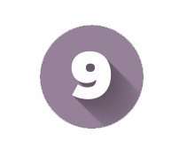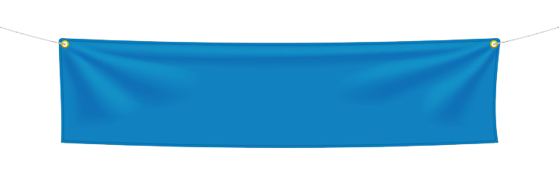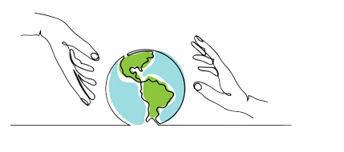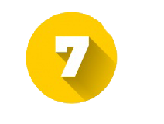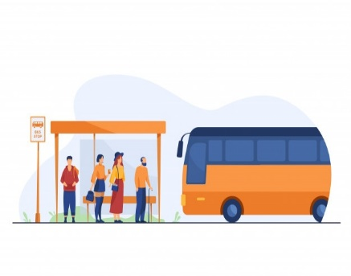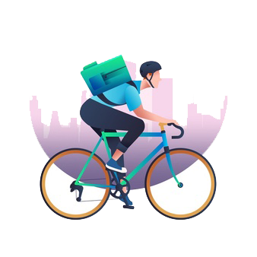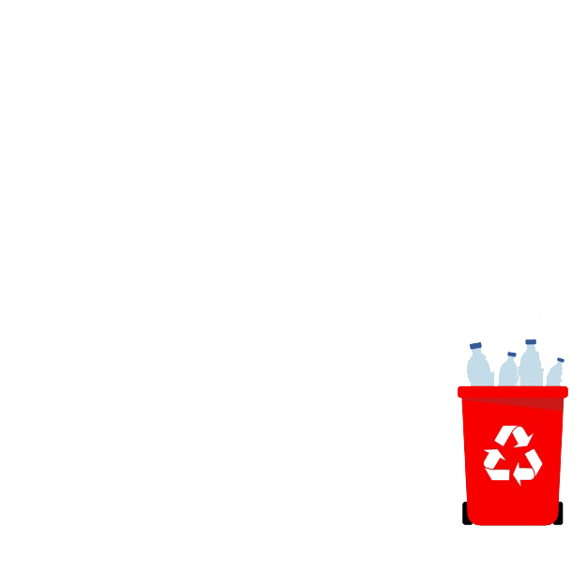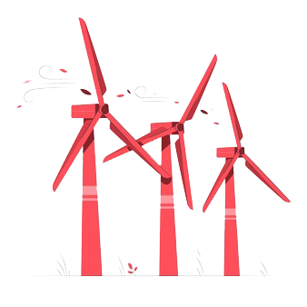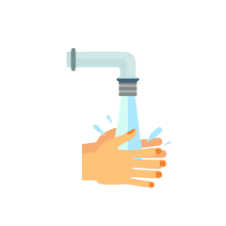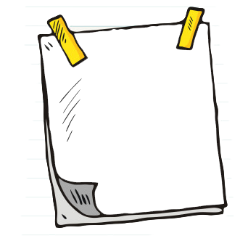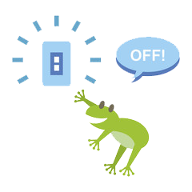

We should/shouldn’t _ _ _ _ _ _ _ _ _ _ _ _ _ _ _ _ _ _ _ _ _ _ _.

What should or shouldn’t we do to

protect our environment?

We should/should’nt _ _ _ _ _ _ _ _ _ _ _ _ _ _ _ _ _ _ _ _ _ _ _.

We should/shouldn’t _ _ _ _ _ _ _ _ _ _ _ _ _ _ _ _ _ _ _ _ _ _ _.

**UNIT**

**SAVING THE PLANET**

**Use public transportation**

**Plant tree**

**Turn off the lights**

**Recycle plastic**

**Waste water**

**Use wind energy**

**Cycle to work**

We should/shouldn’t _ _ _ _ _ _ _ _ _ _ _ _ _ _ _ _ _ _ _ _ _ _ _.

We should/shouldn’t _ _ _ _ _ _ _ _ _ _ _ _ _ _ _ _ _ _ _ _ _ _ _.

We should/shouldn’t _ _ _ _ _ _ _ _ _ _ _ _ _ _ _ _ _ _ _ _ _ _ _.

We should/should’nt _ _ _ _ _ _ _ _ _ _ _ _ _ _ _ _ _ _ _ _ _ _.