***MAKE SENTENCES WITH “SHOULD” AND “SHOULDN’T “***

**PROBLEM 3**

**PROBLEM 2**

**PROBLEM 1**

**SOLUTIONS**

**SOLUTIONS**

**SOLUTIONS**

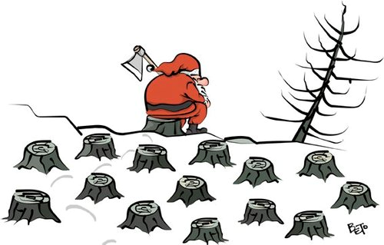

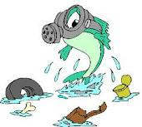

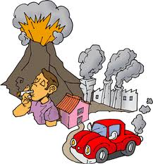

**1.** You should………

**2.** You shouldn’t …….

**3.**

**4.**

**5.**

Hello! My name is Alice. I live in a village near to the Amazon rainforest. In the past, the forest was really beautiful and had a lot of trees. But in time, the Amazon rainforest lost its capacity to fight climate change, and nearly half of it disappeared. Also, the number of animals(leopards, jaguars) decreased. What should I do?

**1.** You should…….

**2.** You shouldn’t …….

**3.**

**4.**

**5.**

Hello! My name is Chen. I live in Hong Kong. Hong Kong is a really beautiful city and has lots of places to visit for tourists. But the air pollution is a big problem for us. We can’t go to outside without wearing masks. What should we do?

Hello! My name is Ali. I live in Trabzon. I eat fish every day. In the past we had a lot of fish in our sea. But now they started to disappear because of water pollution. Also, our dams lost their capacity; we don’t have that much drinking water. What should I do?

**1.** You should………

**2.** You shouldn’t …….

**3.**

**4.**

**5.**