**Who was William Shakespeare?**

**Personal information**

Birthday🎂:_____________________________________________

Place of birth: ☐Stratford-upon-Avon,England ☐ German ☐ Athens, Greece

Number of Sisters and brothers: _________________________________________

Date of death:_____________________________________________________

**Education**

Studies:1.________________2._______________3._________________

**Career**

First job:_________________________________________

Then he started writing ____________, too.

Shakespeare wrote **short poems** which are called: ‘’………………..’’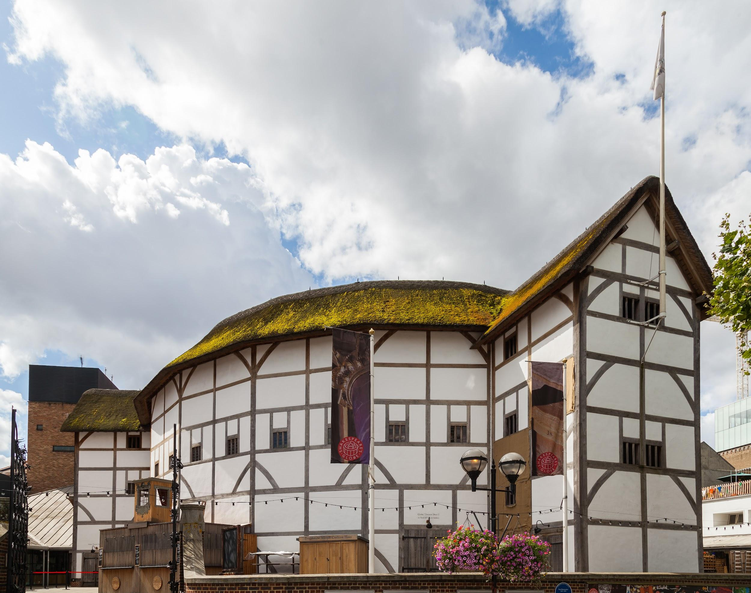

**What is the Globe:**

☐A theatrical play ☐ a new theater ☐ the audience

Note⚠

️ In Shakespeare’s time only men could act in the theater, women were not allowed to play.

**What types of plays did he write?**

1. ……………………………………….. 2. ………………………………………… 3. ……………………………

(Any titles?.................................................................................................................)

**How many plays did he write?**________________________________________

Write a small paragraph about Shakespeare’s life, his biography. (about 100 words) Use the information you gathered. Remember we write about someone in the past (use the past simple).

Name:**William Shakespeare**

William Shakespeare was _____________________________________________________

________________________________________________________________________________________________________________________________________________________________________________________________________________________________________________________________________________________________________________________________________________________________________________________________________________________________________________________________________________________________________________________________________________________________________________________________________________________