**Polar Bears**

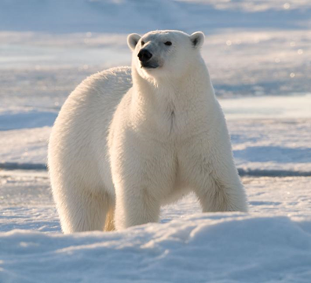Polar bears live in the cold Arctic on ice-covered waters. They are very good swimmers and have big front paws. Their fur is white to hide in the snow, and they have a thick layer of fat to stay warm in the cold water.

Baby polar bears are as small as adult guinea pigs when they are born. When they are fully grown, males are around 8-9 feet tall, and females are about 6-7 feet tall. They usually live for about 20-25 years.

Polar bears like to eat seals, so they spend a lot of time hunting near the ice. But because of climate change, it is becoming more difficult for them to find food. The ice is melting, which means the bears have to search for different kinds of food that are not as good for them. The biggest problem for polar bears is that they are losing their homes because the ice is disappearing. This is mostly happening because of climate change. Other dangers include human activities, hunting too many bears, and building too many things in the Arctic. The polar bears are in danger as they have to spend more time on land and come into contact with people and factories that threaten their habitats.

**Useful words:**

human activities: ανθρώπινες δραστηριότητες

come into contact: έρχομαι σε επαφή με

**Tasmanian Devil**

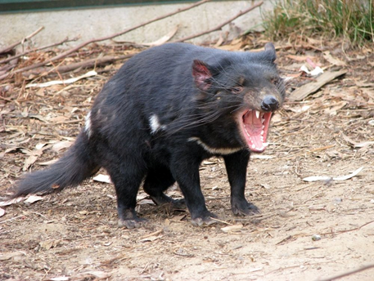Tasmanian devils are big meat-eating animals that live in Tasmania, a large island in south Australia. They are the largest meat eaters in the world! Tasmanian devils look like small dogs with brown or black fur. They have strong jaws and teeth that can bite really hard.

These devils only eat meat, like small animals or animals that are already dead. One cool thing about them is that they can spin around when they feel threatened, just like the cartoon character Taz! They spend their time alone in hollow logs or caves, using their good sense of smell and sight to stay safe and find food.

Sadly, since the 1990s, many Tasmanian devils have died from a serious sickness called devil facial tumor disease (DFTD). This disease is a rare cancer that makes it difficult for the devils to eat. Scientists are trying their best to stop this sickness from spreading and saving the Tasmanian devils from disappearing.

**Useful Words:**

Hollow: κούφιος

Log: κορμός

Rare: σπάνιος

**Blue Whales**

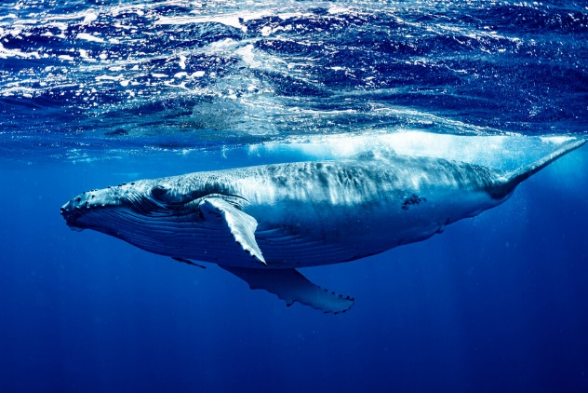Blue whales are big animals that live in the ocean. They can breathe air but like to be in the water because it helps them stay afloat. These whales can be found in oceans all around the world and sometimes swim together in small groups or by themselves.

When a baby blue whale is born, it weighs about two tons (1,814 kilograms). As it grows, it gains 200 pounds (91 kilograms) every day for the first year. These huge animals eat tiny shrimp-like creatures known as krill.

There are only a few thousand blue whales left in the world. People used to hunt them for their fat and oil, almost causing them to become extinct. Luckily, in 1966, a law was made to protect them, and now they are considered to be animals that need to be taken care of because there are not many left.

**Useful words:**

Afloat: επιπλέω

Shrimp- like: που μοιάζει με γαρίδα

**Orangutans**

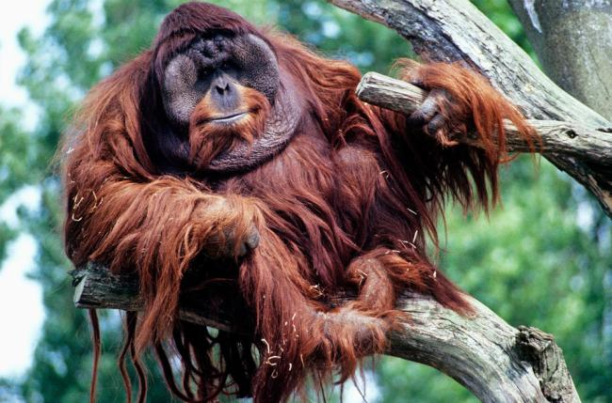Orangutans are big animals that spend most of their time high up in the trees. They live in forests in Asia. When nighttime comes, they make comfy beds out of leaves and twigs in the tree branches. Sometimes they even build a roof to keep dry if it rains.

Adult males weigh about 75 kilograms, while females weigh about 37 kilograms. Orangutans have long, strong arms and hands that help them climb and swing between trees easily. On the ground, orangutans walk on all fours. Orangutans have small ears and noses. They eat fruit, nut, and sometimes insects or bird eggs. They drink water from different places in the trees. Human activities have caused threats to the orangutans and made them endangered species. Threats to wild orangutan populations include hunting ,losing their [habitat,](https://en.wikipedia.org/wiki/Habitat_destruction)  [cutting](https://en.wikipedia.org/wiki/Deforestation) down trees and the illegal [pet trade](https://en.wikipedia.org/wiki/Exotic_pet).

**Useful words:**

Human activities: ανθρώπινες δραστηριότητες

Illegal: παράνομος

Trade: εμπόριο, ανταλλαγή

**Amur Leopard**

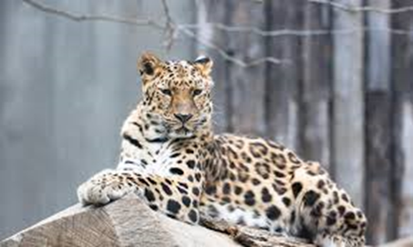Amur leopards can be found in the mountainous forests of eastern Russia and northern China. Named after the Amur River, which runs along both countries, these cats are used to living in this dangerous environment. Their soft, thick fur keeps them warm in the cold, and their large paws work like snowshoes to let them walk on snow.

Amur leopards weigh about 80 pounds, some 30 pounds. But these cats can still kill animals for food, up to three times their size. They prefer to eat deer and wild pigs, but will eat rabbits and mice as well. Loss of habitat and poaching have made Amur leopards one of the rarest wild cats on Earth—and the world’s rarest leopard.

**Useful words:**

Mountainous: ορεινός

Thick: παχύς

Poaching: παράνομο κυνήγι

Rarest: πιο σπάνιο