**Name: _________________________**

**Class: _________________________**

**Date: __________________________**

1. **Read and complete. Fill in the gaps with the words.**

**survive, rhinoceros, krill, endangered,** **deserts, fishing, hunt**

1. 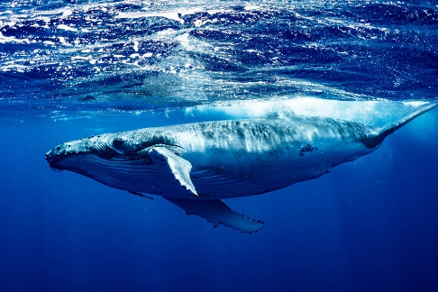The whale is an ____________ animal. It eats _________ . When fishermen go ____________ it cannot eat enough krill to survive.

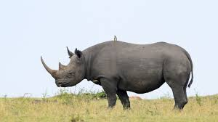

1. The black ______________ lives in the _______________. People _______________ it for its horns. People turn the land into farms and buildings so it cannot _____________.

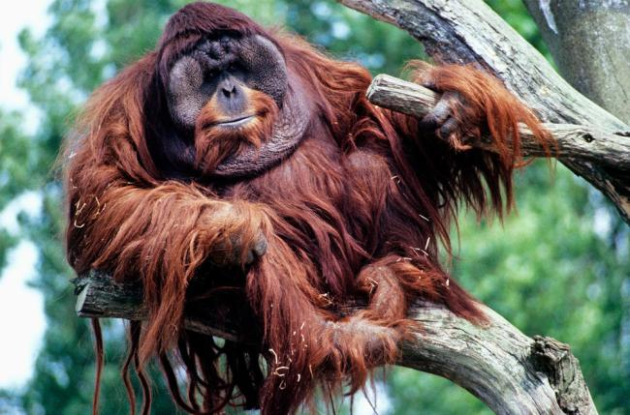**climate, ice, rainforests, cut, polar bear, Arctic, trees, home, live**

1. The orangutan lives in ___________ in the _____________ of South East Asia. People _____________ down trees without planting new ones. It has nowhere to _______________.
2. The _________________ lives on the ____________ in the _______________. Because of _______________ change the ice is melting. So it loses its ________________. 