**https://youtu.be/PW2duKZChA8**

**15th October**

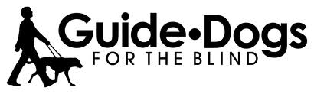

**Video Comprehension Questions: Guide Dogs for the Blind**

**1. What is the name of the guide dog in the video?**

a. Ethan  
b. Brayden  
c. Desmond  
d. Egan

**2. How does the guide dog keep the person safe while walking?**

a. By running ahead of the person  
b. By pulling the person in different directions  
c. By dancing with the person on the street  
d. By stopping when a car is coming

**3. What does the person use to navigate corners and obstacles?**

a. A white cane  
b. A guide dog  
c. A leash  
d. A Gentle Leader

