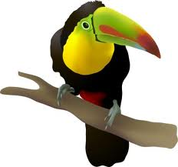
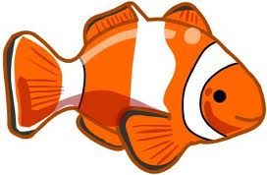
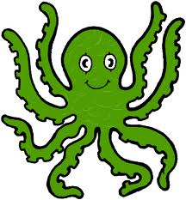
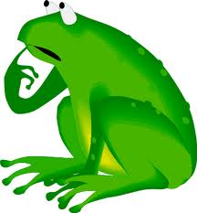
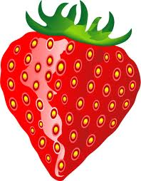
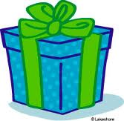
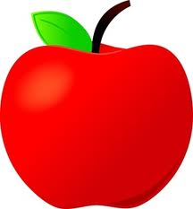

Fill in a or an

_______ igloo 10. _________ tomato
_______ octopus 11. _________ eye
_______ pencil 12. _________ ear
_______ potato 13. _________ big nose
_______ present 14. _________ alligator
_______ ice cream 15. _________ old car
________umbrella 16. _________ iguana
________ fish 17. _________ box
_______ apple tree 18. _________ parrot

Fill in a or an

______ English book 9. ______ dog
___________ apple 10. ____blue notebook
___________ baby 11. ____ red pencil
____________ ball 12. _____ window
____________book 13. _____ ruler
____________door 14. _____ animal
____________ egg 15. _____ dinosaur
____________orange 16. _____ flower

a

or

a
n

