**Test Unit 4**

**Name: _________________________**

**Date: ______________________**

1. **Fill in with the words:**

**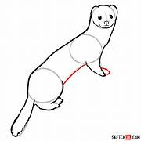***small, hole, food, quick, fruit, tall.*

1. This wall is very _______________!

Oh, but look! A hole so _______________!

2. Eat your vegetables and _______________.

 That’s the right kind of _______________.

3. Run little weasel, _______________! Run through the _______________!

**B. Put the words in the right order:**

1. mole/drinking/Cole/is/the

 _________________________________________________

2. mole/eating/Cole/is/the

_________________________________________________

3. tummy/Her/is/empty

_________________________________________________

4. the/full/is/but/cellar

_________________________________________________

**C. Write the plural of the words**

Plum _________

Goody __________

Cherry _____________

Chip __________

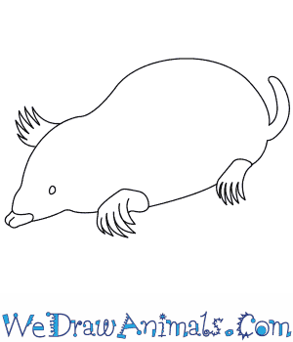Pear __________

Berry ___________

Forest __________

Mole ____________

**D. What does the mole eat?**

|  |  |
| --- | --- |
| Mon, Wed | Κερασια , μουρα |
| Thur, Sat | Ψωμι , τυρι |
| Frid | Γιαουρτι, μελι |
| Tues | Αυγα , μπισκοτα |
| Sun | Γλυκα |

|  |
| --- |
| On Monday he eats ……..  On Thursday and Saturday he has….. |

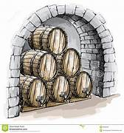**Ε. Match the phrases or words with the pictures**

Pout

Munch

Lick my lips

Full cellar

Vegetables

Fat tummy

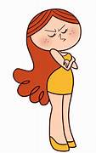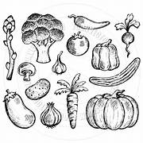



**F. Match the opposite words**

|  |  |
| --- | --- |
| Fat | full |
| small | thin |
| empty | Big |
| Sad | Happy |

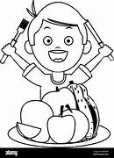

**Good luck !!!!**