

**1.** CROSSWORD: The flight vocabulary

*A. Vocabulary*

**WB**

Unit *4* The history of the aeroplane

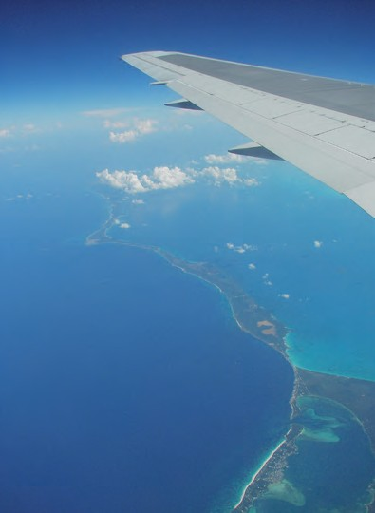

1

2

3

4

5

6

7 8

9

10

11

12

13

14

|  |  |
| --- | --- |
| Across | Down |
| **1.** Planes sometimes fall into it. | **2.** A person travelling on a plane. |
| **5.** It lands on water. | **3.** A Concorde flies 5 times up the of  sound. |
| **6.** A space shuttle has a strong one. | **4.** A journey in the air |
| **7.** This force pulls the plane backward. | **8.** It travels to the moon. |
| **9.** This force pulls the plane down. | **10.** A helicopter can anywhere. |
| **11.** The Wright brothers invented it. | **12.** The person who controls a plane. |
| **13.** This force pushes the plane upward. | **14.** Birds have got wings, so they can ............ |

26 Pupil’s Workbook • **UNIT 4** - The history of the aeroplane