Unit *4*

**WWBB**

**2.** Divide the following words into two groups: “PARTS OF THE PLANE” and “FORCES OF FLIGHT”.

drag, tail, rudder, fuselage, landing gear, wings, engine, gravity, thrust, cockpit, lift

|  |  |
| --- | --- |
| Parts of the plane |  |
| Forces of flight |  |

**3.** Use the following words to complete the text:

Pupil’s Workbook • **UNIT 4** - The history of the aeroplane 27

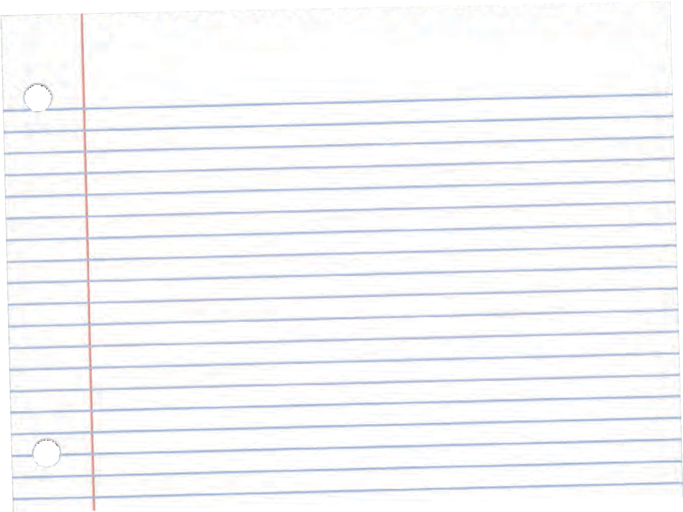

took off, airhostess, air pocket, cockpit, landed, forces, pilot, fuselage, wings, tail, landing gear