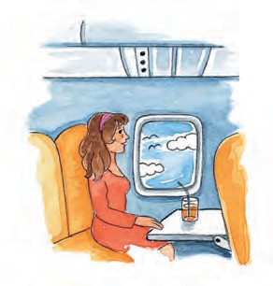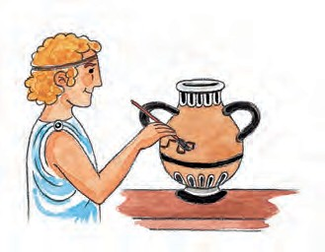

**W**

**O**

**R**

**K**

**B**

**O**

**O**

**K**

In Daedalus’ time...

paint on pottery

eat cheeseburgers

fly by plane X

**5.** Look at the activities below and tick 0 the things people did in Daedalus’ time and cross out

; the things they didn’t do:

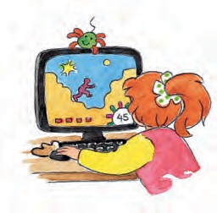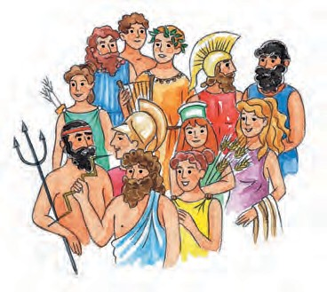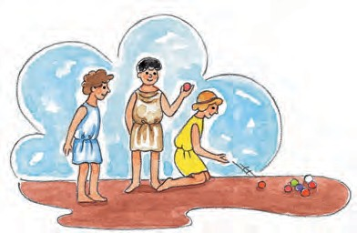

believe in the 12 gods

play games of marbles

play computer games

**6.** Now write 3 things about what people didn’t do in Daedalus’ time:

Ex. People **didn’t fly by plane** in Daedalus time.

**1.** .

**2.** .

**3.** .

Pupil’s Workbook • **UNIT 4** - The history of the aeroplane 31