# Chapter IX

I believe that for his ***escape*** he took advantage of the ***migration*** of a ***flock*** of wild birds. On the morning of his ***departure*** he ***put*** his planet in perfect ***order***. He carefully cleaned out his active ***volcanoes***. He possessed two active volcanoes; and they were very ***convenient*** for ***heating*** his breakfast in the morning. He also had one volcano that was ***extinct***. But, as he said, "One never knows!" So he cleaned out the extinct volcano, too. If they are well cleaned out, volcanoes burn slowly and ***steadily***, without any ***eruptions***. Volcanic eruptions are like fires in a chimney.

On our earth we are obviously much too small to clean out our volcanoes.

That is why they bring no end of trouble upon us.

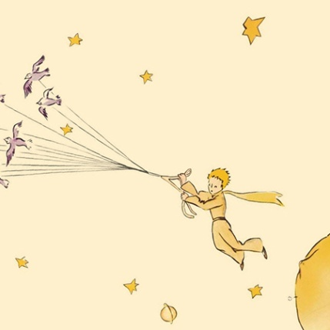The little prince also pulled up, with a certain sense of ***dejection***, the last little ***shoots*** of the baobabs. He believed that he would never want to ***return***. But on this last morning all these ***familiar*** tasks ***seemed*** very ***precious*** to him. And when he watered the flower for the last time, and prepared to place her under the ***shelter*** of her glass globe, he realized that he was very close to ***tears***.

"Goodbye," he said to the flower.

But she made no answer.

"Goodbye," he said again.

The flower coughed. But it was not because she had a cold.

"I have been silly," she said to him, at last. "I ask your ***forgiveness***. Try to be happy . .."

He was surprised by this ***absence*** of ***reproaches***. He stood there all ***bewildered***, the glass globe held arrested in mid-air. He did not understand this quiet ***sweetness***.

"Of course I love you," the flower said to him. "It is my fault that you have not known it all the while. That is of no importance. But you—you have been just as foolish as I. Try to be happy . . . Let the glass globe be. I don't want it any more."

"But the wind-"

"My cold is not so bad as all that. . . The cool night air will do me good. I am a flower."

"But the animals-"

"Well, I must ***endure*** the ***presence*** of two or three ***caterpillars*** if I wish to become ***acquainted*** with the butterflies. It seems that they are very beautiful. And if not the butterflies-and the caterpillars—who will ***call upon*** me? You will be far away ... As for the large animals—I am not at all afraid of any of them. I have my ***claws***."

And, ***naively***, she showed her four thorns.

Then she added: "Don't ***linger*** like this. You have decided to go away. Now go!"

For she did not want him to see her crying. She was such a ***proud*** flower . .