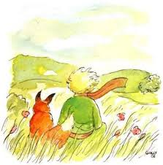**Chapter XXI**

It was then that the fox ***appeared***.

"Good morning," said the fox.

"Good morning," the little prince answered ***politely***,

though when he turned around he saw nothing.

"I’m here," the voice said, "under the apple tree. "

"Who are you?" the little prince asked. "You’re very pretty..."

"I’m a fox," the fox said.

"Come and play with me," the little prince ***proposed***. "I’m feeling so sad. "

"I can’t play with you," the fox said. "I’m not ***tamed***. "

"Ah! Excuse me," said the little prince. But upon ***reflection*** he ***added***, "What does tamed ***mean***? "

"You’re not from around here," the fox said. "What are you looking for? "

"I’m looking for people," said the little prince. "What does tamed mean?"

"People," said the fox, "have guns and they hunt. It’s quite ***troublesome***. And they also ***raise*** chickens. That’s the only interesting thing about them. Are you looking for chickens? "

"No," said the little prince, "I’m looking for friends. What does tamed mean?"

"It’s something that’s been too often ***neglected***. It means, to ***create*** ***ties***..."

"To create ties? "

"That’s right," the fox said. "For me you’re only a little boy just like a hundred thousand other little boys. And I have no need of you. And you have no need of me, either. For you I’m only a fox like a hundred thousand other foxes. But if you tame me, we’ll need each other. You’ll be the only boy in the world for me. I’ll be the only fox in the world for you..."

"I’m beginning to understand," the little prince said. "There’s a flower... I think she’s tamed me..."

"***Possibly***." the fox said.

"On Earth, one sees all kinds of things. "

"Oh, this isn’t on Earth," the little prince said.

The fox seemed quite ***intrigued***. "On another planet? "

"Yes. "

"Are there hunters on that planet? "

"No. "

"Now that’s interesting. And chickens? "

"No."

"Nothing’s perfect," sighed the fox.

But he returned to his idea. "My life is ***monotonous***. I hunt chickens; people hunt me. All chickens are just ***alike***, and all men are just alike. So I’m rather bored. But if you tame me, my life will be filled with sunshine. I’ll know the sound of ***footsteps*** that will be different from all the rest. Other footsteps send me back ***underground***. Yours will call me out of my ***burrow*** like music. And then, look! You see the ***wheat*** ***fields*** over there? I don’t eat bread. For me wheat is of no use whatever. Wheat fields say nothing to me. Which is sad. But you have hair the color of gold. So it will be ***wonderful***, once you’ve tamed me! The wheat, which is golden, will ***remind*** me of you. And I’ll love the sound of the wind in the wheat..."

The fox fell ***silent*** and ***stared*** at the little prince for a long while. "Please... tame me!" he said.

"I’d like to," the little prince ***replied***, "but I haven’t much time. I have friends to find and so many things to learn. "

"The only things you learn are the things you tame," said the fox. "People haven’t time to learn anything. They buy things ready-made in stores. But since there are no stores where you can buy friends, people no longer have friends. If you want a friend, tame me! "

"What do I have to do?" asked the little prince.

"You have to be very ***patient***," the fox answered. "First you’ll sit down a little ways away from me, over there, in the grass. I’ll watch you out of the corner of my eye, and you won’t say anything. Language is the ***source*** of all ***misunderstandings***. But day by day, you’ll ***be able*** to sit a little closer..."

The next day the little prince returned.

"It would have been better to return at the same time," the fox said. "***For instance***, if you come at four in the afternoon, I’ll begin to be happy by three. The closer it gets to four, the happier I’ll feel. By four I’ll be all ***excited*** and ***worried***; I’ll ***discover*** what it costs to be happy! But if you come at any old time, I’ll never know when I should ***prepare*** my heart..." There must be ***rites***. "

"What’s a rite?" asked the little prince.

"That’s another thing that’s been too often neglected," said the fox. "It’s the fact that one day is different from the other days, one hour from the other hours. My hunters, for example, have a rite. They dance with the village girls on Thursdays.

"So Thursday’s a wonderful day: I can take a *stroll* all the way to the ***vineyards***.

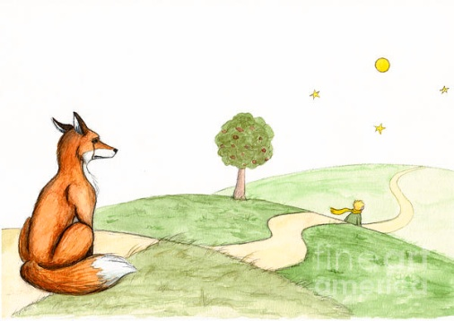If the hunters danced whenever they chose,

the days would all be just alike,

and I’d have no holiday at all. "

That was how the little prince tamed the fox.

And when the time to leave was near:

"Ah!" the fox said.

"I shall ***weep***. "

"It’s your own ***fault***," the little prince said. "I never wanted to ***do*** you any ***harm***, but you insisted that I tame you..."

"Yes, of course," the fox said.

"But you’re going to weep!" the little prince said.

"Yes, of course," the fox said.

"Then you get nothing out of it? "

"I get something," the fox said, "because of the color of the wheat." Then he added, "Go look at the roses again. You’ll understand that yours is the only rose in all the world. Then come back to say good-bye, and I’ll make you the ***gift*** of a secret. "

The little prince went to look at the roses again.

"You’re not at all like my rose. You’re nothing at all yet," he told them. "No one has tamed you and you haven’t tamed anyone. You’re the way my fox was. He was just a fox like a hundred thousand others. But I’ve made him my friend, and now he’s the only fox in all the world. "

And the roses were ***humbled***.

"You are ***lovely***, but you’re empty," he went on. "One couldn’t die for you. Of course, an ***ordinary*** ***passerby*** would think my rose looked just like you. But my rose, all on her own, is more important than all of you together, since she’s the one I’ve watered. Since she’s the one I put under glass. Since she’s the one I sheltered behind a screen. Since she’s the one for whom I killed the caterpillars (except the two or three for butterflies). Since she’s the one I listened to when she ***complained***, or when she ***boasted***, or even sometimes when she said nothing at all. Since she’s my rose. "

And he went back to the fox.

"Good-bye," he said.

"Good-bye," said the fox. "Here is my secret. It’s quite simple: One sees clearly only with the heart. Anything ***essential*** is ***invisible*** to the eyes. "

"Anything essential is invisible to the eyes," the little prince repeated, in order to remember.

"It’s the time you spent on your rose that makes your rose so ***important***. "

"It’s the time I spent on my rose..." the little prince repeated, in order to remember.

"People have forgotten this ***truth***," the fox said. "But you mustn’t forget it. You must become ***responsible*** forever for what you’ve tamed. You’re responsible for your rose..."

"I’m responsible for my rose..." the little prince repeated, in order to remember.