**Past Simple – Regular verbs**

**1.Write the verbs in the right box:**

move – tidy – hop – bake – clean – carry – plan - listen

|  |  |  |  |
| --- | --- | --- | --- |
| -ed | -d | -ied | Double consonant+ed |
| talked | lived | cried | stopped |
|  |  |  |  |
|  |  |  |  |

**2.Write the missing form.**

1.He danced at the party.

\_\_\_\_\_\_\_\_\_\_\_\_\_\_\_\_\_\_\_\_\_\_\_\_\_\_\_\_\_\_\_\_\_\_\_\_\_\_\_\_\_\_\_\_\_\_\_\_\_\_\_\_\_\_\_\_\_\_\_.

\_\_\_\_\_\_\_\_\_\_\_\_\_\_\_\_\_\_\_\_\_\_\_\_\_\_\_\_\_\_\_\_\_\_\_\_\_\_\_\_\_\_\_\_\_\_\_\_\_\_\_\_\_\_\_\_\_\_\_?

2.\_\_\_\_\_\_\_\_\_\_\_\_\_\_\_\_\_\_\_\_\_\_\_\_\_\_\_\_\_\_\_\_\_\_\_\_\_\_\_\_\_\_\_\_\_\_\_\_\_\_\_\_\_\_\_\_\_\_\_.

They didn’t stop at the supermarket

\_\_\_\_\_\_\_\_\_\_\_\_\_\_\_\_\_\_\_\_\_\_\_\_\_\_\_\_\_\_\_\_\_\_\_\_\_\_\_\_\_\_\_\_\_\_\_\_\_\_\_\_\_\_\_\_\_\_\_?

3.\_\_\_\_\_\_\_\_\_\_\_\_\_\_\_\_\_\_\_\_\_\_\_\_\_\_\_\_\_\_\_\_\_\_\_\_\_\_\_\_\_\_\_\_\_\_\_\_\_\_\_\_\_\_\_\_\_.

\_\_\_\_\_\_\_\_\_\_\_\_\_\_\_\_\_\_\_\_\_\_\_\_\_\_\_\_\_\_\_\_\_\_\_\_\_\_\_\_\_\_\_\_\_\_\_\_\_\_\_\_\_\_\_\_\_\_\_.

Did Harry watch TV last night ?

**3.Look at the list and answer the questions.**

|  |  |  |  |
| --- | --- | --- | --- |
|  | clean-house-clipart-1.jpg | playing-computer-games-clipart-4.jpg | study.jpg |
| Tina | 34-343324_check-mark-clip-art-check-clipart-hd-png.png | false.jpg | 34-343324_check-mark-clip-art-check-clipart-hd-png.png |
| Kevin | false.jpg | 34-343324_check-mark-clip-art-check-clipart-hd-png.png | 34-343324_check-mark-clip-art-check-clipart-hd-png.png |

1.Did Tina clean the house? \_\_\_\_\_\_\_\_\_\_\_\_\_\_\_\_\_\_\_\_\_\_\_\_\_\_\_\_\_\_\_.

2.Did Kevin play computer games? \_\_\_\_\_\_\_\_\_\_\_\_\_\_\_\_\_\_\_\_\_\_\_\_\_\_\_.

3.Did Kevin clean the house? \_\_\_\_\_\_\_\_\_\_\_\_\_\_\_\_\_\_\_\_\_\_\_\_\_\_\_\_.

4.Did Kevin and Tina study? \_\_\_\_\_\_\_\_\_\_\_\_\_\_\_\_\_\_\_\_\_\_\_\_\_\_\_.

5.Did Tina play computer games? \_\_\_\_\_\_\_\_\_\_\_\_\_\_\_\_\_\_\_\_\_\_\_\_\_.

**4.What did the Simpsons do last weekend? Read and complete the verbs in Past Simple Tense.**

Last weekend was very special for the Simpson family. Last Saturday, Marge 

\_\_\_\_\_\_\_\_\_\_\_\_\_(cook) and the whole family 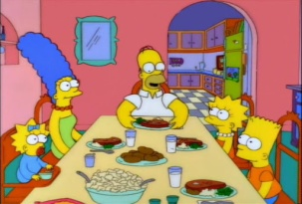 \_\_\_\_\_\_\_\_\_\_\_\_(enjoy) a delicious meal. Then Lisa (play)\_\_\_\_\_\_\_\_\_\_\_\_\_\_\_\_\_\_\_ the saxophone and Marge and Homer  \_\_\_\_\_\_\_\_\_\_\_\_\_(dance). Later they 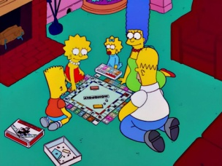

\_\_\_\_\_\_\_\_\_\_\_\_\_\_\_\_(play) board games.

On Sunday morning they 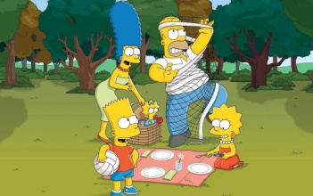 \_\_\_\_\_\_\_\_\_\_\_\_\_\_\_(organise) a picnic in the

woods. In the evening they 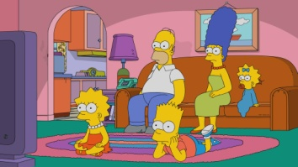 \_\_\_\_\_\_\_\_\_\_\_\_\_\_\_(watch) a film on TV .

They had a lot of fun!