**SOME ANY MUCH MANY A LOT OF (A) FEW (A) LITTLE**

 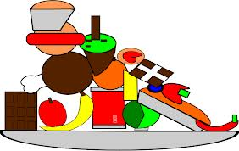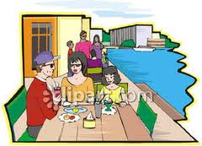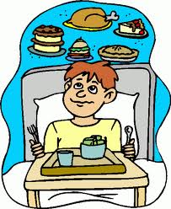

**V. Fill in *a little* or *a few*.**

1. ____________ lemonade

2. ____________ men

3. ____________ milk

4. ____________ sweets 7. ____________ friends

5. ____________ women 8. ____________houses

6. ____________ money 9. ____________ snow

**VI. Choose the correct item.**

1. Have got _______ friends?

A) many B) much C) a lot of

2. There are _______ people in the room.

A) much B) a little C) a lot of

3. Can I have _______ sugar, please?

A) a few B) a little C) little

4. How _______ oranges are on the table?

A) many B) a few C) much

5 How _______ money has Fred got?

A) many B) little C) much

6. There are _______ monkeys at the zoo.

A) much B) a few C) a little.

**IV. Fill in the blanks with *much*, *many*, and**

***a lot of*.**

1. John hasn’t __________ money.

2. There is __________ gold in the bag

3. There aren’t ________ birds in the sky!

4. There aren’t ________ cars in the street.

5. Are there __________ apples on the tree?

6. Jane spends __________ money at the shops.

7. Have you got __________ bread in the cupboard?

8. Are there __________ children on the beach?

9. We are early. We have __________ time.

**III. Put in *much* or *many*.**

1. I haven’t got ___________ time.

2. Do you eat ___________ pasta?

3. I don’t eat ___________ meat.

4. There aren’t ___________ people here.

5. We don’t have ___________tomatoes to make a salad.

6. Is there ___________ flour in the cupboard?

7. Have you travelled to ___________ countries?

8. Was there ___________ traffic on the road?

**II. Write some sentences with *some*.**

***Ex:*** *0. Would you like* ***some*** *more coffee?*

*0. Could I have* ***some*** *bread?*

1. (Ask for coffee)______________________________________

2. (Offer juice)_________________________________________

3. (Offer rice)_________________________________________

4. (Ask for tomatoes) ___________________________________

5. (Offer more potatoes)________________________________

6. (Ask for more milk)___________________________________

7. (Ask for oil) _________________________________________

**I. Circle the correct answers.**

1.I don’t have ***some / any*** toothpaste.

2.Have you got ***some / any*** cherries?

3. We need ***some / any*** more coffee.

4. She’s got ***some / any*** interesting friends.

5. I didn’t have ***some / any*** breakfast today.

6. He hasn’t got ***some / any*** salt.

7. Have you got ***some / any*** brothers and sisters?

8. I’m having ***some / any*** problems with my car.

9. Are there ***some / any*** restaurants near here?