**Read the email and answer the questions.**

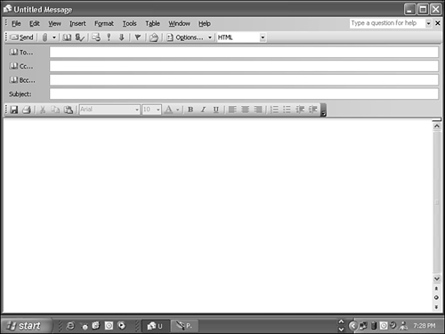

**Hi, Tim!**

It’s Friday today! On Fridays, I get up at quarter past seven. Then I get dressed , I have breakfast and then dad drives me to school. School starts at quarter past eight. I come home from school at half past one. I eat lunch and then I do my homework. I sometimes play the guitar .

It’s six o’clock now. At the moment I am not playing the guitar. I am waiting for my mother to drive me and my best friend to the cinema. I love movies especially comedies. My mum is calling me now so I must go.

Bye for now,

Anne

Answer the questions

1.When does Anne get up?

__________________________________________________________.

2.How does she go to school?

__________________________________________________________.

3.What does she usually do after school?

__________________________________________________________.

4.Who is she waiting for?

_________________________________________________________.

5.Where is she going now?

_________________________________________________________.

**Task :** Write an email to a friend about what you usually do on a school day and what you are doing now. You can use some of the words below.

|  |
| --- |
| read books / go to the park / watch a DVD / play computer games / play board games/ do my homework / listen to music / go to school |



|  |
| --- |
| **Remember!**  **Present simple** : καθημερινές συνήθειες  **Present continuous** : πράξη που γίνεται τώρα |

Hi, ___________________!

It’s Friday today. On Fridays I ________________________________________

____________________________________________________________________

____________________________________________________________________

_______________________________________________________________________________________________________________________________________________________________________________________________________________________________________________________________________________.

It’s ________________________o’clock now. At the moment I________________________________________________________________________________________________________________________________________________________________________________________________________________________________________________________________________________________________________________________________________________________________________________________________________________________.

Bye for now,

_______________________.