GREETINGS : Complete the countries and nationalities.
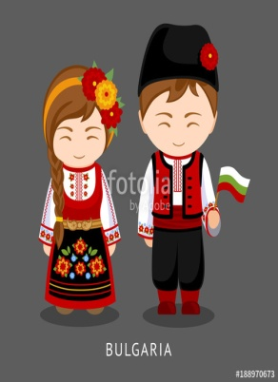  1.I’m from  ___________________  I’m________________ | 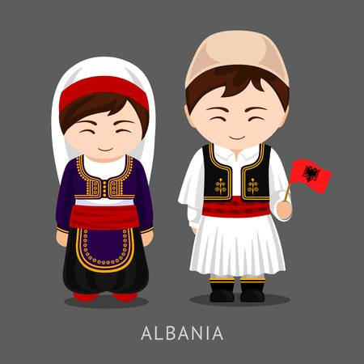  5.I’m from  ___________________  I’m_______________ | 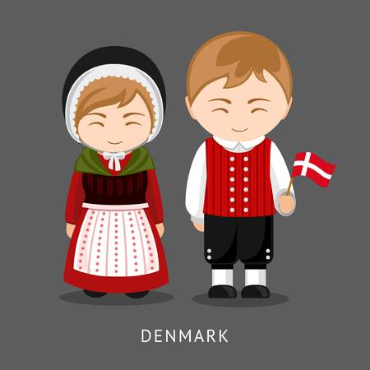  9.I’m from  ____________________  I’m_________________
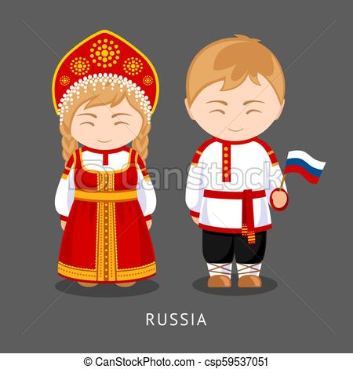  2.I’m from  ___________________  I’m________________ |   6.I’m from  ___________________  I’m________________ | 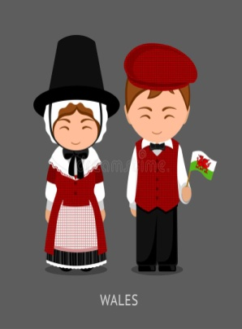  10.I’m from  ____________________  I’m_________________
  3.I’m from  ___________________  I’m________________ |   7.I’m from  ___________________  I’m________________ |   11.I’m from  ___________________  I’m________________
  4.I’m from  ___________________  I’m________________ | 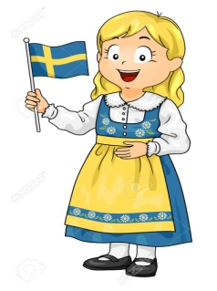  8.I’m from  ____________________  I’m_________________ |   12.I’m from  ____________________  I’m_________________

