**Name: ________________ Date :___________________**

**Preference = Προτίμηση**

**What do you like Well, I enjoy Oh, I hate chess. Then we**

**doing in your free playing chess. I prefer riding my can go cycling !**

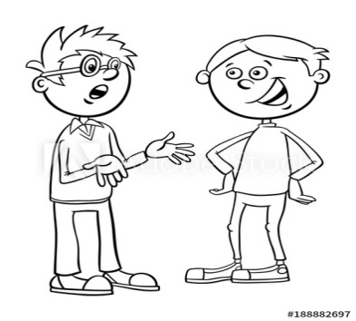 **time? What about you? bike.**



|  |
| --- |
| Δείχνω τι μου αρέσει με τα ρήματα :  **love =αγαπώ, like=μου αρέσει, enjoy=απολαμβάνω** + ουσιαστικό / ρήμα-**ing**  I love music. I love listening to music.  Δείχνω τι δεν μου αρέσει με τα ρήματα :  **don’t like=δεν μου αρέσει, dislike=αντιπαθώ, hate=μισώ** + ουσιαστικό / ρήμα-**ing**  I dislike puzzles . I dislike doing puzzles.  Δείχνω ότι προτιμώ κάτι περισσότερο από κάτι άλλο με το ρήμα :  **Prefer=προτιμώ +** ουσιαστικό / ρήμα-ing **to +** ουσιαστικό / ρήμα-ing  I prefer football to basketball  I prefer playing football to playing basketball. |

**Complete the e-mail**

**Dear ____________________**

**I’m __________________________. I’m __________________years old.**

**I’m a student in __________________________of Primary school .**

**In my free time I like ________________________________________________.**

**I also enjoy_________________________________________________________.**

**I don’t like__________________________________________________________.**

**My favourite hobby is__________________________________________________.**

**Time to go now**

**____________________________**