2011-09-07_1345

**Present Continuous Question**

**“be” +Υποκείμενο + ρήμα +“ing”**

**Am I walking?**

**Are you painting?**

**Is he talking?**

**Is she laughing?**

**Is it raining?**

**Are we cooking?**

**Are you smiling?**

**Are they singing?**

**Present Continuous Negative**

**“be” +”not”+” ρήμα + “ing”**

**I am not walking.**

**You are not painting.**

**He is not talking.**

**She is not laughing.**

**It is not raining.**

**We are not cooking.**

**You are not smiling.**

**They are not singing.**

**Present Continuous Affirmative**

**“be” + ρήμα +“ing”**

**I am walking.**

**You are painting.**

**He is talking.**

**She is laughing.**

**It is raining.**

**We are cooking.**

**You are smiling.**

**They are singing.**

2011-09-07_1347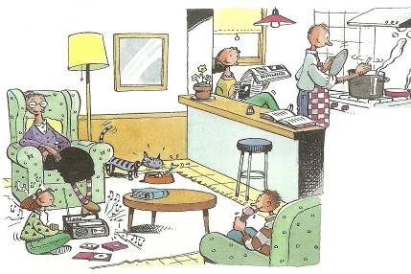

Match the sentences with the pictures.

The cat is eating fish.

Dad is cooking dinner.



Bob is eating ice-cream.

Grandma is sleeping.

Liz is listening to music.

Mum is reading the newspaper.

Correct the sentences . Διόρθωσε τις προτάσεις.

1. We eating a lot of sweets at the moment. .....................................................
2. He is drive a car at present. ............................................................................
3. Joana playing her toys with Peter. .................................................................
4. My friends are plant a tree in the park. .........................................................
5. They are read an interesting article. ..............................................................
6. They am swimming in the lake. .....................................................................
7. I am study Μaths now. ...................................................................................
8. She watching a comedy on TV. .......................................................................

2011-09-07_1402

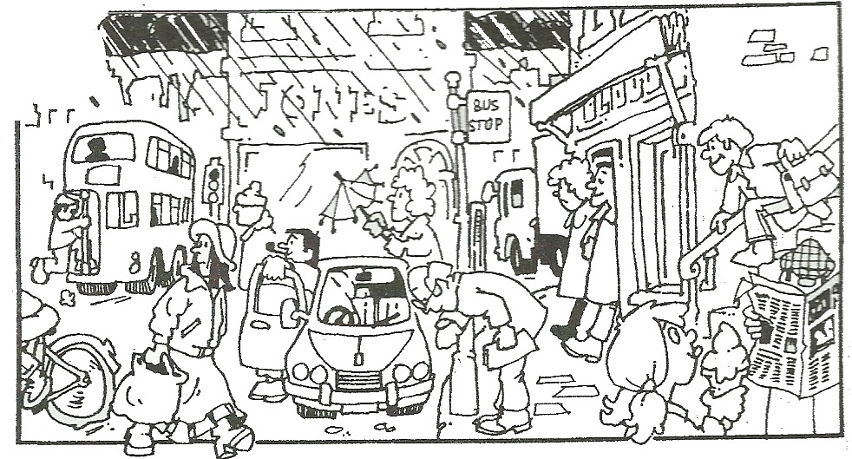

Χρησιμοποίησε λέξεις από τη στήλη A και B και γράψε τι κάνουν οι άνθρωποι στην παραπάνω εικόνα .

**the café**

**the car**

**the bus**

**the bike**

**the stairs**

**the newspaper**

**two bags**

**ice-cream**

**the watch**

**the umbrella**

**look at**

**carry**

**run down**

**leave**

**get onto**

**open**

**read**

**get out of**

**eat**

**ride**

EXAMPLE

The old man **is looking** at the watch.

**\_\_\_\_\_\_\_\_\_\_\_\_\_\_\_\_\_\_\_\_\_\_\_\_\_\_\_\_\_\_\_\_\_\_\_\_\_\_\_\_\_\_\_\_\_\_\_\_\_\_\_\_\_\_\_\_\_\_\_\_\_\_\_\_\_\_\_\_\_\_\_\_\_\_\_\_\_\_\_\_\_\_\_\_\_\_\_\_\_\_\_\_\_\_\_\_\_\_\_\_\_\_\_\_\_\_\_\_\_\_\_\_\_\_\_\_\_\_\_\_\_\_\_\_\_\_\_\_\_\_\_\_\_\_\_\_\_\_\_\_\_\_\_\_\_\_\_\_\_\_\_\_\_\_\_\_\_\_\_\_\_\_\_\_\_\_\_\_\_\_\_\_\_\_\_\_\_\_\_\_\_\_\_\_\_\_\_\_\_\_\_\_\_\_\_\_\_\_\_\_\_\_\_\_\_\_\_\_\_\_\_\_\_\_\_\_\_\_\_\_\_\_\_\_\_\_\_\_\_\_\_\_\_\_\_\_\_\_\_\_\_\_\_\_\_\_\_\_\_\_\_\_\_\_\_\_\_\_\_\_\_\_\_\_\_\_\_\_\_\_\_\_\_\_\_\_\_\_\_\_\_\_\_\_\_\_\_\_\_\_\_\_\_\_\_\_\_\_\_\_\_\_\_\_\_\_\_\_\_\_\_\_\_\_\_\_\_\_\_\_\_\_\_\_\_\_\_\_\_\_\_\_\_\_\_\_\_\_\_\_\_\_\_\_\_\_\_\_\_\_\_\_\_\_\_\_\_\_\_\_\_\_\_\_\_\_\_\_\_\_\_\_\_\_\_\_\_\_\_\_\_\_\_\_\_\_\_\_\_\_\_\_\_\_\_\_\_\_\_\_\_\_\_\_\_\_\_\_\_\_\_\_\_\_\_\_\_\_\_\_\_\_\_\_\_\_\_\_\_\_\_\_\_\_\_\_\_\_\_\_\_\_\_\_\_\_\_\_\_\_\_\_\_\_\_\_\_\_\_\_\_\_\_\_\_\_\_\_\_\_\_\_\_\_\_\_\_\_\_\_\_\_\_\_\_\_\_\_\_\_\_\_\_\_\_\_\_\_\_\_\_\_\_\_\_\_\_\_\_\_\_\_\_\_\_\_\_\_\_\_\_\_\_\_\_\_\_\_\_\_\_\_\_\_\_\_\_\_\_\_\_\_\_\_\_\_\_\_\_\_\_\_\_\_\_\_\_\_\_\_\_\_\_\_\_\_\_\_\_\_\_\_\_\_\_\_\_\_\_\_\_\_\_\_\_\_\_\_\_\_\_\_\_\_\_\_\_\_\_\_\_\_\_\_\_\_\_\_\_\_\_\_\_\_\_\_\_\_\_\_\_\_\_\_\_\_\_\_\_\_\_\_\_\_\_\_\_\_\_\_\_\_\_\_\_\_\_\_\_\_\_\_\_\_\_\_\_\_\_\_\_\_\_\_\_\_\_\_\_\_\_\_\_\_\_\_\_\_\_\_\_\_\_\_\_\_\_\_\_\_\_\_\_\_\_\_\_\_\_\_\_\_\_\_\_\_\_\_\_\_\_\_\_\_\_\_\_\_\_\_\_\_\_\_\_\_\_\_\_\_\_\_\_\_\_\_\_\_\_\_\_\_\_\_\_\_\_\_\_\_\_\_\_\_\_\_\_\_\_\_\_\_\_\_\_\_\_\_\_\_\_\_\_\_\_\_\_\_\_\_\_\_\_\_\_\_\_\_\_\_\_\_\_\_\_\_\_\_\_\_\_\_\_\_\_\_\_\_\_\_\_\_\_\_\_\_\_\_\_\_\_\_\_\_\_\_\_\_\_\_\_\_\_\_\_\_\_\_\_\_\_\_\_\_\_\_\_\_.**