**Write the school subjects .**

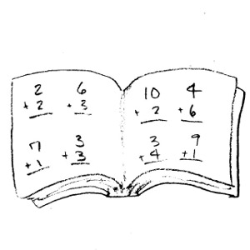    

M ___ t ___ s A ___ ___ C ___ m __ ___ t __ ___ R ___ l ___ g ___ ___ ___ s L __ ___ g __ __ g ___

S t ___ d __ ___ s E d ___ c ___ t ___ ____ n

    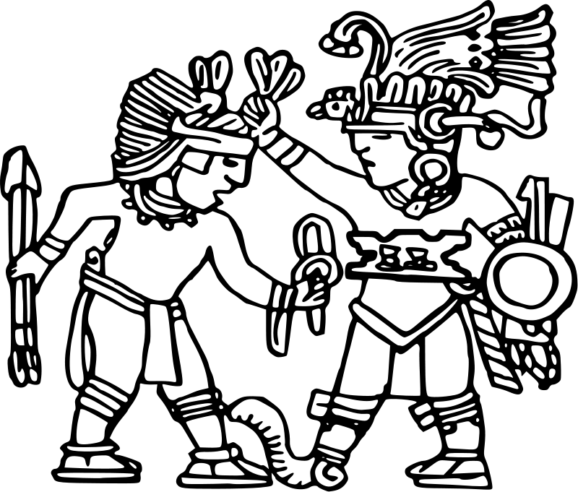

P h ____ s ___ c ___ l M ___ s ___ ___ S c __ __ n __ ___ G ___ ___ g ___ a ___ ___ y H ___ s ___ ___ r ___

E d____ c ___ t ___ ___