

Do your best

# Match them up! Αντιστοίχισε τις εικόνες με τις λέξεις.

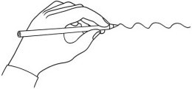Draw a line to match the picture and the word.

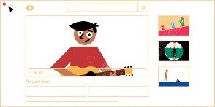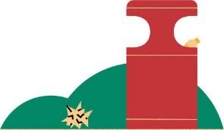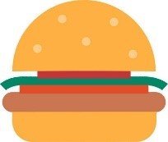

|  |  |  |  |  |
| --- | --- | --- | --- | --- |
|  |  |  |  |  |
|  |  |  |  |  |

|  |  |  |  |  |
| --- | --- | --- | --- | --- |
| the sea | a computer | meat | plastic | a tap |
| litter | planet Earth | recycling | a reusable bottle | brush your teeth |

# Where does it go?

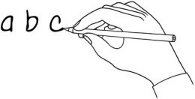Listen to the song. Write these words and phrases in the correct group.

|  |  |  |
| --- | --- | --- |
| ~~turn off your TV~~ | use too much plastic | use a reusable bottle |
| eat too much meat | leave the tap running | recycle |

|  |  |
| --- | --- |
| Do - Τι πρέπει | Don’t-Τι δεν πρέπει |
| turn off your TV |  |

[www.britishcouncil.org/learnenglishkids](http://www.britishcouncil.org/learnenglishkids)

© British Council, 2020 The United Kingdom’s international organisation for educational opportunities and cultural relations. We are registered in England as a charity.



# Match them up! Ένωσε τους στίχους του τραγουδιού.

Listen to the song. Match the sentence halves.

Don’t use too much plastic to save the planet that you love.

You’re doing your very best at your home and at your school.

Do not leave the tap running cos it can end up in the sea.

Recycle everything you can recycling’s really cool.

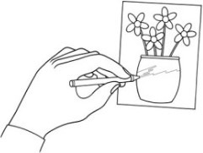Recycling’s not just an obligation, as you brush your teeth for bed.

# Write and draw!

What do you do at home and at school to help save the planet? Draw a picture and write about it!

..........................................................................................................................................................................................................................................................................

..........................................................................................................................................................................................................................................................................

..........................................................................................................................................................................................................................................................................

..........................................................................................................................................................................................................................................................................

[www.britishcouncil.org/learnenglishkids](http://www.britishcouncil.org/learnenglishkids)

© British Council, 2020 The United Kingdom’s international organisation for educational opportunities and cultural relations. We are registered in England as a charity.