**1.Write the verbs in the right box. Γράφω τα ρήματα στο σωστό κουτάκι:**

watch – tidy – wash – carry – play – listen

|  |  |  |
| --- | --- | --- |
| -s | -es | -ies |
| He / She / It walks | He / She / It go**es** | He / She / It cr**ies** |
|  |  |  |
|  |  |  |

**2.Describe the man’s daily routine. Περιγράφω την καθημερινή ρουτίνα του ήρωα.**

get up

get dressed

have /a shower

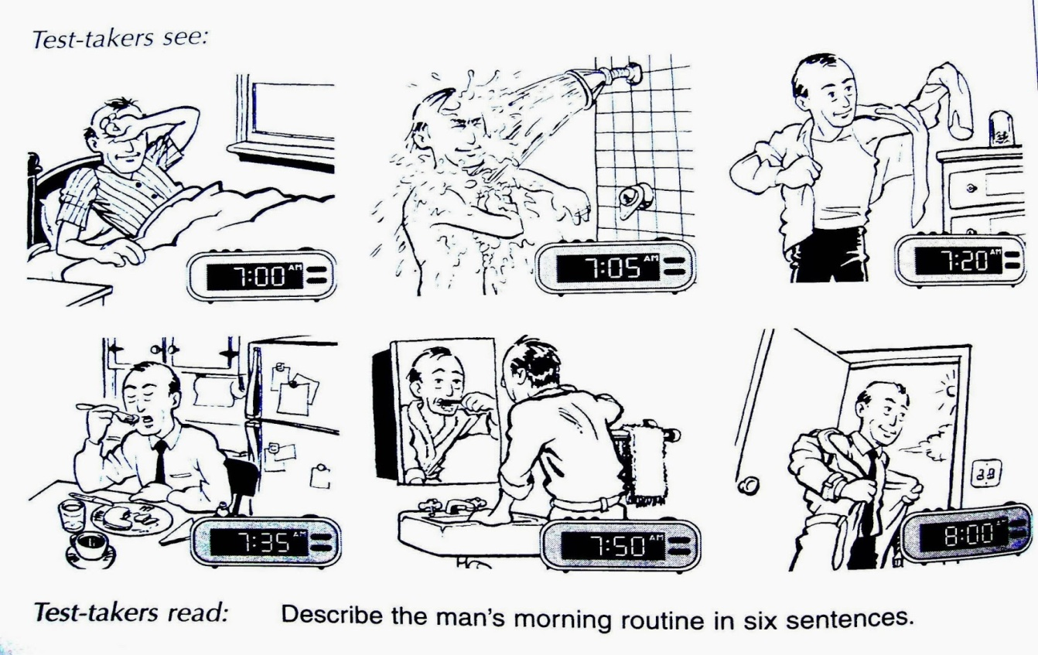

eat / breakfast

go / to work

brush / teeth

Eg. He gets up at 7:00 every day.

1.At 7:05 he_______________________________________.

***He / She / It + ρήμα + s***

2.At 7:20 he_____________________­­__________________.

3.At 7:35 he_______________________________________.

4.At 7:50 he _______________________________________.

5.At 8:00 he_______________________________________.

**3.Write about your habits.Γράψε για τις δικές σου συνήθειες.**

**Use - Χρησιμοποίησε: always / usually / often / sometimes / never.**

|  |
| --- |
| take exercise / listen to music  eat ice-cream/ride a bike  make my bed /watch TV  play computer games/draw |

Eg. I always make my bed.

1._______________________________________________.

2._______________________________________________.

3._______________________________________________.

4._______________________________________________.