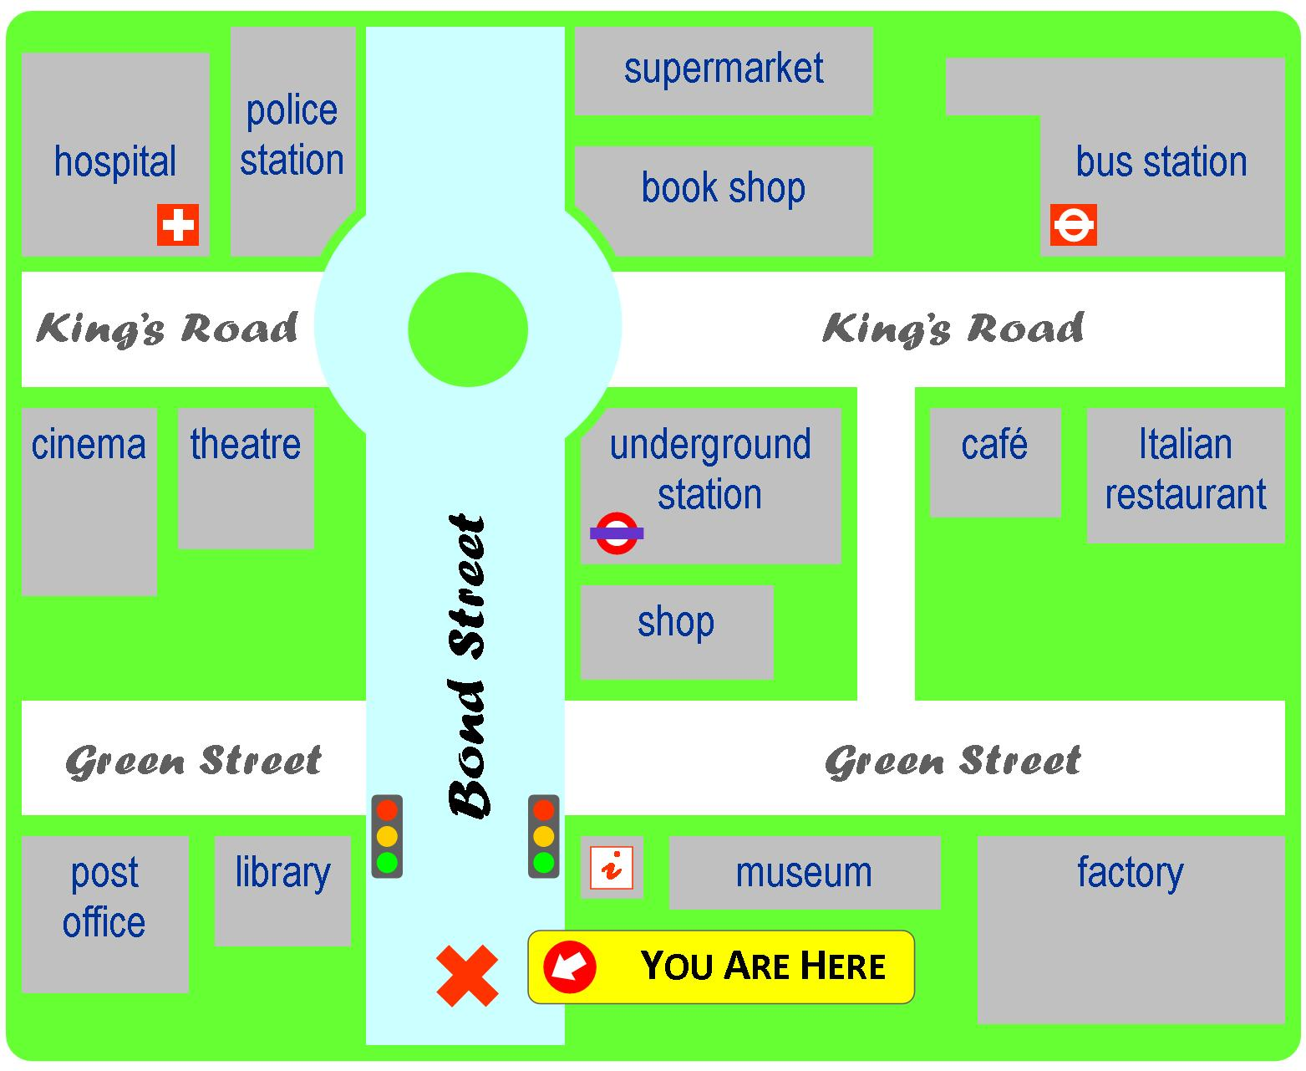
- Excuse me! How can I get to the bus station?

- Excuse me! Can you please tell me the way to the hospital?

- Excuse me! How can I get to the post office?

* You start from the red cross. X

