Έξτρα υλικό από το βιβλίο της 5ης τάξης ( Διαβάστε τα κείμενα και δείτε την άσκηση στις Ασκήσεις)
Easter in Norway
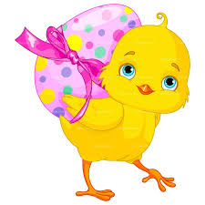
Easter in Norway is full of Easter chickens, Easter eggs in all colors and sometimes Easter bunnies. Yellow chickens are everywhere at Easter time. Painted chickens, plastic chickens, cotton chickens, chickens made of all sorts of materials can be seen in private homes, shop windows, newspapers and magazines, on plastic bags and on television. So, yellow has become the color of Easter in Norway. Maundy Thursday, Good Friday and Easter Monday are national holidays in Norway. School children however have 6 days of Easter vacation (not counting the weekends). The Norwegians in general do not pay much attention to the religious aspect of Easter. Of course they know the story, but only some will go to church.

Easter in Mexico
Easter celebration in Mexico is held in two big parts - Semana Santa and Pascua. The first one means the whole of the Holy Week - Palm Sunday to Easter Saturday. And the Pascua is the period from the Resurrection Sunday to the following Saturday. For most Mexicans, this two-week period is the time for a great vacation. People enjoy this time with the community of their choice. Semana Santa celebrates the last days of the Christ’s life. Pascua is the celebration of the Christ’s Resurrection. It is also the end of Lent. In many communities, the full Passion Play is enacted from the Last Supper, the Betrayal, the Judgement, the Procession of the 12 Stations of the Cross, the Crucifixion and, finally, the Resurrection. In some communities, real crucifixion is included. The enactments are often nicely staged, costumed and acted, with participants preparing for their roles for nearly the full year leading up to Semana Santa.
Enactment = αναπαράσταση
Resurrection = Ανάσταση
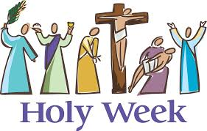
community = κοινότητα
Last Supper = Μυστικός Δείπνος
Betrayal = Προδοσία
Judgement = Δίκη, κρίση
Procession = πορεία
Crucifixion = Σταύρωση
Lent = νηστεία
Easter in Africa
In Africa, Easter is an important celebration in the Christian communities. In the Easter Vigil hundreds of people assemble in the church building. In most parish churches people expect with excitement the Easter Vigil, because there are no lights, usually beginning at 3pm and finishing at dark, around 6pm. The church is decorated by Vitenge and Kanga, clothes made up in the form of butterflies, flowers, banana trees etc. Christian hymns are accompanied by the beating of drums and Kigelegele, the high-pitched sounds made by women.
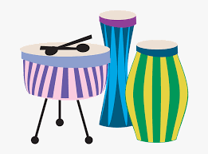
Assemble = συγκεντρώνονται
are accompanied = συνοδεύονται

